Managing Drugs and Alcohol in the Workplace

# Andrew Ermer, Manager – National Construction Services, Australian Industry Group

# General Statistics

* 1 in 9 drove a motor vehicle under the influence of alcohol
* 1 in 17 verbally abused someone under the influence of alcohol
* 1 in 4 were verbally abused by someone under the influence of alcohol
* 1 in 50 were physically abused by someone affected by illicit drugs

# Workplace Statistics

* 10% of workplace deaths drug or alcohol related
* 20-25% of workplace accidents drug or alcohol related
* 61 % of people reporting frequent use of drugs and/or alcohol were in full time employment

# Why take positive action?

* Protect health and safety
* Minimise risk of inappropriate behaviour
* Improve work performance
* Reduce cost of absenteeism and benefits claims
* Decreased alertness and impaired judgement
* Higher staff turnover

# OHS Obligations (Common Law)

Employer Duties

* Duty to take reasonable care to ensure the safety and welfare of employees.

Employee Duties

* Duty to exercise reasonable care and to attend to the work with skill and competence.

# OHS Obligations (Legislation)

Employer Duties

* Employer must, so far as is reasonably practicable, provide and maintain a working environment that is safe and without risks to health. Includes: plant, systems of work, instruction and training.
* Employer must, so far as is reasonably practicable, monitor the health and safety of employees.
* Duties extend to persons other than employees (i.e. the public).

# Employee Duties

* Employees must take reasonable care for their own health and safety and that of others (eg. by ensuring they are not affected by drugs/alcohol in a way that may put themselves or others at risk); and cooperate with the employer with respect to action taken by the employer to comply with OHS obligations

Note: Words vary from State to State but these are the General Principles

# Reasonable Steps

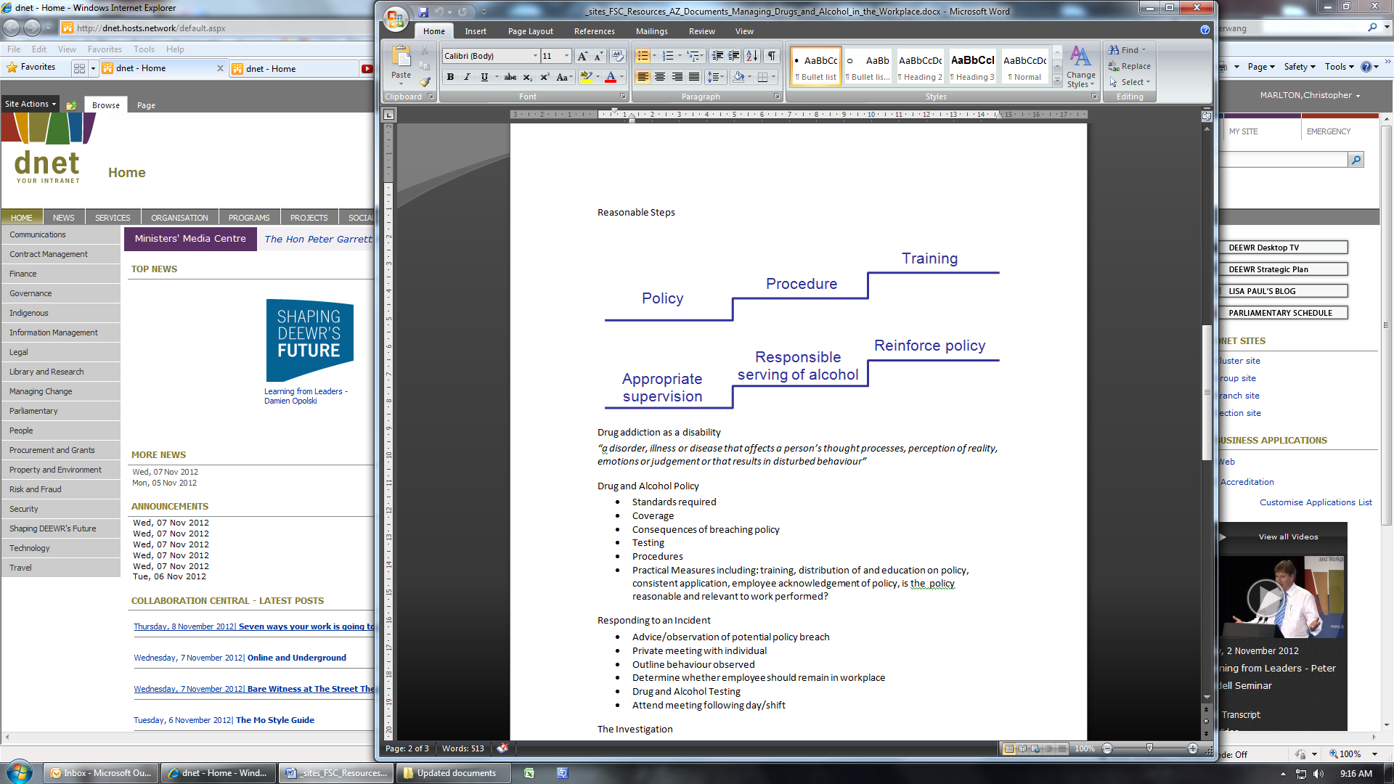

# Drug addiction as a disability

“a disorder, illness or disease that affects a person’s thought processes, perception of reality, emotions or judgement or that results in disturbed behaviour”

# Drug and Alcohol Policy

* Standards required
* Coverage
* Consequences of breaching policy
* Testing
* Procedures
* Practical Measures including: training, distribution of and education on policy, consistent application, employee acknowledgement of policy, is the policy reasonable and relevant to work performed?

# Responding to an Incident

* Advice/observation of potential policy breach
* Private meeting with individual
* Outline behaviour observed
* Determine whether employee should remain in workplace
* Drug and Alcohol Testing
* Attend meeting following day/shift

# The Investigation

* Detailed Records
  + observations of others
  + records of discussions including initial interview
  + record arrangements for follow-up meeting
* Maintain Confidentiality
* Follow Up Interview
  + provide opportunity to respond
* Determine appropriate Outcome

# Influencing Outcome

* Degree of risk
* Workplace policies
* Strength of evidence
* Seriousness of breach
* Previous work history
* Any previous incidents

# Options Available

* No disciplinary action
* Counselling
* Warning / first and final warning
* Referral to EAP
* Termination of employment

# Impairment Considerations

