The Building Trades Group

Drug and Alcohol Program

# THE PROBLEM

* Responsible for 20% to 25% of all industrial   
  accidents
* 62% of abusers in full time employment
* 16% of males in Sydney detox centres are from the construction industry

# WORKPLACE PROBLEMS

* Safety
* Health
* Personal
* Absenteeism
* Poor performance
* Industrial

# BACKGROUND OF THE BTG PROGRAM

* WORKPLACE PROGRAM FOCUSED ON SAFETY
* Run by a dedicated body established 1989
* Developed by target group
* Education
* Peer intervention
* Harm reduction
* Nationally accepted & institutionalised policy

# A SIMPLE PHILOSOPHY

* If you choose to use drugs or alcohol, that’s your business
* If you choose to do it in the workplace, that’s our business
* If you want to stop drinking or using, maybe we can help

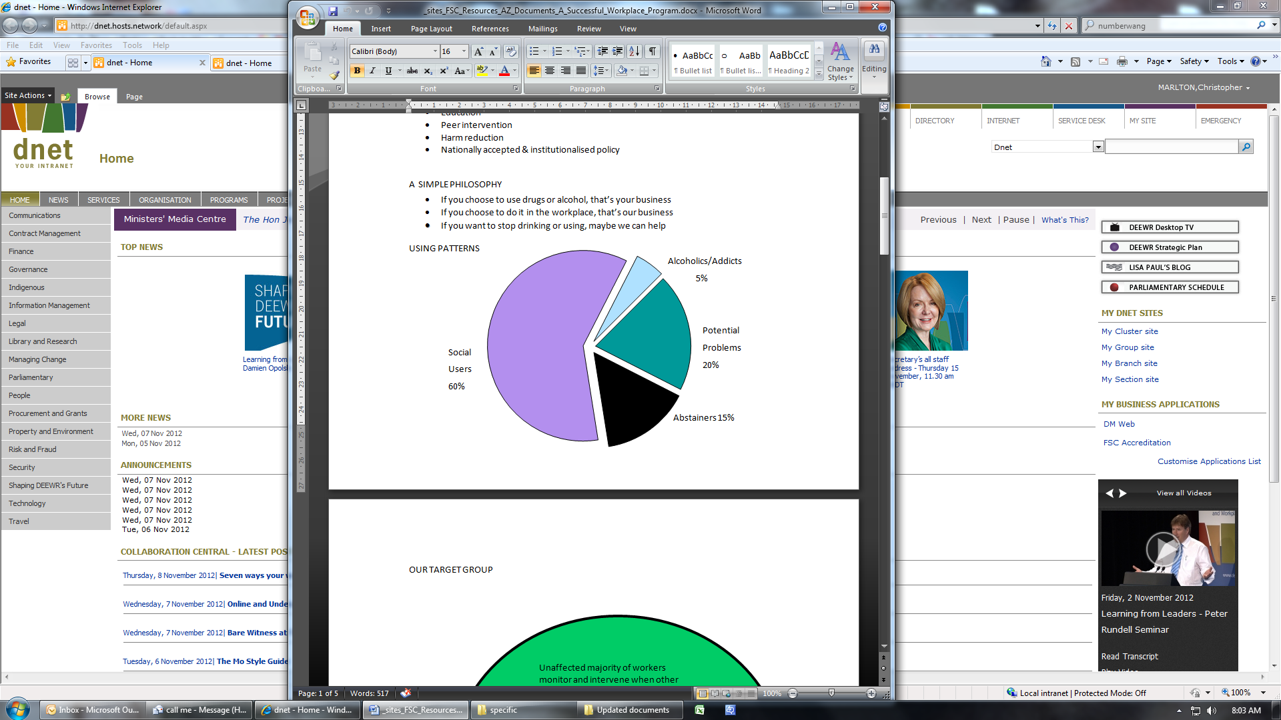

# OUR TARGET GROUP

A ven diagram showing a small red circle in a large green circle. The green circle represents the unnaffected majority of workers who are capable of responsible behaviour and the red circle represents the affected minority who are incapable of acting in a responsible way.


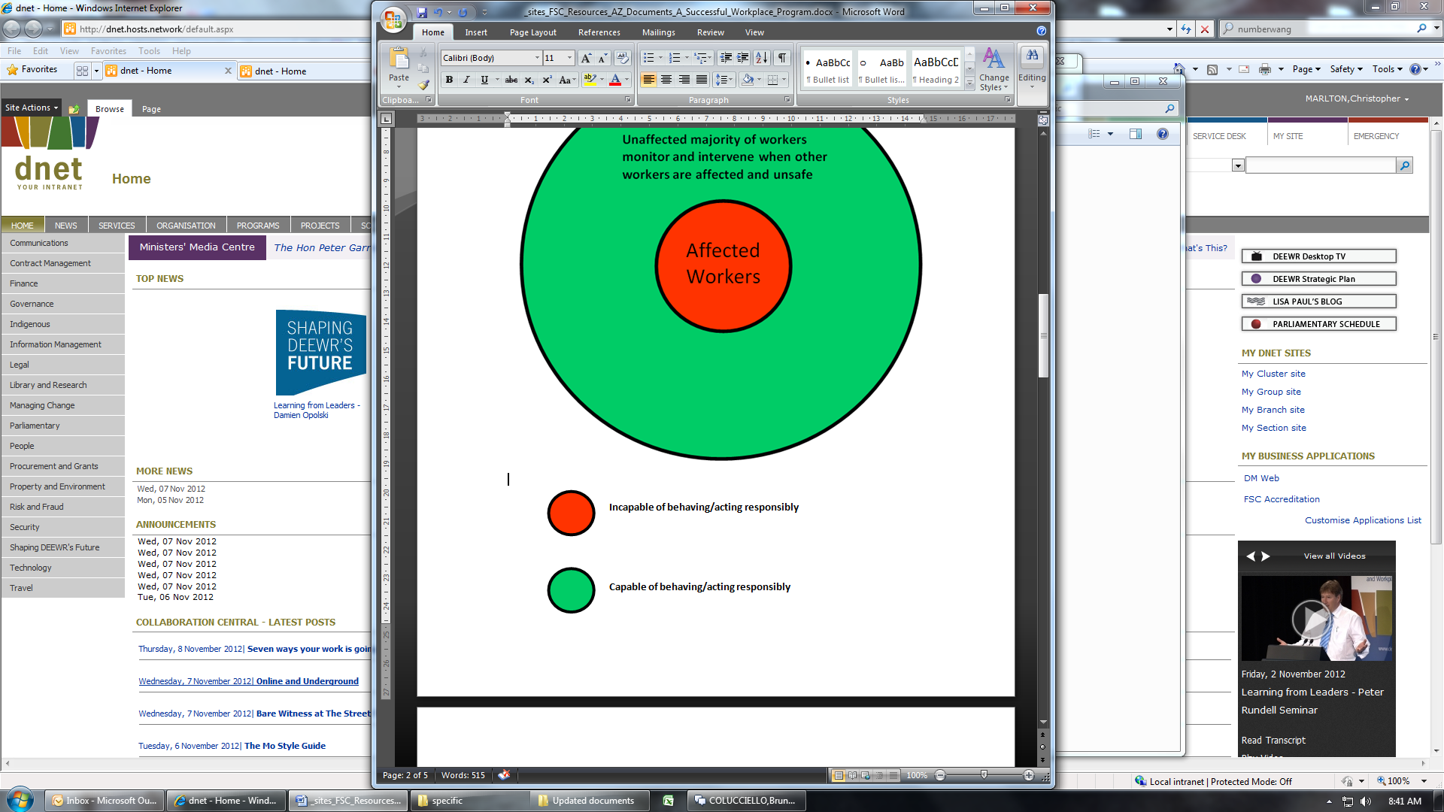

# PROGRAM OBJECTIVES

* Increase awareness of workplace D & A issues
* Promote BTG program
* Encourage intervention by workers
* Provide training
* Increase numbers of workers in treatment

# PROGRAM PRINCIPLES

* Safety
* Harm reduction
* Peer intervention
* Taking responsibility
* Education
* Changing attitudes
* Referral for treatment where necessary

# PROGRAM COMPONENTS

* On site awareness sessions
* Safety Committee training
* Apprentice training courses
* HIV/AIDS awareness & syringe disposal training
* Rehabilitation & treatment services for D & A and gambling

# REACH AND RESULTS

All figures for New South Wales only

* 1,430 awareness sessions to 137,000 workers (NSW)
* 340 training courses for 3,540 key industry workers
* 2,620 apprentice training courses for 29,100 apprentices

# ADDITIONAL HEALTH RELATED ACTIVITIES

* Policy on safe removal of syringes found in the workplace
* Safe drinking & drug use guidelines
* Developed guidelines for responsible serving and use of alcohol at social or industry functions
* HIV/AIDS education & awareness campaign
* Presentation of Life Care Skills education for apprentices

# ACHIEVEMENTS AND RECOGNITION

* United Nations
* “Not at Work Mate” Video
* Consultancy services
  + BHP BIPD
  + Boral Timber
  + Fonterra Group
  + New Zealand Post
  + Shell Oil Refinery
  + Streets Ice Cream
  + Various Councils
* Established CIDAF & “Foundation House”
  + Located in Rozelle
  + Opened in 2000
  + Staffed 24 hours 7 days
  + Provides D & A and gambling
  + Residential & outpatient services

# FOUNDATION HOUSE

## Services Provided

* Assessment
* Counselling
* Referral to detoxification
* 28 day residential program
* Outpatient counselling
* Family groups and counselling
* Relapse prevention
* Gambling services

# STRENGTHS OF PROGRAM

* Unique & original
* At the coalface
* Developed & implemented   
  by target group
* Run by a dedicated entity
* Appeals to all stakeholders
* Demonstrated success
* Ongoing & sustainable

# SUMMARY

* Workers, unions and employers can combine to play an effective role in the provision of safety and health promotion programs
* Utilising existing resources and structures gives maximum results for minimum investment
* Effectiveness of peer based safety / education programs
* Health / social projects and the workplace can be compatible partners

THE BUILDING TRADES GROUP   
DRUG & ALCOHOL PROGRAM

www.btgda.org.au

www.cidaf.asn.au