**Federal Safety Commissioner Guidance – COVID-19 (Coronavirus)**



This Guidance has been developed to provide information on COVID-19 to companies accredited under the Work Health and Safety Accreditation Scheme (the Scheme). Examples of practical steps to help companies meet the Federal Safety Commissioner Audit Criteria Guidelines (the Scheme Criteria) are included

# What is COVID-19?

COVID-19 is a new respiratory coronavirus first reported in December 2019. Coronaviruses cause respiratory infections ranging from the common cold to more severe diseases such as Middle East Respiratory Syndrome (MERS), Severe Acute Respiratory Syndrome (SARS) and now COVID-19. It has since become a global pandemic, including cases in Australia, resulting in significant numbers of infected people and fatalities.

COVID-19 is a communicable disease that most likely spreads from person-to-person in a workplace through:

* Close **contact with a person while they are infectious** who coughs or sneezes, and/or;
* **Touching objects or surfaces** (such as door handles or tables) contaminated from a cough or sneeze from an infectious person, and then **touching your mouth or face**.

Symptoms of COVID-19 include fever, coughing, sore throat and shortness of breath. The following [infographic](https://www.health.gov.au/resources/publications/coronavirus-covid-19-identifying-the-symptoms) from the Department of Health explains the different symptoms you may experience if you have coronavirus (COVID-19), a cold, or the flu.

It is important that companies accredited under the Scheme manage the risk of COVID-19 so far as is reasonably practicable, and in accordance with relevant Federal and State/Territory requirements.

1Most Australian jurisdictions, including the Commonwealth, have implemented model WHS laws. Victoria has similar laws and Western Australia introduced legislation in November 2019 that mirrors the model WHS Act (expected to come into effect during 2020).

[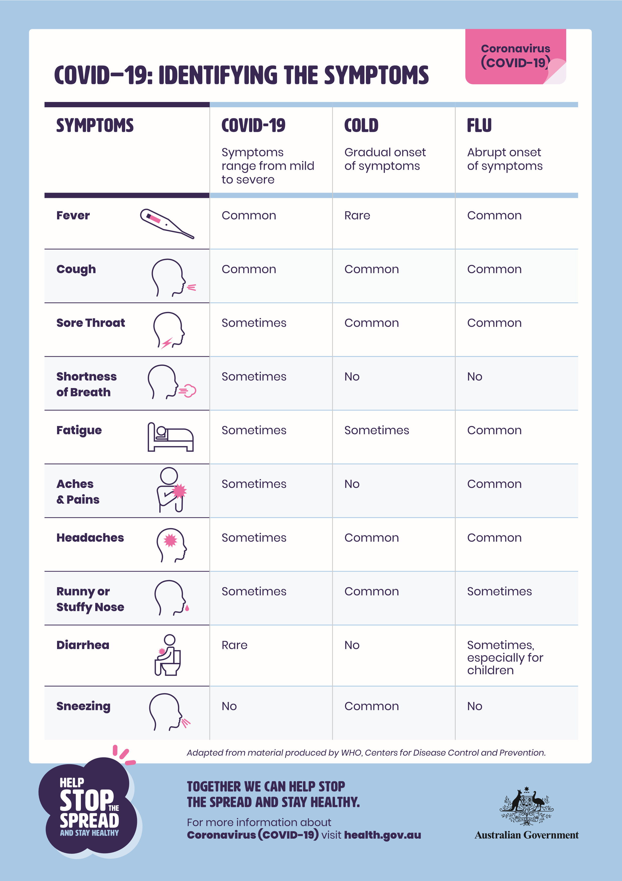](https://www.health.gov.au/resources/publications/coronavirus-covid-19-identifying-the-symptoms)Testing may not be readily available to confirm whether someone has COVID-19. Safe Work Australia has provided information on [what to do if a worker has a suspected or confirmed case](https://www.safeworkaustralia.gov.au/doc/what-do-if-worker-has-covid-19-infographic).

# What are my obligations?

The model WHS laws1 require employers to ensure, so far as is reasonably practicable, the health and safety of their workers and others at the workplace. This includes:

* Providing and maintaining a work environment that is without risk to health and safety; and
* Providing adequate facilities for workers in carrying out their work.

As an employer, you must identify risks of COVID-19 infection at the workplace, and eliminate or minimise those risks. This is reinforced by the conditions attached to accreditation under the Scheme – companies must, at all times, have and implement appropriate WHS policies and safe working practices.

COVID-19 should be treated like any other health and safety risk onsite. It should be assessed and controlled in accordance with your HIRAC process, taking into account the guidelines made available by the Federal and State/Territory Governments.

# What steps should I take?

To meet your obligations under the conditions of Scheme accreditation you need to identify, risk assess and control all hazards relevant to your site, including COVID-19.

Risks from the COVID-19 virus can be physical or psychosocial. What you can do to manage the risk of exposure to COVID-19 will depend on your workplace and the work that you do.

At the moment, there is no immunisation or cure available for COVID-19. To help stop the spread of the virus, the Department of Health advises that people:

* Practice good hygiene;
* Practice physical distancing (this means staying at least 1.5m apart);
* Follow limits set by State/Territory Governments on the number of people able to gather publicly; and
* Understand how and when to self-isolate.

You must implement control measures to minimise the spread of COVID-19 and ensure that other measures to address well known work health and safety risks continue to be implemented (e.g. Safe Work Method Statements). This is the case even if implementing control measures results in delays to your project schedule, or cause disruptions to projects.

# Pay particular attention to…

The particular risks associated with COVID-19 will be different at each workplace or site. However, there are a few controls that will be common to all workplaces.

## **Physical distancing**

Working closely together increases the risk of exposure to COVID-19. You must do everything reasonably practicable to keep workers apart. This could include office staff working from home, limiting site access to just the essential personnel needed to do the day’s work, minimising interaction between groups and keeping staff a safe distance apart (at least 1.5m). This applies in all areas of the workplace including crib/break rooms and in vehicles. Note that legal obligations related to Right of Entry must still be complied with.

## Cleaning

The length of time COVID-19 survives on objects and surfaces varies. Usual cleaning schedules, focusing on high contact areas such as water coolers, hoist/lift controls, crib rooms and equipment, door handles and stair handrails will need to be increased based on infection control principles. See the Department of Health information sheet on [Environmental cleaning and disinfection principles for COVID-19 for further information](https://www.health.gov.au/sites/default/files/documents/2020/03/environmental-cleaning-and-disinfection-principles-for-covid-19.pdf).

## Informing workers

Your staff, as well as subcontractors on-site, need to know the symptoms of COVID-19 and the measures to control the risk of exposure you are adopting. You are encouraged to put in place a documented system for informing workers about what you are doing in response to COVID-19.

## Encouraging good hygiene

Good hygiene helps to stop the spread of COVID-19. Consider measures to encourage all workers on site to practice increased personal hygiene standards. This could include providing access to hand washing and hand sanitisers, providing access to disinfectant to sanitise shared tools and hanging posters to educate everyone on good hygiene practices. Guidance on hand washing is available from the [Department of Health](https://www.health.gov.au/resources/publications/coronavirus-covid-19-print-ads-good-hygiene-is-in-your-hands).

## Documenting and checking

A documented risk assessment of high contact areas should be undertaken to ensure additional controls are in place, including a robust cleaning regime. You should check the documented processes are being implemented and remain up to date with Government advice.

## Planning ahead

It’s possible one of your staff or a subcontractor who has been on your site will catch COVID-19. You should prepare a documented process for what you will do in the case of a confirmed case of COVID-19 on your site. The plan should cover your immediate response and returning to normal operations. Advice on this is available from [Safe Work Australia](https://www.safeworkaustralia.gov.au/doc/what-do-if-worker-has-covid-19-infographic).

# Scheme Criteria

Companies accredited under the Scheme are required to comply with the Scheme Criteria at all times on all sites. A list of the Scheme Criteria most relevant to managing COVID-19 is attached to this Guidance along with practical examples of steps that could be taken to meet each criterion.

## For further information:

* Safe Work Australia Factsheet – Building and construction: Minimising the risk of exposure to COVID-19 **–** [**covid-19 building-and-construction**](https://www.safeworkaustralia.gov.au/covid-19-information-workplaces/preparing-workplaces-covid-19/building-and-construction-minimising)
* Safe Work Australia – [**COVID-19 Information for small business**](https://www.safeworkaustralia.gov.au/covid-19-information-workplaces/covid-19-information-small-business)
* Department of Health **–** [**Coronavirus (COVID-19) resources**](https://www.health.gov.au/resources/collections/novel-coronavirus-2019-ncov-resources)
* Department of Health – [**Local state and territory health departments**](https://www.health.gov.au/about-us/contact-us/local-state-and-territory-health-departments)
* Department of Health information sheet – [**Environmental cleaning and disinfection principles for COVID-19**](https://www.health.gov.au/sites/default/files/documents/2020/03/environmental-cleaning-and-disinfection-principles-for-covid-19.pdf)
* Master Builders Association Victoria – **COVID-19 Guidelines for the building and construction industry**
* Housing Industry Association **–** [**COVID-19 Update**](https://hia.com.au/covid-19)
* Visit the FSC website at **www.fsc.gov.au**
* Contact the FSC Assist Line on **1800 652 500**
* Contact the OFSC via email at **ofsc@jobs.gov.au**

This fact sheet was last updated 17 April 2020. The Office of the Federal Safety Commissioner (OFSC) has prepared this fact sheet for general information only, and it does not replace professional advice. This fact sheet is derived from a variety of sources and has been prepared without taking into account your individual objectives, situations or needs. You should consider your personal circumstances, and if appropriate, seek independent legal, financial or other professional advice before acting. The OFSC has endeavoured to ensure the currency and completeness of the information in this fact sheet at the time of publication; however, this information may change over time. The OFSC expressly disclaims any liability caused, whether directly or indirectly, to any person in respect of any action taken on the basis of the content of this fact sheet.

**WHS Accreditation Scheme criteria relevant to COVID-19 and practical examples**

|  |  |  |
| --- | --- | --- |
| Scheme Criterion | What’s generally required of Accredited Companies | Example process |
| **WH3 Legal Requirements** | Health and safety legal and other requirements should be identified and understood, and processes are to be in place to ensure that information is available on site, and that changes are monitored and managed. | State and Territory Governments have introduced legally enforceable physical distancing and other standards, including requirements which apply to workplaces. These requirements and their effects on construction workplaces are to be identified and understood – and the requirements must be communicated to workers through company and established site communication processes. |
| **WH12 Hazard Identification Risk Assessment and Control**  **WH14 Health Surveillance and Exposure Monitoring** | COVID-19 should be treated as any other safety hazard. The potential impacts should be identified and assessed (by a competent person, as per company requirements) and controlled in accordance with the established HIRAC process, considering all applicable / relevant Federal and State Government guidelines / requirements.  Inspection systems should be established to ensure controls are implemented properly and are working to address the hazard.  Any identified monitoring requirements are to be implemented as per the risk assessment. | A ‘competent person’ should consider the risk posed by COVID-19 and the appropriate controls for limiting the spread of infection within the company operations. Depending on the site, this could include some or all of the following measures:   * Increased screening of workers entering the site – e.g. health and travel declarations and temperature testing. * Staggered start, finish and break times for workers onsite to minimise the number of people onsite or in crib rooms at the same time. * Revisions to all SWMS applicable onsite to ensure that work is undertaken in a way that keeps workers at least 1.5m apart at all times. Where work is not possible without close personal contact, appropriate controls are implemented. * Use of lifts/hoists is limited to a maximum of 4 people (for a standard sized lift/hoist). * Toolbox talks and/or pre-start meetings updated to include reminders about handwashing, personal hygiene etiquette and physical distancing. * Hand washing facilities and/or hand sanitiser are provided in all common areas (site entrance/exit, crib rooms, toilets, lift foyers and stairwells). * High-traffic areas (e.g. toilets, crib rooms, lift/hoist wait areas and stairwells and frequent-touch areas (e.g. door handles, light switches, lift buttons, kitchenware, taps and rubbish bin lids) are identified across the workplace. * Increased cleaning and disinfecting of site, particularly high traffic areas and frequently touched services. Where necessary, or where required by risk assessment, assurance processes are in place to confirm cleaning effectiveness. * Cleaning of shared tools or plant is undertaken regularly. Assurance processes are in place to confirm cleaning effectiveness. * Site access restricted to essential personnel only (safety personnel, including government regulators, are essential).   You should also consider the mental health risks, including those arising from any control measure you implement to manage COVID-19. More information is available from [Safe Work Australia](https://www.safeworkaustralia.gov.au/covid-19-information-workplaces/mental-health-and-covid-19). |
| **WH13 Emergency Preparedness and Response** | A review of the company, and project, Emergency Preparedness and Response Procedures should be undertaken, considering the general guidelines relating to the spread of COVID-19 (e.g. limiting physical contact between persons, limiting groups of people to less than 2, ensuring social distancing is maintained, and what needs to be done if there is a confirmed COVID-19 case). | The company’s Emergency Management process should be reviewed and if necessary, updated to include the site Emergency Procedures for risks posed by COVID-19 onsite. Depending on the site, this could include some or all of the following measures:   * Site evacuation plans are updated to include physical distancing requirements. This includes maintaining a minimum of 1.5m distance while evacuating and the identification of multiple assembly areas so workers can maintain the minimum distance once evacuated. * First Aid Officers (and anyone else required to be in close proximity to another person) issued with appropriate PPE (such as) fitted mask, surgical gloves, face shield and medical gown. First Aid Officers are trained in managing COVID-19 exposure safely. * Specific emergency procedures are developed for managing a confirmed COVID-19 infection onsite, including response processes and return-to-work clearances. These are communicated to workers. |
| **WH15 Incident Investigation and Corrective Action** | Where a case of COVID-19 is suspected or confirmed at the organisation’s workplace, an investigation should be undertaken in accordance with the established documented incident investigation process, to review implemented control measures for effectiveness, and identify any relevant corrective/preventative actions. | The company Incident Investigation and Corrective Action process should be reviewed and updated if necessary, taking into account the following:   * The need to isolate the person from others physically at the workplace. * The requirement to inform relevant authorities of the suspected or confirmed case. This should include, at least, the COVID-19 Hotline and relevant State or Territory WorkSafe Authority.   Identifying all other personnel who have had close contact or casual contact with the suspected/known COVID-19 patient in the 24hours before they displayed symptoms. Those workers should be contacted and sent home to isolate.  Identify the different locations in the workplace visited by the COVID-19 patient so they can be cleaned.  Review of existing processes in place for managing COVID-19 for effectiveness.  Further guidance on what to do if a workers is suspected or confirmed to have COVID-19 is available from [Safe Work Australia](https://www.safeworkaustralia.gov.au/covid-19-information-workplaces/what-do-if-worker-has-covid-19). |
| **FP1 Senior Management Commitment** | Senior Management should participate in the review of any HIRAC processes undertaken by the company to manage the risks associated with COVID-19. | Senior management should be visibly involved in any HIRAC process to manage the risk associated with COVID-19 as well as the evaluation of the measures implemented. Senior managers should also be seen to promote and model the control measures.  While physical distancing will likely prevent frequent senior management site visits to discuss WHS issues, it is important that senior managers find alternate ways to engage workers on COVID-19 control measures. It is also vital that senior managers put in place suitable alternative measures to ensure other non-COVID related risks continue to be effectively managed onsite. This may include, for example:   * Revised frequency of onsite safety inspections and discussions by senior managers. * Utilising technology to continue engagement with workers and safety inspections (e.g. teleconferences, videoconferences, webcasting and digital site walks). |
| **FP3 Whole of Project Consultation** | Accredited companies are required to establish and implement a process for the WHS consultation, cooperation and coordination arrangements with workers and/or their representative(s). | Workers and/or their health and safety representative(s) must continue to be consulted on any proposed changes that may affect their health and safety, with any applicable changes communicated to the workforce, in accordance with the established process.  During consultation, physical distancing must be maintained; alternatives may include: Video / tele conferencing, External meetings, limiting participants, and Postponing non-essential meetings. |
| **FP4 Management of Subcontractor WHS** | There are requirements to manage contractors relating to:  The communication of the Principal Contractors WHS Management Plan and/or Project Risk Assessment;  Applying HIRAC to procurement;  SWMS submission and review;  Site inductions; and  Participation in site inspections. | Following the review / implementation of all applicable Company WHS management tools, these should be issued to subcontractors, so they are aware of the controls implemented at the project and can amend their safe systems of work and related work processes accordingly.  In addition, these changes should be communicated to workers, subcontractors and any visitors. This could be achieved through:   * Updates to the site induction process. * Direct communication to workers (e.g. emails, noticeboard notices and toolbox or pre-start talks). * Using posters around site to remind everyone about the control measures in place to manage COVID-19.   Companies should review their SWMS review process to confirm that contractors have safe systems of work for managing COVID-19 risks relevant to their scope of work.  Inspections should only include essential personnel (that is, be undertaken by site management and those directly involved in the work activity), and be conducted in accordance with social distancing requirements. The requirement for participation of contractors can be temporarily reviewed as part of this process. |
| **FP5 Project Performance Measurement** | WHS Management Plan contents, project site inspections and WHS performance report requirements should be reviewed to consider new project-specific hazards, corrective action priorities and escalated/communicated within the company. | WHS Management Plans need to consider the project-specific hazards associated with the scope of work, and the WHS roles/responsibilities for the management of the identified requirements.  Organisations should review their inspection program, and WHS performance reports, to ensure they monitor the ongoing compliance with COVID-19 controls, as established via the HIRAC process and Government guidelines, which are then communicated through the company WHS reporting process. Examples include criteria/reports associated with compliance with physical distancing; workplace cleaning and disinfection controls; personal hygiene controls; and availability/use of suitable cleaning products and PPE. |
| **FP6 WHS Training** | Training requirements for the project should be identified, including for any specific COVID-19 hazards and controls, and implemented. Specific further training should also be considered for key safety staff (e.g. site supervisors, first aid officers and safety officers). | Specific training relating to COVID-19 should include (but not be limited to): symptoms of COVID-19; control measures to prevent COVID-19 spread; and providing clear direction and guidance about what is expected of workers, including: when to stay away from the workplace, and what action to take if they become unwell. |