



Federal Safety Commissioner

Hazard 2020 Safety Campaign Update

October 2020 – May 2021

Contents

Overview of The Hazard 2020 Update 3

Introduction & How Accredited Companies Should Use this Report 4

Statement from the Federal Safety Commissioner 5

Hazard 2020 Audits - Overview 6

Hazard 2020 Incident Reports - Overview 7

Mobile Plant Update 8

Corrective Action Reports Issued 9

CAR Issue Rates and Type 10

CAR Analysis and Trends 11

Incident Reports 12

Incident Reports Analysis of Trends 13

Scaffolding Update 14

Corrective Action Reports Issued 15

CAR Issue Rates and Type 16

CAR Analysis and Trends 17

Incident Reports 18

Incident Reports Analysis of Trends 19

Additional Resources 20

Education 21

Glossary 22

# DecorativeOFSC Symbol Red & White opaque surround

# Overview of

# The Hazard 2020 Update

# Introduction

The 12-month Hazard 2020 campaign, launched in October 2020, targets scaffolding and mobile plant safety risks on building and construction sites of companies accredited under the Work Health Safety Accreditation Scheme (the Scheme). Analysis of Scheme reporting data from the previous three years shows that mobile plant and scaffolding are the most common incident types reported to the Office of the Federal Safety Commissioner (OFSC) and are the most frequently issued hazard related Corrective Action Reports (CARs) on Scheme audits.

Key observations include:

* over 50 per cent of reported incidents associated with a high-risk hazard are either mobile plant or falls from height related; and
* almost 60 per cent of CARs issued for on-site hazards relate to mobile plant or scaffolding.

The Hazard 2020 campaign aims to reduce mobile plant and scaffolding risks through targeted audits, the publication of informative fact sheets and industry case studies, and ongoing data reporting. This document provides an update of the Hazard 2020 campaign and the key data insights collected to the mid-point of the campaign (16 October 2020 to 31 May 2021).

# Interpreting this Report

This report summaries the hot spots of non-compliance with mobile plant and scaffolding audit criteria identified at audits of companies accredited under the Scheme and seeking Scheme accreditation between 16 October 2020 and 31 May 2021. The data from these audits does not cover all companies accredited under the Scheme – it is a sample of those companies audited during this period.

The report also outlines safety incidents associated with mobile plant and scaffolding reported by accredited companies between 16 October 2020 and 31 May 2021. This data includes all incident reports received by the OFSC as at 1 September 2021 for the October 2020 to May 2021 period. Accredited companies must report the following safety incidents to the OFSC:

* any fatality on any project;
* all work-related Lost Time Injuries (LTIs) occurring on projects where the company is the head contractor and the value of the project is at least $4 million;
* all work-related Medically Treated Injuries (MTIs) occurring on Scheme-covered projects where the company is the head contractor; and
* all dangerous occurrences on Scheme-covered projects where the company is the head contractor.

# Statement from the Federal Safety Commissioner

I launched the 12-month Hazard 2020 Safety Campaign in October 2020 to look more closely at the two most frequent areas of non-compliance with Work Health and Safety Accreditation Scheme (the Scheme) requirements over the last three years – mobile plant and scaffolding. These hazards were also the most frequently associated with safety incidents reported to my Office during that period.

The interim results outlined in this report show good safety improvements in some areas, but also raise some significant concerns.

In general, leading indicators of safety concerns (i.e. audit results) show improved compliance with Scheme requirements in relation to mobile plant. In some areas, improvements are greater than five percentage points on the 2017-2019 trend. This is a pleasing result, although there remains room for improvement in a number of areas, particularly ensuring mobile plant operations take account of site-specific hazards (despite improvements, this sub-criteria is still failed by more than one in three companies).

More concerning is the lack of improvement or declining compliance in relation to Scheme requirements with aspects of scaffolding and mobile cranes. Of biggest concern are:

* 52 per cent of companies audited failed to ensure temporary structures (the overwhelming majority of which was scaffolding) were installed by a competent person and were verified as correctly installed prior to use.
* 42 per cent of companies audited failed to ensure scaffold plans were developed when required and changes to the plan were signed off by a qualified person.
* 36 per cent of companies failed to have or implement safe systems of work for the use of mobile cranes taking into account ground conditions, the development of lift plans where required and the lifting of materials and workers.

Lag indicators of safety concerns (i.e. safety incident reports) confirm the need for ongoing improvement in relation to mobile plant and scaffolding. The proportion of incidents reported that resulted in, or had the potential to result in, serious or life-threatening injuries was too high (33 per cent for mobile plant and 26 per cent for scaffolding).

The building and construction industry has shown enormous determination in rising to the challenge of COVID-19. Through raising awareness of the areas of concern identified so far in the Hazard 2020 campaign, I am hopeful the industry will similarly rise to the challenge of ensuring every worker goes home safely every day.

The OFSC will continue to support companies to achieve better mobile plant and scaffolding safety outcomes by providing guidance and education materials, highlighting examples of good or innovative practice that work, and facilitating links to other resources and materials. Should your company require assistance, I would encourage you to make use of the materials available at [www.fsc.gov.au](http://www.fsc.gov.au) or to contact us on 1800 652 500.

- David Denney, September 2021

# Hazard 2020 Audits - Overview

* The OFSC conducted **183** audits involving Hazard 2020 criteria from 16 October 2020 to 31 May 2021.
* **169** audits reviewed mobile plant criteria, and **61** reviewed scaffolding criteria.

# Hazard 2020 Incident Reports - Overview

* The OFSC received **102** incident reports from Scheme accredited companies for incidents involving either mobile plant or scaffolding hazards to the end of May 2021.
* **83** incidents involved mobile plant or related hazards and **19** incidents involved scaffolding or related hazards.
* Approximately two-thirds of both mobile plant incidents and scaffolding incidents were categorized as Lost Time Injuries (LTIs).
* **11 per cent** of mobile plant incidents were categorized as Medically Treated Injuries (MTIs), while **32 per cent** of scaffolding incidents were MTIs.
* No fatalities were reported against either high-risk hazard.





# Mobile Plant Update

# Mobile Plant – Corrective Action Reports Issued

* The OFSC reviewed **2028** mobile plant sub-criteria, issuing **454** CARs to the end of May 2021.
* Non-compliance with mobile plant sub-criteria during this period was **22.4 per cent**, which is **1.3** percentage points lower than the previous three-year average from 2017-2019.

|  |  |
| --- | --- |
| **Mobile Plant Sub-criteria Definitions** | |
| **H16.1** | The risks associated with the use of mobile plant are identified, assessed, and controlled in accordance with the Hierarchy of Control. |
| **H16.2** | The system ensures that a Plant Risk Assessment is carried out on all items of plant prior to use on-site. |
| **H16.3** | Safe systems of work are established for the operation of mobile plant taking into account; the operator manual; outcomes from the plant risk assessment; site specific requirements; and the need for ROPS and FOPS. |
| **H16.4** | Safe systems of work have been developed for all above ground and underground services taking into account; identification and location of services; management of works adjacent to services; and any necessary liaison with the asset owner. |
| **H16.5** | Safe systems of work have been developed for the use of mobile cranes taking into account; ground conditions; development of lift plans in accordance with relevant legislation, codes of practice and Australian standards; and lifting of materials and workers. |
| **H16.6** | The system ensures there is an inspection and maintenance program for rigging and lifting equipment. |
| **H16.7** | The system ensures that movement of plant and vehicles on-site is controlled. |
| **H16.8** | The system ensures that all workers operating mobile plant are licensed trained or competent. |
| **H16.9** | The system ensures there is an inspection program that is specific to the needs of the type of mobile plant, taking into account; regulatory inspections and registration; manufacturers’ inspection requirements; pre-start inspections; and commissioning prior to use on-site. |
| **H16.10** | The system ensures that there is a process for the ongoing maintenance of mobile plant. |
| **H16.11** | The system ensures that emergency procedures are established specific to the scope of works. |
| **H16.12** | Other hazard-related activity. |

# Mobile Plant – CAR Issue Rates and Type

# Of the 454 mobile plant CARs issued:

**There are two levels of CARs, Major and Minor. A Major is the absence of a documented process, and/or the absence of implementation of a process where the opportunity for implementation has occurred in relation to a specific criterion. A Minor non-conformance is where there is a partially documented and implemented process where the opportunity for implementation has occurred in relation to a specific criterion.**

* + **50 per cent** (**227)** were for lack of appropriate documentation;
  + **31 per cent (143)** were for inadequate onsite implementation; and
  + **19 per cent (84)** for both a lack of documentation and implementation.

|  |  |  |  |  |  |  |  |  |  |
| --- | --- | --- | --- | --- | --- | --- | --- | --- | --- |
| **Sub-criteria** | **CARs**  **Issued** | **Times**  **Audited** | **Non-compliance %** | **Documentation** | | **Implementation** | | **Both** | |
| **#** | **%** | **#** | **%** | **#** | **%** |
| **H16.1** | 20 | 169 | 11.8% | 10 | 50.0% | 6 | 30.0% | 4 | 20.0% |
| **H16.2** | 34 | 169 | 20.1% | 9 | 26.5% | 12 | 35.3% | 13 | 38.2% |
| **H16.3** | 65 | 169 | **38.5%** | 36 | 55.4% | 19 | 29.2% | 10 | 15.4% |
| **H16.4** | 32 | 169 | 18.9% | 18 | 56.3% | 8 | 25.0% | 6 | 18.8% |
| **H16.5** | 59 | 169 | **34.9%** | 37 | 62.7% | 12 | 20.3% | 10 | 16.9% |
| **H16.6** | 47 | 169 | **27.8%** | 24 | 51.1% | 13 | 27.7% | 10 | 21.3% |
| **H16.7** | 27 | 169 | 16.0% | 13 | 48.1% | 9 | 33.3% | 5 | 18.5% |
| **H16.8** | 33 | 169 | 19.5% | 18 | 54.5% | 10 | 30.3% | 5 | 15.2% |
| **H16.9** | 58 | 169 | **34.3%** | 21 | 36.2% | 24 | 41.4% | 13 | 22.4% |
| **H16.10** | 55 | 169 | **32.5%** | 26 | 47.3% | 24 | 43.6% | 5 | 9.1% |
| **H16.11** | 22 | 169 | 13.0% | 15 | 68.2% | 4 | 18.2% | 3 | 13.6% |
| **H16.12** | 2 | 169 | 1.2% | 0 | 0.0% | 2 | 100.0% | 0 | 0.0% |
| **Total** | **454** | **2028** | **22.4%** | **227** | **50%** | **143** | **31%** | **84** | **19%** |

**Mobile Plant CARs – Major v Minor**

# Mobile Plant – Sub-criteria CAR Issue Rates

* CARs were most commonly issued against **H16.3** which requires companies to ensure safe systems of work are established for the operation of mobile plant. CARs were issued **65** times out of **169** audits where it was reviewed.
* The other sub-criteria in relation to which CARs have been issued at a rate greater than 25 per cent are **H16.5**, **H16.9**, **H16.10** and **H16.6**.
* In March 2021, the CAR issue rate for **H16.5** was up to **42 per cent** of all times reviewed. Improvements through to the end of May 2021 saw the issue rate at the end of that month reduce to **34.9 per cent**, which is **0.7 per cent** higher than the previous three-year average.
* **Sixty-five per cent** of mobile plant CARs issued were classed as Minor non-conformances.

# Mobile Plant – Sub-Criteria CAR Analysis and Trends

An analysis of the five most frequently failed mobile plant sub-criteria shows that the reasons for CARs being issued are evenly split between deficient WHS system documentation and a failure to implement the compliant systems on-site.

* **H16.3** – CARs are most frequently issued for non-compliance with this sub-criterion due to a failure to develop or implement safe systems of work for mobile plant which take account of site-specific risks. Companies are too often relying on generic systems which are applied from site to site without regard to the actual hazards present where the plant is being used.
* **H16.5 –** CARs are most frequently issued for failing to develop safe systems of work that take into account the relevant legislation, codes and standards.
* **H16.9** which addresses inspections for mobile plant, shows that companies are not including sufficient processes for regulatory inspections and registrations of third-party plant prior to it being used on site. Further to this, when a process is developed, companies are not carrying out pre-start inspections correctly.
* CARs in relation to **H16.10** are being issued at a high rate due to companies consistently failing to develop sufficient processes to ensure the maintenance is occurring. From an implementation perspective, CARs are most commonly issued due to a failure to record maintenance when it occurs.
* **H16.6** requires the safety system to ensure an inspection and maintenance program exists for rigging and lifting equipment. The most common reasons for failure of this sub-criterion were the lack of process, issues with frequency of inspections, and issues with the definition of competency for person performing the inspection.

**Most frequently failed Mobile Plant sub-criteria – Major v Minor by year**

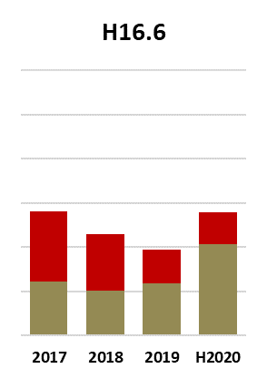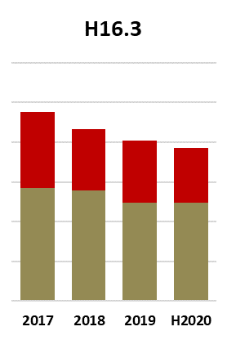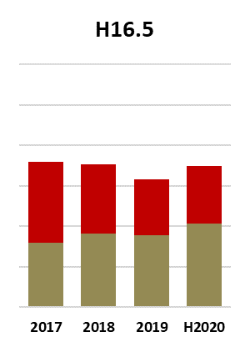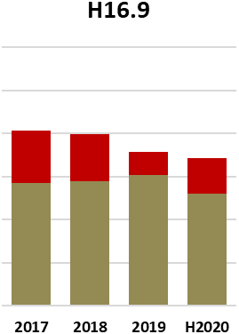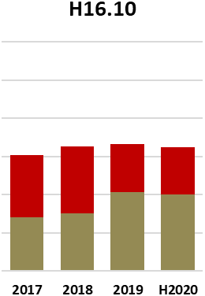

# Mobile Plant – Incident Reports

* Of the **83** mobile plant incidents reported, **33 per cent** were classed as *Severe* or *Life at Risk*.
* Severe incidents were composed of **13** LTIs and **12** Dangerous Occurrences.
* **Two** mobile plant incidents reports were classified as placing the worker’s life at risk.

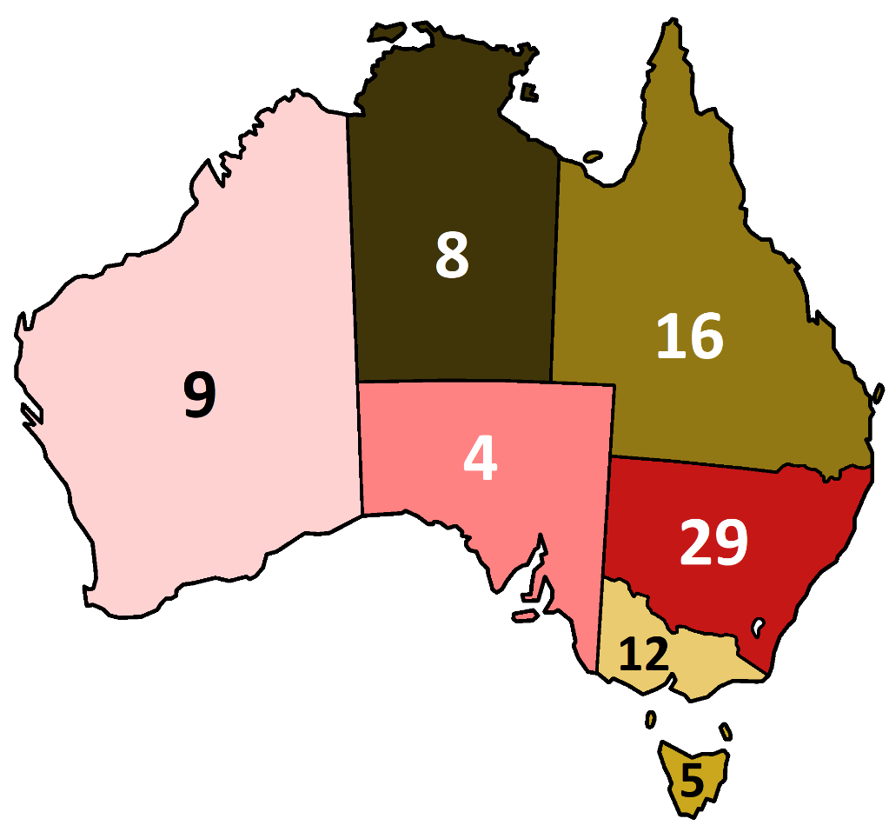

**Number of Incidents Reported in Each State or Territory**

# Mobile Plant – Incident Reports Analysis of Trends

* The most frequent mobile plant related injury involved workers being jammed/crushed between mobile plant, and workers being struck by mobile plant or by an object involving plant.
* The next most frequent is trips, stumbles and slips.



# Scaffolding Update

# Scaffolding – Corrective Action Reports Issued

* The OFSC have reviewed **531** scaffolding sub-criteria, issuing **156** CARs during Hazard 2020.
* Non-compliance with scaffolding sub-criteria during this period is **29.5 per cent**, which is **0.6** per cent points lower than the previous three-year average from 2017-2019.

|  |  |
| --- | --- |
| **Scaffolding Sub-criteria Definitions** | |
| **H1.1** | The risks associated with the potential for a person falling are identified, assessed and controlled in accordance with the Falls from Height Hierarchy of Control. |
| **H1.4** | Safe systems of work have been developed to ensure that where fall restraint/fall arrest equipment is being used on site: workers have been formally trained in the use of such equipment; there is a maintenance and inspection schedule for the equipment; attachment points are designed and certified by a qualified person; and attachment points are installed by a trained person and regularly inspected by a competent person. |
| **H1.6** | The system ensures that there is safe access and egress for all areas where work at heights is being undertaken. |
| **H5.1** | The risks associated with structural alterations, structural support systems and temporary structures are identified, assessed, and controlled in accordance with the Hierarchy of Control. |
| **H5.2** | Safe systems of work developed for the erection and dismantling of structural support systems and temporary structures; prevention of persons falling; management of potential falling objects; and management of penetrations. |
| **H5.4** | The system ensures that; a scaffold plan has been developed by a qualified person; and changes to the installation design are authorised and signed off by a qualified person; or a risk assessment has been conducted to determine the need for a Scaffold Plan. |
| **H5.5** | The system ensures that the building structures/materials/foundations have been assessed and controls are in place prior to starting alterations to the structure or construction of temporary structures. |
| **H5.6** | The system ensures that structural support systems and temporary structures are installed by a competent person and verified as correctly installed prior to use in accordance with relevant legislation, codes of practice and Australian standards; manufacturers’ requirements; or where applicable the drawing/plan. |
| **H5.7** | The system ensures that structural support systems and temporary structures are regularly inspected to monitor the effectiveness of the system/ structure in accordance with relevant legislation, codes of practice and Australian standards; manufacturer’s requirements; or where applicable the drawing/plan. |
| **H5.8** | The system ensures that emergency procedures are established specific to the scope of works. |

# 

# Scaffolding – CAR Issue Rates and Type

**There are two levels of CARs, Major and Minor. A Major is the absence of a documented process, and/or the absence of implementation of a process where the opportunity for implementation has occurred in relation to a specific criterion. A Minor non-conformance is where there is a partially documented and implemented process where the opportunity for implementation has occurred in relation to a specific criterion.**

* Of the **156** scaffolding CARs issued:
  + **64** were for lack of documentation;
  + **46** were for inadequate implementation; and
  + **46** were for both documentation and implementation issues.
* **H1.4**, **H5.4** and **H5.6** show the most concerning non-compliance rates.

|  |  |  |  |  |  |  |  |  |  |
| --- | --- | --- | --- | --- | --- | --- | --- | --- | --- |
| **Sub-criteria** | **CARs** | **Times** | **Non-compliance %** | **Documentation** | | **Implementation** | | **Both** | |
| **Issued** | **Audited** | **#** | **%** | **#** | **%** | **#** | **%** |
| **H1.1** | 14 | 61 | 23% | 3 | 21.4% | 6 | 42.9% | 5 | 35.7% |
| **H1.4** | 25 | 61 | **41%** | 15 | 60.0% | 5 | 20.0% | 5 | 20.0% |
| **H1.6** | 13 | 60 | 21.7% | 6 | 46.2% | 3 | 23.1% | 4 | 30.8% |
| **H5.1** | 8 | 50 | 16% | 4 | 50.0% | 1 | 12.5% | 3 | 37.5% |
| **H5.2** | 14 | 50 | 28% | 6 | 42.9% | 5 | 35.7% | 3 | 21.4% |
| **H5.4** | 21 | 50 | **42%** | 5 | 23.8% | 9 | 42.9% | 7 | 33.3% |
| **H5.5** | 12 | 49 | 24.5% | 8 | 66.7% | 2 | 16.7% | 2 | 16.7% |
| **H5.6** | 26 | 50 | **52%** | 7 | 26.9% | 9 | 34.6% | 10 | 38.5% |
| **H5.7** | 16 | 50 | 32% | 6 | 37.5% | 4 | 25.0% | 6 | 37.5% |
| **H5.8** | 7 | 50 | 14% | 4 | 57.1% | 2 | 28.6% | 1 | 14.3% |
| **Total** | **156** | **531** | **29.42%** | **64** | **41.0%** | **46** | **29.5%** | **46** | **29.5%** |

# 

**Scaffolding CARs – Major v Minor**

# Scaffolding – Sub-criteria CAR Issue Rates

* Non-compliance with scaffolding sub-criteria is highest in relation to **H5.6**, which requires companies to ensure structural support systems are installed by a competent person and verified as correctly installed prior to use. CARs against this sub-criterion have been issued **26** times out of **50** Hazard 2020 audits.
* The other sub-criteria in relation to which CARs have been issued at a rate of greater than **25 per cent** are **H5.4**, **H1.4**, **H5.7** and **H5.2**.
* In January 2021, all 5 sub-criteria showed non-compliance rates above **60 per cent**. By June the rates for every sub-criterion except H5.6 fell to below the three-year average.
* **Fifty-nine per cent** of scaffolding CARs issued were classed as Minor non-conformances.

# Scaffolding – CAR Analysis and Trends

The dataset available in relation to scaffolding CARs raised is still small, so some caution is required in drawing detailed inferences from the interim Hazard 2020 results so far. However, the non-compliance rates for four of the five leading sub-criteria (H1.4, H5.4, H5.6 and H5.7) are greater than 40 per cent. The fifth highest non-compliance rate in relation to H5.7 is greater than 30 per cent. Non-compliance with these sub-criteria is primarily a result of a failure to implement safe systems of work on site combined with system deficiencies. The leading causes of non-compliance for each sub-criterion are set out below:

* **H5.6**, is most commonly failed by companies due to WHS systems not defining the competencies required by a person undertaking pre-use inspections, and the associated failure to ensure the person performing the inspections onsite holds these competencies.
* **H5.4** is most frequently failed due to the process not ensuring changes to design and changes to scaffold are approved by a qualified person.
* **H1.4** is most frequently failed due to the system not defining what makes a person qualified to install or design a safe system of work, or a competent person to check working at height equipment.
* **H5.7** is most frequently failed due to a failure to undertake the required inspection after extreme weather events, the system not requiring regular inspections, or the system only addressing scaffolding and no other temporary structures.
* **H5.2** is most frequently failed when the system only covers some aspects of the criteria, and when the scaffold has not followed the plan.



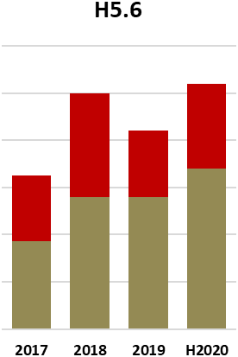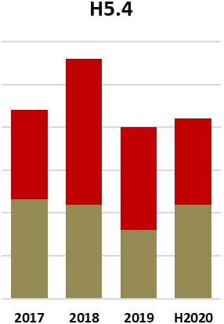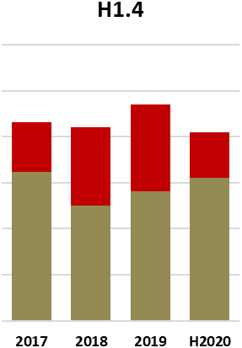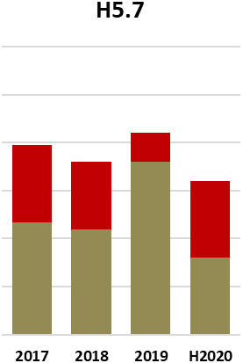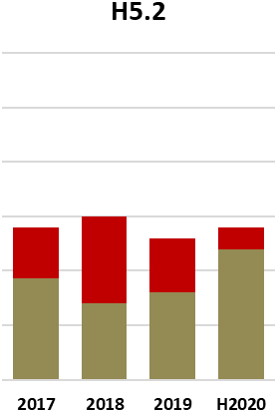

**Most Frequently failed Scaffolding Sub-criteria – Major v Minor by Year**



# Scaffolding – Incident Reports

* Of the **19** scaffolding incidents reported, **68 per cent** were classified as Not Severe and **16 per cent** were classified as Severe.
* The largest number of scaffolding incidents classed as Not Severe were LTIs **(7)**, then MTIs **(6)**.
* **5 of the 19 reported incidents were severe or placed a worker’s life at risk – meaning 26 per cent were in this highest risk category.**

# 

**Number of Incidents Reported in Each State or Territory**

# Scaffolding – Incident Reports Analysis of Trends

* The most frequent scaffolding related injury was caused by workers being struck by objects falling from scaffolding or protruding objects striking a worker.
* The second most frequent scaffolding related injury was falls from or involving scaffolding.
* The other scaffolding injuries were all hand injuries/lacerations on scaffolding.



# Additional Resources

# Education

## Fact Sheets

Mobile plant and scaffolding hazard management fact sheets were published on [www.fsc.gov.au](http://www.fsc.gov.au) at the launch of the campaign. The fact sheets cover onsite risks, company requirements, key focus areas, principles of hazard management and an overview of all Scheme audit criteria. Additional resources and guides have been published throughout the [Hazard 2020 safety campaign](https://www.fsc.gov.au/hazard-2020).

## Webinars

The OFSC’s Hazard 2020 webinar series brings together speakers from industry, technical experts and associations to foster learning and collaboration on WHS issues. The webinars are not an endorsement of companies, products or methods, but an opportunity to share the experiences of industry in dealing with WHS challenges relating to scaffolding and mobile plant.

### Webinar One: Mobile Elevated Work Platforms

The first Hazard 2020 online educative forum was held on 18 February 2021. Scheme accredited company CPB Contractors presented on its use of secondary guarding systems on Mobile Elevated Work Platforms (MEWP), one of the most common pieces of mobile plant on construction sites. The Elevating Work Platform Association (EWPA) presented an outline on EWPA guidance and on the functions of the EWPA. Federal Safety Officer (FSO) Brett Jones provided information on how the Scheme audit criteria applies to MEWPs. The webinar closed with an engaging Q&A with significant interest from attendees.

### Webinar Two: Scaffolding Risk Management

On 29 April 2021 the OFSC held the second of the Hazard 2020 webinar series, with a focus on Scaffolding Risk Management. Probuild Constructions presented on anti-tampering scaffold options available through the new technology Scaffshield. FSO Ralph Willson gave a presentation on scaffolding management from a Scheme audit criteria perspective, and the webinar closed with a Q&A session.

### Webinar Three: Articulated Mobile Crane Risk Management

The third Hazard 2020 webinar was held on Thursday 15 July 2021. With a feature presentation by Rory Bracken and Tom Clarke from Fulton Hogan, and Brandon Hitch from the Crane Industry Council of Australia, this webinar provided practical guidance on use of articulated mobile cranes. FSO Julian Bedford also presented on the subject of mobile crane risk management in relation to Accreditation Scheme criteria. A Q&A session with all presenters closed the webinar.

## Case Studies

Case studies developed by the OFSC highlight innovative risk management approaches being used by accredited companies. The first video showcases Scheme accredited company COLAS’ use of halo lighting and other technology to eliminate mobile plant incidents on-site, and has been published to www.fsc.gov.au. Additional video case studies will be published in the coming months.

# 

# Glossary

## Federal Safety Officer (FSO)

Federal Safety Officers (FSOs) are consultants engaged by the OFSC to conduct audits under the Scheme. FSOs are selected through a tender process run periodically by the OFSC. Once they have been selected through the tender process, FSOs undergo a two-stage engagement process. Firstly, they are engaged as consultants to the Attorney-General's Department and by way of a Deed of Standing Offer (as set out in the tender). Following this, they are appointed as FSOs by the FSC under a legislative instrument, giving them the legal authority to enter sites and conduct audits on behalf of the FSC.

## Scheme Audits

As part of the Work Health and Safety Accreditation Scheme, companies are required to undergo onsite audits to both become accredited and maintain accreditation. At any onsite audit, a Corrective Action Report (CAR) can be raised.

## Corrective Action Report (CAR)

A Corrective Action Report (CAR) is a formal finding made by FSOs during the Scheme auditing process to identify where companies need to take further action. An FSO raises a CAR when they determine that a certain aspect of the system being audited does not conform to the OFSC audit criteria. This assessment is based on their review of documentary evidence and observation of onsite activities.

## Incident Reports

* Dangerous occurrence - An incident where no person is injured, but could have been injured, resulting in Serious Personal Injury, Incapacity or Death. Also commonly called a “near miss.”
* MTI (Medically Treated Injury) - An MTI is a work-related occurrence that results in treatment by, or under the order of, a qualified medical practitioner, or any injury that could be considered as being one that would normally be treated by a medical practitioner but does not result in the loss of a full day/shift.
* LTI (Lost Time Injury) - An LTI is a work-related occurrence that results in a permanent disability or injury resulting in time lost from work of one day/shift or more.
* Fatality - A work-related occurrence that results directly or indirectly in the death of a person onsite (including deaths due to natural causes which occur on the project site).

For more information visit [www.fsc.gov.au/hazard-2020](http://www.fsc.gov.au/hazard-2020) or call FSC Assist on 1800 652 500 / email [ofsc@jobs.gov.au](mailto:ofsc@jobs.gov.au)