Establish the load input to the ground
- Know your lift details:
  - What is the weight of the load and rigging equipment?
  - What is the crane’s configuration to perform the lift?
- Use the OEM software or CICA Outrigger App estimate to calculate the pressure of each tyre/outrigger/track on the ground. If OEM software isn’t available, use the simplified estimate.
  - Do this for the crane lift configuration and empty hook with high boom angle configuration to assess common maximum ground pressure conditions.
Planning

- Determine the type of ground the crane is operating on and its allowable ground pressure.
  - The ground pressure is usually estimated visually by the crane operator when lifting smaller capacity loads.
  - However, certification of the allowable ground pressure must be obtained from a geo-technical engineer.
  - Double check that weather doesn’t change the ground capacity on the day of the lift.
Remember the more complex the lift, the more detailed the consultation required!
Considerations for Mobile Crane
Ground Conditions

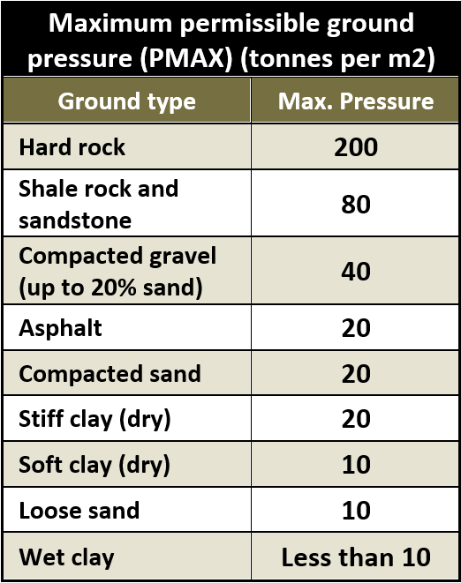
Investigate the ground capacity
(Do this for the entire lift pad or travel route of the crane)

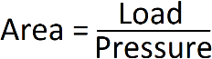
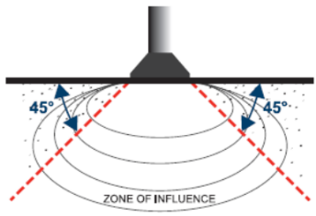
Transfer the crane load into the ground
- Calculate the minimum area of the pad or mat using the formula:

- Are timbers set-up level and do they feature a minimum cross section of 200mm x 75mm?
- Are Bog mats required? If so, who is certifying the bog mat design? Are they competent?
Once the crane has been set up
- Monitor the ground for settling or compaction under load. Verify the crane is still level. This should be carried out throughout the day.
- Verify that the lift plan includes the correct details, including known load and rigging weights, and working radius.

Timber Pad
Bog Mat
Following the above steps, and compliance with the lift plan
- Continue further inspection of ground conditions after significant weather events.
- Ensure records are available to verify that what was required to be completed has been completed in accordance with the documented process/system.
Execute
Setup
- Does the maximum allowable ground pressure need to be reduced due to hazards in the area (e.g. pits/soft spots/ excavations, underground services)?
  - Remember the 1:1 rule when operating near excavations.

