

Brighton Bypass Case Study: Outstanding Safety Performance Completed Ahead of Schedule

Background

Located north of Hobart Tasmania, the Brighton Bypass is a 9.5 km predominately dual carriageway constructed on the Midland Highway, bypassing Brighton and Pontville. The Brighton Bypass provides a safer, more efficient route between Hobart and Tasmania’s northern cities and ports.

The Bypass is Tasmania’s largest ever road infrastructure project, involving construction of thirteen major structures and associated civil engineering works.

The $191 million project—which received funding from the Australian Government Department of Infrastructure, Transport, Regional Development and Local Government—was completed months ahead of schedule by Australian Government Building and Construction OHS Accreditation Scheme (the Scheme) accredited builders Thiess, John Holland, VEC Civil Engineering, and Hazell Bros Group.

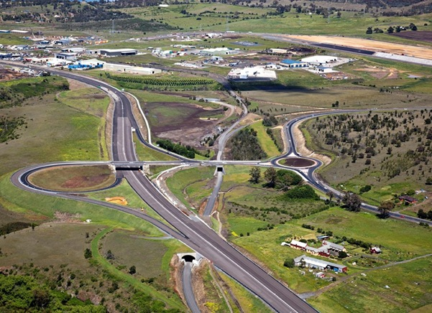

Addressing the challenges

Key challenges faced during construction of the Brighton Bypass project included large companies working together as part of a joint venture, and a lack of available skilled workers due to a number of other major civil infrastructure projects taking place in Tasmania at the time.

Thiess Constructions’ method of overcoming the skills shortage was to mix teams to integrate both experienced workers and newcomers to the construction industry. Thiess also realised that with lesser skilled construction workers on board, a greater focus on safety induction and management was required. When asked how they worked through the challenge of increasing the skill set of construction workers, Thiess explained that “the awareness of and attitudes to the current standards in safety management needed more focus. By acknowledging this prior to project commencement and conducting both on and off site training through various training providers, we were able to improve the skill base and safety standards of the local industry.”

The challenge of working together was overcome by companies undergoing extensive training and workshops, and having the ability to recognise each company’s strengths. According to Thiess, “Early joint venture workshops and training sessions allowed all parties to bring their collective knowledge to the table and share amongst the project team”. VEC Civil Engineering added that “VEC Civil Engineering is a Tasmanian company based in Ulverstone, whereas Thiess is a large multinational company. Bringing the entities together for the Brighton Bypass resulted in having local knowledge and experience along with national support. The best policies and practises from each company were decided on from the onset to ensure delivery of a high quality product on time, budget and safely.”

Helpful advice for companies undertaking similar projects

John Holland suggests companies undertaking similar projects should focus on safe design and constructability to ensure hazards are reduced or eliminated, and risks controlled before the commencement of any construction work. For example, John Holland revealed that “the Brighton Interchange Overpass was reduced from a two-span to a single-span structure during the early contractor involvement phase, eliminating a potential collision hazard with a central pier, and future maintenance WHS requirements were addressed in the design phase such as the provision of handrails on culvert structures.”

VEC Civil Engineering also noted that “a safety culture was developed around effective communications utilising regular toolbox talks, safety observations and multiple levels of safety control, involving all levels from labour to upper management.” Employees were encouraged by the company to be responsible for their own safety and the safety of others, and continual learning coupled with constant vigilance enabled the project to be finished safely and ahead of schedule.

The Australian Government Building and Construction OHS Accreditation Scheme and the project

The Scheme had a very positive effect on the safe construction of the Brighton Bypass project. Hazell Bros Group confirmed that the Scheme enabled them “to maintain a high level of system functionality and compliance”, while the Scheme’s reporting process also helped Hazell Bros Group to collect valuable data to assist in improving the company’s WHS performance.

Thiess agreed that their accreditation under the Scheme was beneficial to the safety of workers. They noted that “the OFSC guidelines enabled us to provide a framework of what was expected from all workers and Subcontractors on the project. The knowledge that we had from our accreditation provided us with in-depth knowledge of industry best practice and guidelines that we could provide to our subcontractors and workforce.”

The outcome of this project is evidence that being accredited under the Scheme is a valuable asset to companies in improving safety performance and business practices.

About these case studies

The Australian Government is committed to improving the WHS standards for all workers on building and construction projects.

These case studies have been developed to share practical ideas that can be adopted by industry to assist in their own management of WHS issues.

The Federal Safety Commissioner consults widely with industry, WHS authorities and other relevant agencies to promote a cooperative approach to improving WHS performance.

**For further information:**

* Visit the FSC website at **www.fsc.gov.au**
* Contact the FSC Assist Line on **1800 652 500**
* Contact the OFSC via email at **ofsc@dewr.gov.au**

The Office of the Federal Safety Commissioner has prepared this case study to promote workplace health and safety (WHS) in the industry. When developing OHS initiatives, businesses and individuals should consider the circumstances and requirements particular to them and seek professional advice where required.

While the Commonwealth has exercised reasonable care in providing useful information, the Commonwealth makes no representations, express or implied, as to the accuracy of the information contained in this case study. The Commonwealth accepts no liability for any use of the information contained in this case study or any reliance placed on it.

This case study may list persons, organisations, products or services or may incorporate material sourced from third parties. Such lists or material are assembled in good faith. However, any such list or material does not necessarily constitute any form of endorsement by the Commonwealth of that person, organisation, product, service, or third party. The Commonwealth does not accept any responsibility for such list or material.