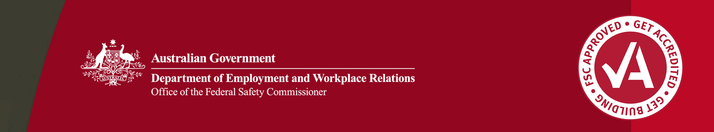

Safety culture program: Bovis Lend Lease Incident & Injury Free

Incident & Injury Free

Incident & Injury Free (IIF) is an international program developed by Bovis Lend Lease to encourage a positive health and safety culture in the company.

Through IIF, Bovis Lend Lease have adopted the following vision: *Bovis Lend Lease will operate incident and injury free and we are committed to realising this wherever we have a presence.*

IIF focus points

*Incident & Injury Free* was implemented by Bovis Lend Lease Australia in 2002. The IIF program complements the Bovis Lend Lease Environment, Health and Safety Management (EH&S) framework, and sets six focus points for the company.

These are to:

* identify IIF leaders and champions
* motivate employees to operate and maintain IIF
* ensure efficient and effective implementation of EH&S processes
* assist subcontractors to implement IIF, and to improve execution of Safe Work Method Statements
* gain recognition, support and involvement from clients
* gain recognition, support and involvement from the community

IIF initiatives

In consultation with workers, Bovis Lend Lease Australia have developed a range of innovative and practical measures to implement the IIF program. Initiatives including workplace signage and slogans, as well as safety BBQs and lunches, are just some examples.

The initiatives recognise the importance of promoting safety in a manner which is relevant to workers at the site level.

sign that reads Everyone's job is important, everyone's job is safety, nothing takes priority over your safety.

Workplace signage

Bovis Lend Lease worksites are distinctive for their safety signs, which have been introduced to increase safety awareness on site.

Slogans, such as *Enjoy Tomorrow—Think Safe Today*, are developed by workers at the start of each project to remind those on site of the importance of safe work practices. Management at Bovis Lend Lease ACT believes that this helps to develop buy-in of workers, ensuring that they take ownership of their safety and that of their workmates.

sign that says It only takes a second to fall in love. The words "in love" are crossed out. Underneath this, the sign states:

Think safety
Think of your love dones
Think again

Incident & Injury Free

signboard with slogan 'Your family needs you home safe today'

Workplace safety plans

At the start of each project, an IIF safety plan is developed. This plan details the actions that will be undertaken to enable the worksite to meet the focus points of IIF. All company employees and subcontractors are required to read and adhere to the plan.

The Office of the Federal Safety Commissioner has prepared this case study to promote workplace health and safety (WHS) in the industry. When developing OHS initiatives, businesses and individuals should consider the circumstances and requirements particular to them and seek professional advice where required.

While the Commonwealth has exercised reasonable care in providing useful information, the Commonwealth makes no representations, express or implied, as to the accuracy of the information contained in this case study. The Commonwealth accepts no liability for any use of the information contained in this case study or any reliance placed on it.

This case study may list persons, organisations, products or services or may incorporate material sourced from third parties. Such lists or material are assembled in good faith. However, any such list or material does not necessarily constitute any form of endorsement by the Commonwealth of that person, organisation, product, service, or third party. The Commonwealth does not accept any responsibility for such list or material.

Through the IIF safety plan, workers are encouraged to take responsibility for their own safety and that of their co-workers.

Workers and managers are also encouraged to identify and address unsafe practices, and to advise anyone working unsafely to do the right thing.

Safety barbeques

As part of the focus on developing a safety culture, Bovis Lend Lease hold regular safety BBQs for their projects. The purpose of these BBQs is to provide company employees and subcontractors an informal environment in which to discuss the WHS risks and hazards associated with their particular project, and to enable them to work out strategies for improvement.

Safety newsletters

To encourage awareness and participation in the IIF program, various project sites have developed monthly newsletters for circulation to company employees, subcontractors and clients. The newsletters showcase the safety initiatives being implemented on the worksite, and aim to encourage all those involved in the construction process to continue to aspire to higher WHS standards.

About these case studies

The Australian Government is committed to improving the WHS standards for all workers on building and construction projects.

These case studies have been developed to share practical ideas that can be adopted by industry to assist in their own management of WHS issues.

The Federal Safety Commissioner consults widely with industry, WHS authorities and other relevant agencies to promote a cooperative approach to improving WHS performance.

**The vision of the Federal Safety Commissioner is a building and construction industry where no one is harmed.**

**For further information:**

* Visit the FSC website at **www.fsc.gov.au**
* Contact the FSC Assist Line on **1800 652 500**
* Contact the OFSC via email at **ofsc@dewr.gov.au**