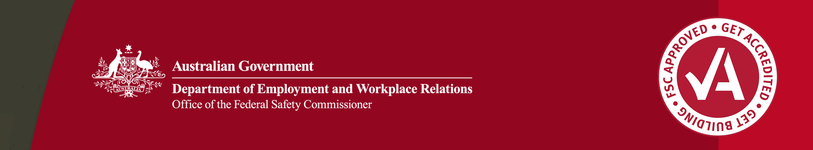

Effective OHS initiatives: AW Edwards STAT-EAST Works

## Background

A W Edwards Pty Limited is a privately owned Australian company which commenced operations in 1921.

In late 2004, A W Edwards began building four underground stations to service the new Epping to Chatswood Rail Line in Sydney, New South Wales. All these underground works were handed over on time in 2007.

The $190 million STAT-EAST Works project comprised fit out, services installation, entry structures and concourse works. Also included were works on the station cavern ceilings, landscaping and installation of lifts and escalators.

The STAT-EAST Works project included construction within a ‘live’ rail environment to replace an existing station facility.

A W Edwards and other contractors worked side by side to deliver the project and assure the safety of workers and rail patrons. All phases of the project required a high degree of coordination, planning and communication, as A W Edwards installed the services to the stations while the civil contractor installed the services in the tunnel.

Addressing the challenges

The majority of the STAT-EAST Works project was conducted underground, heightening the risks and hazards to employees.

These risks include:

* maintaining air quality
* noise
* falls from heights
* confined spaces
* changes in control of the sites over the life of the project.

A W Edwards created a Site Safety Plan to address these and other risks. The Site Safety Plan included:

* coordination and consistency of safety on all four separate sites for the one project
* a unique risk assessment tool and incident reporting table
* specific corrective action procedures in relation to safety and environmental breaches
* a safety protocols risk matrix tool for workers working underground, in confined spaces and at heights
* communication procedures for consultation between A W Edwards and other contractors.

Initiatives implemented

A W Edwards identified the challenges and worked with senior staff and on site employees to implement initiatives which could achieve a high level of occupational health and safety during the life of the project.

The initiatives included:

* a thorough review of methodology/staging
* a process of reviewing and providing a work permit to subcontractors based on their Safe Work Methods Statements (SWMS)
* training for subcontractors and workers in how to write and review SWMS
* consultation between the four different sites, with both management and workforce involvement so that ‘lessons learnt’ between the sites were communicated clearly
* ‘Daily Musters’—providing successful communication and consultation between all workers and management on a daily basis.

Results

Communication and consultation was successful between A W Edwards and other contractors, resulting in improved OHS performance.

The introduction of the ‘Daily Muster’ initiative proved successful in identifying issues throughout the project and ensuring these were relayed to all employees on a daily basis.

In turn this helped subcontractors and employees at all levels to understand, review and update their Safe Work Method Statements (SWMS) on a regular basis.

MBA Award

The Office of the Federal Safety Commissioner has prepared this case study to promote workplace health and safety (WHS) in the industry. When developing OHS initiatives, businesses and individuals should consider the circumstances and requirements particular to them and seek professional advice where required.

While the Commonwealth has exercised reasonable care in providing useful information, the Commonwealth makes no representations, express or implied, as to the accuracy of the information contained in this case study. The Commonwealth accepts no liability for any use of the information contained in this case study or any reliance placed on it.

This case study may list persons, organisations, products or services or may incorporate material sourced from third parties. Such lists or material are assembled in good faith. However, any such list or material does not necessarily constitute any form of endorsement by the Commonwealth of that person, organisation, product, service, or third party. The Commonwealth does not accept any responsibility for such list or material.

A W Edwards was awarded the 2006 Federal Safety Commissioner’s Award for Excellence in Occupational Health and Safety for an exceptional safety record in the face of significant hazards. This award was presented in conjunction with the Master Builders Safety Award in Civil Construction at the Master Builders Australia 2006 National Building and Construction Awards.

For further information about the STAT-EAST Works

Ph : 02 9958 1474 Web: [www.awedwards.com.au](http://www.awedwards.com.au)

About these case studies

The Australian Government is committed to improving the WHS standards for all workers on building and construction projects.

These case studies have been developed to share practical ideas that can be adopted by industry to assist in their own management of WHS issues.

The Federal Safety Commissioner consults widely with industry, WHS authorities and other relevant agencies to promote a cooperative approach to improving WHS performance.