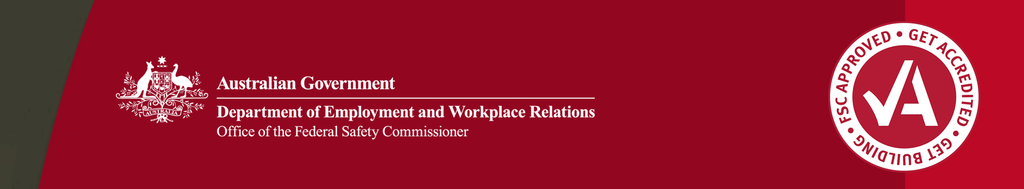

Safety Training: John Holland Passport to Safety Excellence

The Passport to Safety Excellence (PSE) Training Program is a John Holland Group workplace health and safety (WHS) initiative. It is a key element of the John Holland Occupational Health, Safety and Workers’ Compensation (OHS&WC) Improvement Strategy and aims to assist the company achieve their vision of ‘NO HARM’.

## Safety critical positions

The first step of this WHS initiative involved the identification of all the safety critical positions within the company.

To be considered safety critical the position had to have a direct and/or indirect impact on WHS in the workplace.

Fourteen safety critical leadership positions were identified at John Holland ranging from Leading Hand to Managing Director.

## Safety critical activities

The next step was to determine the WHS activities that needed to be undertaken by each position in order to achieve best practice safety standards in the workplace.

Thirty five safety critical activities were identified.

Some safety critical activities include:

* undertaking design safety reviews for constructability, operability and maintenance
* identifying and resolving workplace hazards
* planning and delivering Toolbox talks
* facilitating group/work team WHS discussions and meetings
* identifying and including suitable WHS requirements into subcontractor packages
* carrying out a formal WHS-related review of tender documents
* developing and implementing positive safety culture programs.

John Holland then developed skill and behavioural competencies that were needed to effectively undertake every identified critical WHS activity. These competencies are closely aligned to the requirements of the company’s OHS&WC Management System.

Competency-based adult training module and assessment mechanisms were then developed to deliver the WHS training to the whole organisation throughout Australia.

John Holland has had the Passport to Safety Excellence Training Program accredited nationally, as a Certificate IV in Safety Leadership—Construction.

## PSE benefits

The PSE is designed to equip personnel in these safety critical positions with the skills and behavioural competencies required to effectively carry out each of the safety critical activities, including:

* knowledge of what core tasks are needed to meet John Holland and legislative requirements
* an understanding of why, how and to what standard each task needs to be performed to achieve the required outcomes
* specific training and senior management support to meet the needs of individual positions
* proof of competency that is portable across John Holland and eventually accepted by all companies, institutions and sectors
* recognition from a national training body.

## The future

**For further information:**

* Visit the FSC website at **www.fsc.gov.au**
* Contact the FSC Assist Line on **1800 652 500**
* Contact the OFSC via email at **ofsc@dewr.gov.au**

Since introducing the program John Holland expects to deliver over 7000 training days to more than 1000 employees. John Holland aims to extend the PSE to clients, subcontractors, other companies and relevant institutions.

No harm

The Office of the Federal Safety Commissioner has prepared this case study to promote workplace health and safety (WHS) in the industry. When developing OHS initiatives, businesses and individuals should consider the circumstances and requirements particular to them and seek professional advice where required.

While the Commonwealth has exercised reasonable care in providing useful information, the Commonwealth makes no representations, express or implied, as to the accuracy of the information contained in this case study. The Commonwealth accepts no liability for any use of the information contained in this case study or any reliance placed on it.

This case study may list persons, organisations, products or services or may incorporate material sourced from third parties. Such lists or material are assembled in good faith. However, any such list or material does not necessarily constitute any form of endorsement by the Commonwealth of that person, organisation, product, service, or third party. The Commonwealth does not accept any responsibility for such list or material.

To achieve the company vision of ‘NO HARM’, John Holland recognises the importance of providing personnel in safety critical positions with the skills and knowledge they require to complete their work effectively and deliver safe outcomes.

For further information in relation to the Passport to Safety Excellence Training Program contact:

Group Safety Manager

Ph: 03 9934 5209

www.johnholland.com.au

## About these case studies

The Australian Government is committed to improving the WHS standards for all workers on building and construction projects. These case studies have been developed to share practical ideas that can be adopted by industry to assist in their own management of WHS issues.

The Federal Safety Commissioner consults widely with industry, WHS authorities and other relevant agencies to promote a cooperative approach to improving WHS performance.

**The vision of the Federal Safety Commissioner is a building and construction industry where no one is harmed.**