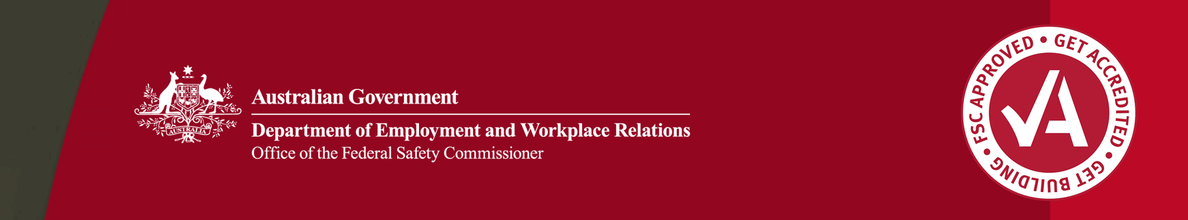

Driving cultural change in small business: Sharpe Bros (Aust) Pty Ltd

Safety is everyone’s responsibility

Safety in the workplace is everyone’s responsibility. But instilling a culture of responsible safety behaviour   
can be a challenge.

Sharpe Bros (Aust) Pty Ltd is a family owned civil contracting and road maintenance company that is committed to improving the WHS awareness and performance of their employees. To support this commitment, they have implemented a simple yet effective program to develop and maintain a positive safety culture on their project sites.

Photo of Sharpe Bros employees at a pre-start meeting.

Sharpe Bros employees at a pre-start meeting.

Complacency is a safety hazard

Concerned complacency might increase the potential for an incident or injury in the workplace, Sharpe Bros management decided to implement a safety awareness program to reinforce safety policies and procedures to employees on the job. Specifically, they wanted a simple awareness raising device that would encourage employees to put themselves in the shoes of a safety officer and always consider the safety of themselves and their co-workers.

They wanted a device that was visual, positive and fun, and would serve as a mascot for employees. For this, they developed the character, Safety Bro.

Building a safety champion

Safety Bro is a champion of safety in the workplace who encourages important safety and injury prevention behaviours through the presentation of his image and motivational slogans such as ‘What would Safety Bro think?’

The original concept emerged during consultation with employees when one employee commented that safety is vital because ‘big brother’ is always watching you. Meant partly as a pun on the company name, Sharpe Bros, and joint Managing Directors, Michael, Richard and Hayden Sharpe, it wasn’t long before ‘big brother is watching you’ evolved to become ‘Safety Bro is working with you’ and the Safety Bro character was born.

Given employee enthusiasm for Safety Bro, Sharpe Bros management took immediate steps to incorporate the concept into the company’s overall WHS framework. Used to complement the company’s formal policies and procedures, the image of Safety Bro was designed to remind employees to always consider safety—after all ‘What would Safety Bro do?’

The Safety Bro image is now reproduced on stickers and prominently displayed throughout the workplace—on coffee cups, safety induction handbooks, message boards, work stations, lunch rooms and in the boardroom. The image is also advertised on all Sharpe Bros plant, equipment and vehicles.

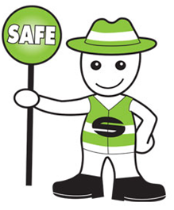

Safety Bro

A Safety Bro website, www.safetybro.com.au, My Space page, www.myspace.com/safetybro, and mobile SMS are used to send regular messages and to make WHS announcements to employees. These activities all serve to remind employees of the importance of safe work behaviours and to make safety something tangible, likeable and memorable.

Picture of the front page of the Safety Bro website, www.safetybro.com.au

Safety Bro website, [www.safetybro.com.au](http://www.safetybro.com.au)

A simple initiative with big results

The Safety Bro program has proved an excellent counter to complacency in the workplace and has renewed enthusiasm for safety in a way that has engaged all employees. New employees and contractors on Sharpe Bros’ projects are amazed by the bold and visual impact of Safety Bro, and many have noted how impressed they are that safety has a face at Sharpe Bros.

A champion of workplace safety, the Safety Bro program has seen Sharpe Bros awarded the Best Workplace Health and Safety Practices in Small Business at the 2007 National Safe Work Australia Awards hosted by the Australian Safety and Compensation Council, and the 2007 WorkCover NSW Safe Work Australia Awards.

Commenting on the program’s success, Michael Sharpe remarked ‘Working in the construction industry, which has one of the highest rates of injuries, safety is paramount so we have invested time and energy building a strong safety culture. ..Safety Bro has become everybody’s best mate. He is an integral member of the team and has inspired renewed enthusiasm for safety issues’.

ASCC Chairman, Bill Scales AO (left) and then Deputy Prime Minister, the Hon Julia Gillard, with Sharpe Bros Joint Managing Directors (L-R), Hayden, Michael and Richard Sharpe at the 2007 National Safe Work Australia Awards.

ASCC Chairman, Bill Scales AO (left) and then Deputy Prime Minister, the Hon Julia Gillard, with Sharpe Bros Joint Managing Directors (L-R), Hayden, Michael and Richard Sharpe at the 2007 National Safe Work Australia Awards.

Cultural change in small business

Since the 2007 National Safe Work Australia Awards, Sharpe Bros have been approached by other small businesses looking for a simple and effective method for promoting WHS in the workplace.

The lesson for small business operators interested in improving the WHS awareness and performance of their employees is that the simplest concept can be effective provided everyone in the workplace is involved and management are committed to getting the WHS message across.

About these case studies

The Australian Government is committed to improving the WHS standards for all workers on building and construction projects.

These case studies have been developed to share practical ideas that can be adopted by industry to assist in their own management of WHS issues.

The Federal Safety Commissioner consults widely with industry, WHS authorities and other relevant agencies to promote a cooperative approach to improving WHS performance.

**The vision of the Federal Safety Commissioner is a building and construction industry where no one is harmed.**

The Office of the Federal Safety Commissioner has prepared this case study to promote workplace health and safety (WHS) in the industry. When developing OHS initiatives, businesses and individuals should consider the circumstances and requirements particular to them and seek professional advice where required.

While the Commonwealth has exercised reasonable care in providing useful information, the Commonwealth makes no representations, express or implied, as to the accuracy of the information contained in this case study. The Commonwealth accepts no liability for any use of the information contained in this case study or any reliance placed on it.

This case study may list persons, organisations, products or services or may incorporate material sourced from third parties. Such lists or material are assembled in good faith. However, any such list or material does not necessarily constitute any form of endorsement by the Commonwealth of that person, organisation, product, service, or third party. The Commonwealth does not accept any responsibility for such list or material.

**For further information:**

* Visit the FSC website at **www.fsc.gov.au**
* Contact the FSC Assist Line on **1800 652 500**
* Contact the OFSC via email at **ofsc@dewr.gov.au**