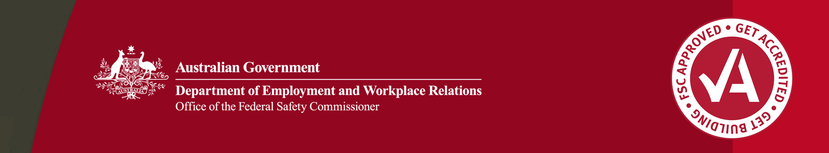

Supporting safe design through education

Raising awareness

Safe design, or safety in design, is about hazard identification and risk management early in the design phase to eliminate or reduce risk of injury in construction, use, maintenance and demolition of structures.

A challenge in the building and construction industry is to raise awareness of safe design. The Office of the Federal Safety Commissioner (OFSC) encourages and promotes safe design through a number of activities. One of these activities has been to provide development opportunities for engineers.

Supporting education of engineers

In 2007–08, the OFSC provided support to the Association of Consulting Engineers Australia (ACEA) by funding ten regional engineers to attend the two-day course, ‘Associated Professional Certificate in Safety in Design’. This course was created and organised by ACEA and the University of Sydney.

By the end of April 2008, six OFSC-funded participants had attended. These engineers would not have been able to attend without this funding. A total of 198 participants have attended since courses started in May 2007.

The Office of the Federal Safety Commissioner has prepared this case study to promote workplace health and safety (WHS) in the industry. When developing OHS initiatives, businesses and individuals should consider the circumstances and requirements particular to them and seek professional advice where required.

While the Commonwealth has exercised reasonable care in providing useful information, the Commonwealth makes no representations, express or implied, as to the accuracy of the information contained in this case study. The Commonwealth accepts no liability for any use of the information contained in this case study or any reliance placed on it.

This case study may list persons, organisations, products or services or may incorporate material sourced from third parties. Such lists or material are assembled in good faith. However, any such list or material does not necessarily constitute any form of endorsement by the Commonwealth of that person, organisation, product, service, or third party. The Commonwealth does not accept any responsibility for such list or material.

The course is aimed at increasing awareness of the role and obligations of consulting engineers. The course covers topics such as legislation, guidance material, codes of practice, practical tools for safe design and developing a safety culture.

Safe design in action

OFSC-funded participants are already putting their new skills to good use by incorporating safe design in their work planning and procedures. Practical examples from our participants include:

* introducing an office procedure to document safe design
* implementing a simple and effective procedure for safety into the quality management system in the form of a job safety and environmental analysis worksheet
* instigating a systematic approach to identifying WHS issues in buildings or structures.

The OFSC will continue to support safety in design through awareness and education. More information on the work of the OFSC on safe design is available at www.fsc.gov.au.

About these case studies

The Australian Government is committed to improving the WHS standards for all workers on building and construction projects.

These case studies have been developed to share practical ideas that can be adopted by industry to assist in their own management of WHS issues.

The Federal Safety Commissioner consults widely with industry, WHS authorities and other relevant agencies to promote a cooperative approach to improving WHS performance.

The vision of the Federal Safety Commissioner is a building and construction industry where no one is harmed.

**For further information:**

* Visit the FSC website at **www.fsc.gov.au**
* Contract the FSC Assist Line on **1800 652 500**
* Contact the OFSC via email at **ofsc@dewr.gov.au**