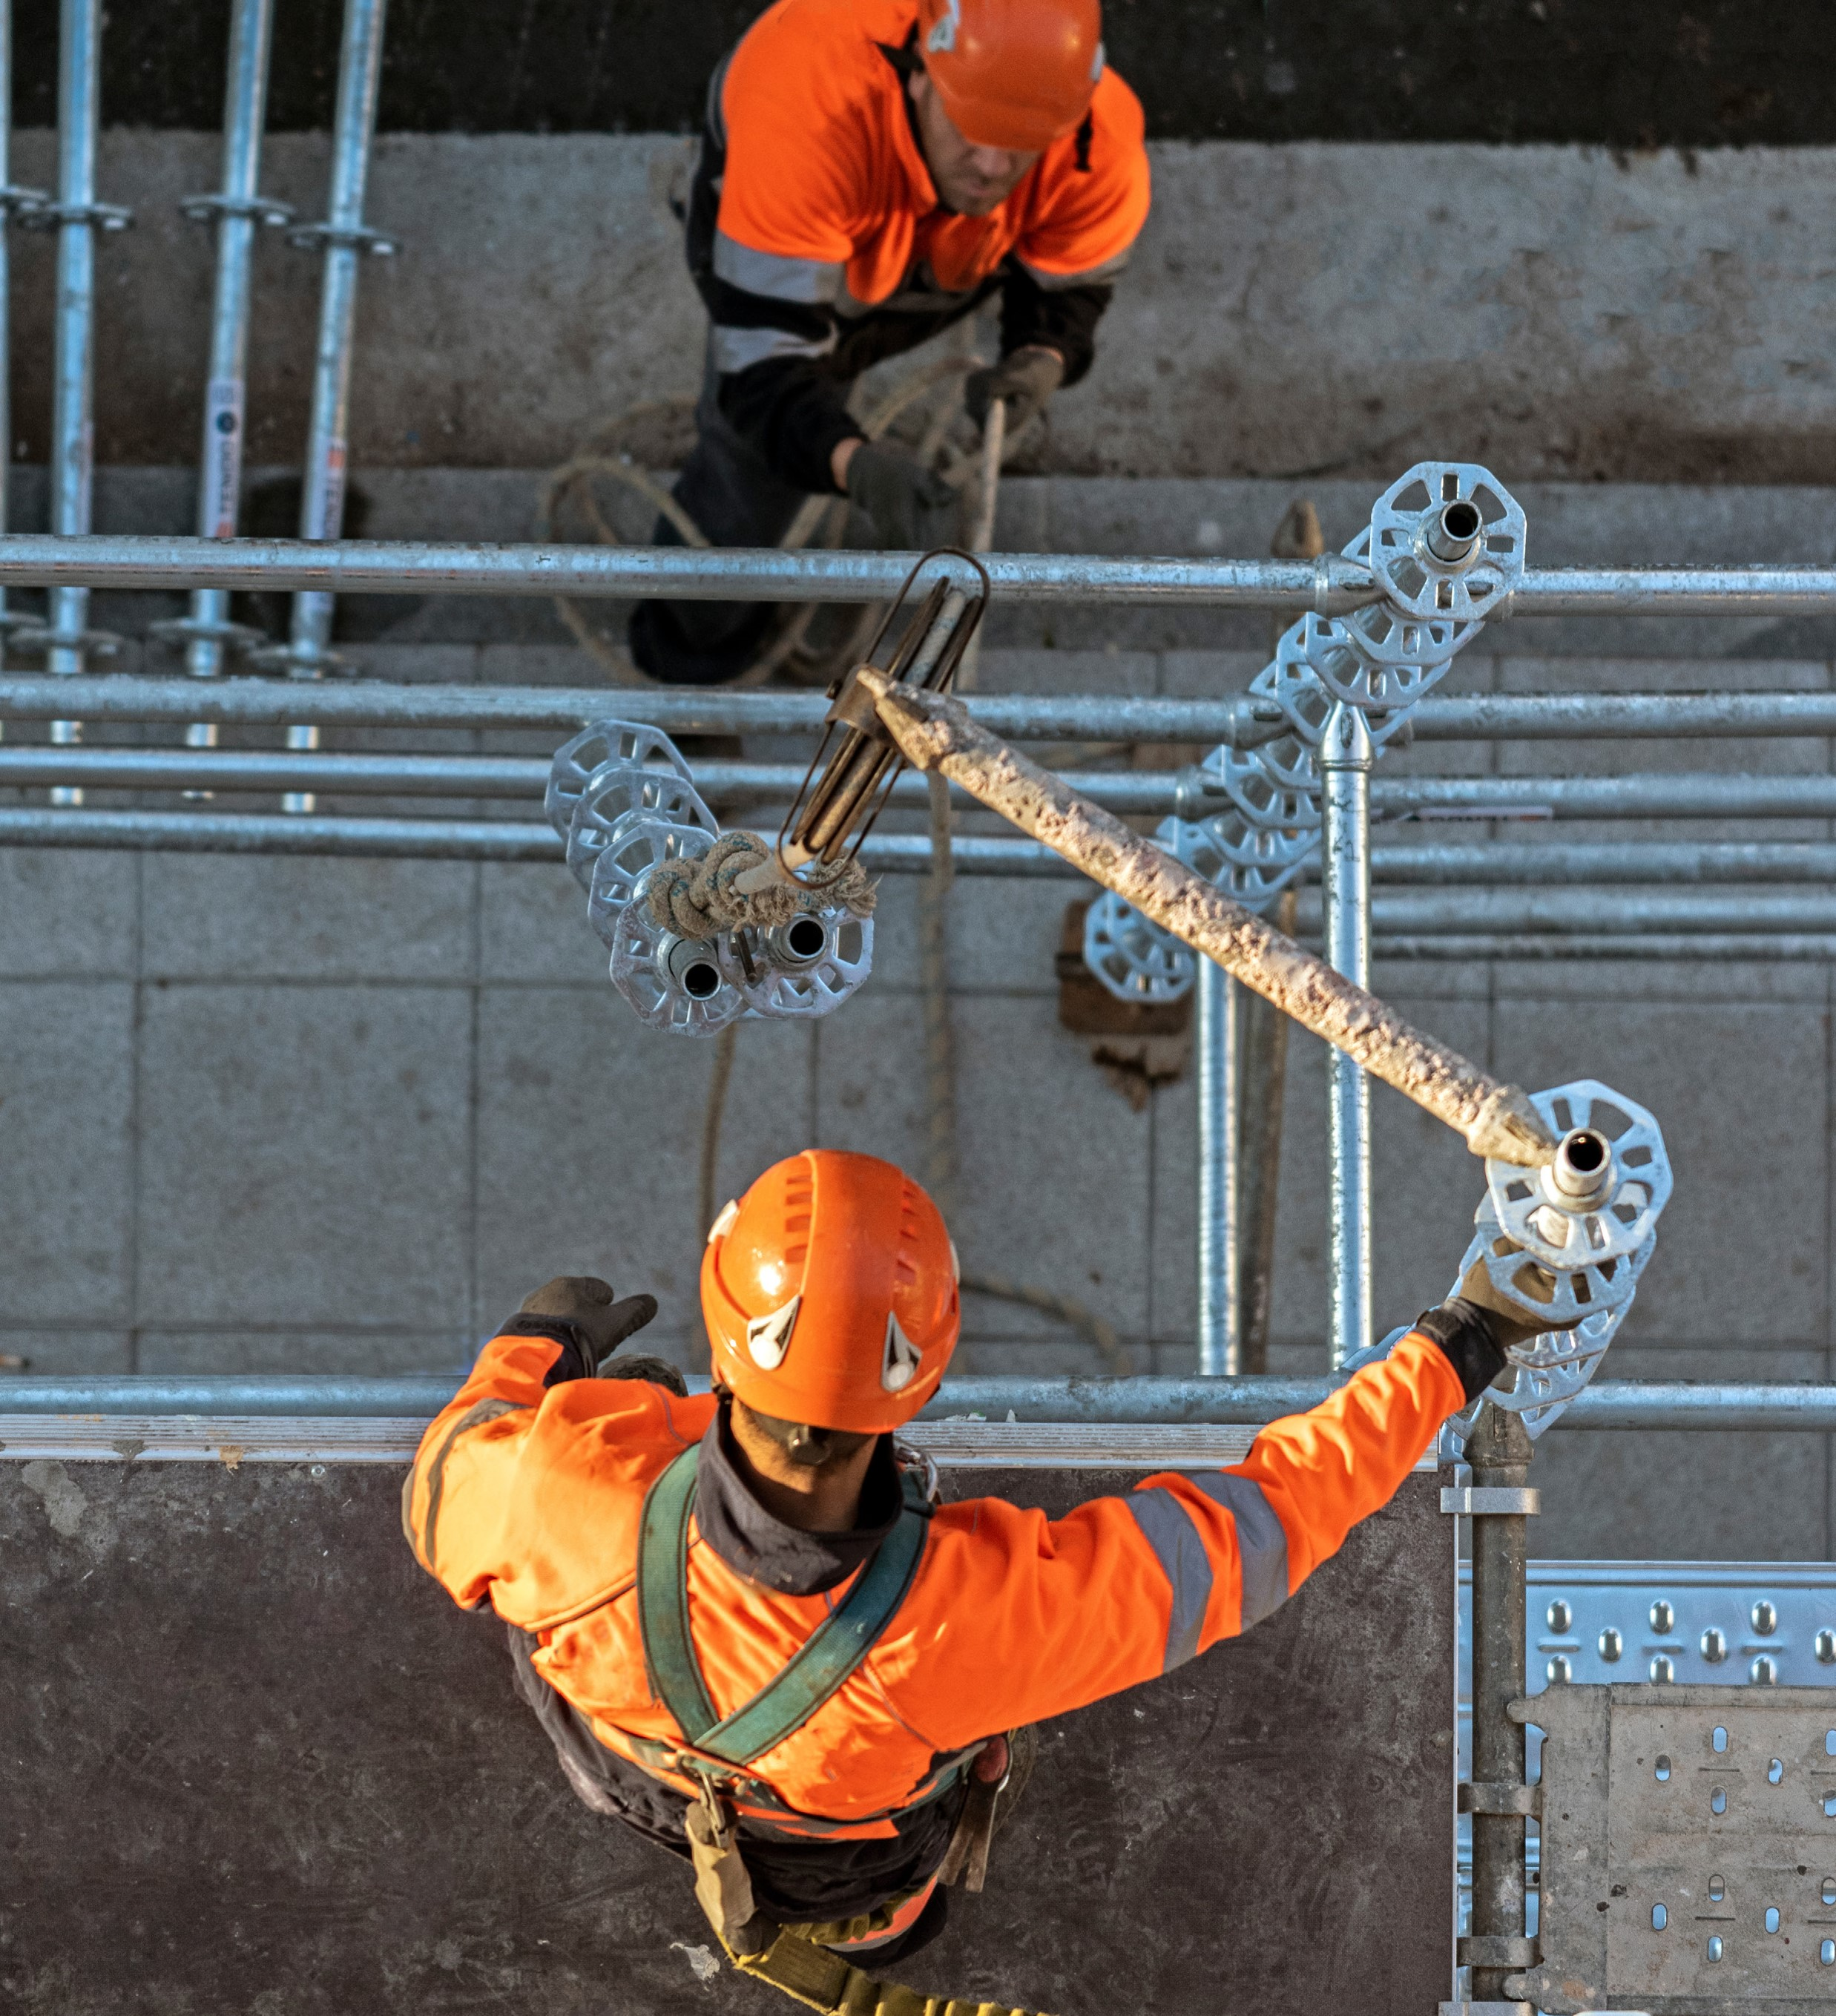

Scaffold safety begins at the very start of the job. So before you

even set foot on the structure, check it’s free of hazards and safe

for use. Make sure your scaffold has been inspected at least once in

the past 30 days. Never remove or move scaffolding components.

**To avoid potential working at height risks,**

**it’s just better to work on the ground. But,**

**in our industry, that’s not always possible.**

**For times you need to work at height,**

**scaffolds are one of the safer options.**

**Scan the QR code to**

**learn more about**

**our working at**

**height campaign,**

**What’s Up?**

