

Working at

height

—

Scaffolding

Toolbox Talk:

Proudly produced in

collaboration with the

Office of the

Federal Safety

Commissioner



This Toolbox Talk has been produced through a collaboration between Ventia and the Office of the Federal Safety Commissioner. Further scaffolding resources can be found at [fsc.gov.au](http://www.fsc.gov.au/) or by scanning the QR code on the cover

# Presenter Guide

* Find a quiet space. Check that everyone can hear you and each other.
* This Toolbox Talk can be delivered in its entirety. Or, depending on the time available, audience and focus, each page can be delivered as separate smaller Toolbox Talks.
* Ask workers to engage in discussion by talking to a recent event, sharing stories and asking questions.
* Consider giving a practical demonstration or showing relevant photos, videos or diagrams.
* Print page 4 and the last page of this Toolbox Talk. Share as a handout and post on noticeboards.

# The Facts

* Scaffolding has the potential to cause serious harm or even death and continues to be 1 of the biggest safety compliance risks in the industry.
* A recent industry report found the highest number of scaffolding incidents occurred due to the erecting and dismantling of scaffolding and from falling or falling objects and scaffolds not being erected according to the design/plan and manufacturer requirements.
* Each region has variations in compliance obligations but usually include compliance with manufacturers and design requirements, erection and dismantling by competent workers, risk assessments being undertaken and using fit for purpose equipment.

# Key Messages

When working with scaffold, everybody involved must understand their responsibilities and take action to ensure everyone stays safe.

Workers using a scaffold must ensure:

* They are fit to work at height.
* Only suitably trained, competent and qualified people can erect, change or dismantle scaffolding.
* They never remove scaffold components or make changes to the scaffold as it may impact the structural integrity and introduce new risks.
* Where there is a risk of people accessing an area under and around a scaffold, an exclusion zone is put in place to isolate them from falling objects.
* They check the scaffold tag to confirm the scaffold is safe for use and has been inspected in the last 30 days.
* Handrails, midrails and kickboards are checked and in place.
* The scaffold is not overloaded.
* Local laws, site rules and procedures relevant to the works are followed.

Supervisors must ensure:

* Scaffolders on site have the right qualification for the type of scaffold they are working on.
* Scaffold is inspected prior to being put into use, the structure matches the approved design (and/or manufacturer’s guidance) and that a handover certificate has been received from the scaffolder.
* Risks associated with the erection, use and dismantling of the scaffold are identified and controlled.
* The scaffold is inspected by a competent person every 30 days, after weather events, after a change to the scaffold and after any safety incident involving the scaffold.
* Signage or tagging is fitted to scaffold access points and states whether the scaffold is open for use, its load capacity and when it was last inspected.

|  |
| --- |
| **Discussion questions and answers**  Discussion  Suitable exclusion zones must be established during scaffold use. They must prevent people from accessing the scaffold area where objects may fall. People and plant/vehicles must be kept away from impacting scaffold stability. Unauthorised people must not be prevented from accessing or climbing scaffolding (especially unattended scaffolding). When protecting against falling objects, the exclusion zone must be large enough to allow for objects that may deflect off the structure if dropped.  **Answers include**   * Secure tools using tool lanyards * Ensure kickboards are in place * Use perimeter containment screening (where design approval permits) * Ensure good housekeeping, limit the number items and materials stored on the scaffold * Site communications and signage to warn people of the risk * Use drop chutes or material hoists for raising and lowering items * Schedule work for periods when there are less people on site.   **Question**  In addition to exclusion zones what are some other ways to prevent or protect against falling objects?  Discussion  Poor compliance with scaffolding requirements is a serious issue that safety regulators in all regions continue to focus on. In a recent inspection campaign, a regional regulator visited 428 sites with scaffolding. They identified:   * 49% of sites allowed workers to access incomplete scaffolds * 43% of sites had working decks with missing planks, ledgers or hop-ups * 43% of sites had missing mid rails * 32% of sites did not have a handover certificate (or written confirmation) by a competent person * 30% of sites had scaffolds that appeared to have been altered by unlicenced tradies and workers. |

## Question

What are some other requirements and considerations related to scaffolding that you should ensure?

## Answers include

* Do the scaffolders have the right competency e.g. high-risk work licence?
* Is the scaffold appropriate for the load?
* Are ground conditions suitable and scaffold secured and stable?
* Are planks and lapboards in good condition, of uniform thickness and secured against movement (to prevent trip hazards)?
* Are platforms fully decked across their full width, free of gaps and have guardrails, mid-rails and kickboards fixed to any open side?
* Is there safe access to every scaffold platform?
* Are scaffolds a safe distance from power lines?
* Is the scaffolding isolated from other workers and the public?
* Are mobile scaffolds (where fall from height is less than 4m) being erected as per manufacturer requirements?

## **Focus Areas**

To ensure everyone's safety, it’s vital that key scaffold hazards are correctly managed. The diagram below shows some of the things you should visually check from the ground, before using a scaffold:

Additional considerations

•

Exclusion zone around scaffold established to prevent mobile plant strikes, unauthorised access and to

prevent persons from entering an area where they are exposed to falling objects.

•

Scaffold erected close to building to minimise gaps for falling objects i.e. within 225mm.

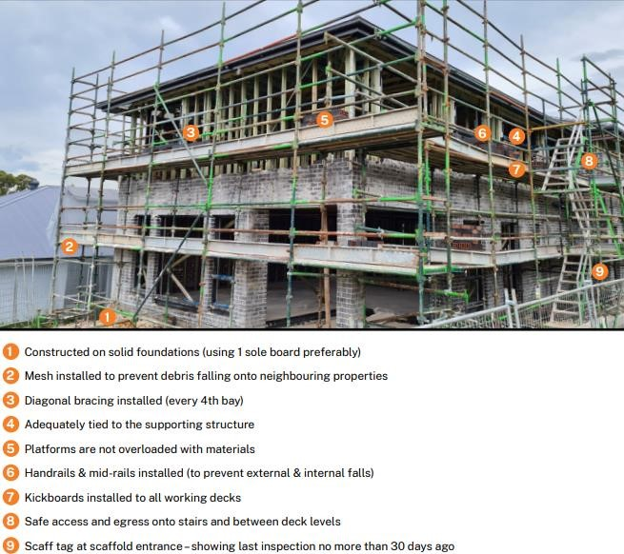

*© State of New South Wales (SafeWork NSW). For current information go to* [*safework.nsw.gov.au*](https://www.safework.nsw.gov.au/)

|  |
| --- |
| **Ask**   * Do we have any new or inexperienced workers   who need extra support or supervision?   * Do we have any work at height equipment not fit for purpose or not in good working order? * Do we know if anything has changed or is likely to change from our original task plans? |

**Scenario** (or share a personal story from the team)

A contractor was welding a new support arm on a mount to strengthen the existing fixed antenna that was located on the side of a building. The support mount was located 5m above the ground. Scaffolding was organised and erected to allow access for the welding activity.

The welding task was scheduled the day after the scaffolding was finished being erected. On the day of the task, it was quite windy. The welder decided to secure a welding blanket to the scaffold railing to prevent sparks from being blown in the area around and below the scaffold. The blanket caught a sudden gust of wind. The force caused the scaffolding to fall over and collapse to the ground.

The welder fell with the scaffolding and incurred serious injuries to their left leg, arm and shoulder. The worker could not work for 2 months. The job was delayed by 2 weeks while the safety regulator investigated the event.

### Questions to ask workers

1. What could have been done to prevent this event?

**Answers include**

* Establish a safe system of work through a risk assessment (e.g. SWMS).
* Do not fit any mesh or materials unless approved in the scaffold design.
* Reassess the conduct of any work at height activity when conditions are unsuitable e.g. windy or rainy.
* The supervisor and/or spotter should have ensured safe work practices.

2. What should the welder check before using the scaffold?

**Answers include**

* Ensure the area below a scaffold is isolated from people or plant to minimise interactions and exposure to falling objects.
* Check there is good housekeeping on and below the scaffold and there are no combustible items below or near the area being welded.
* Prior to use, inspect the scaffolding to ensure it remains safe to use and has no signs of tampering.
* Ensure there is no change in ground conditions e.g. the ground is suitably level and stable to support the scaffold.
* Ensure the scaffold tag indicates the scaffold is safe for use and the date of last inspection date is within 30 days.

## **Stay Safe When Working with Scaffolding**

Actions:

* Inspect scaffold at the start of each day and ensure:

o There are no visible signs of damage or faults (e.g. no signs of tampering)

o It is constructed on solid foundations

o Controls are in place to prevent falling objects (e.g. mesh)

o Diagonal bracing is installed

o Platforms are not overloaded with materials

o Handrails and midrails are fitted

o Kickboards are installed to working decks

o A method for safe access and egress is provided (e.g. ladders, stairs)

o A scaffold tag is located at the scaffold access points showing last inspection no more than 30 days ago

o Scaffold is positioned close to building with minimal gaps for falling objects i.e. within 225mm.



Proudly produced in

collaboration with the

Office of the

Federal Safety

Commissioner



* Participate in a risk assessment that identifies any task or localised activity-specific hazards.
* Ensure appropriate exclusion zones are in place to protect people from falling objects. Make sure tools or materials cannot fall off.
* Lock wheels before using a mobile scaffold.
* Never climb a scaffold structure or guardrails.
* Do not change or modify any part of scaffold.
* Stop work if you believe that works are unsafe to proceed/continue.
* Report any hazard, compliance issue or incident to your supervisor.