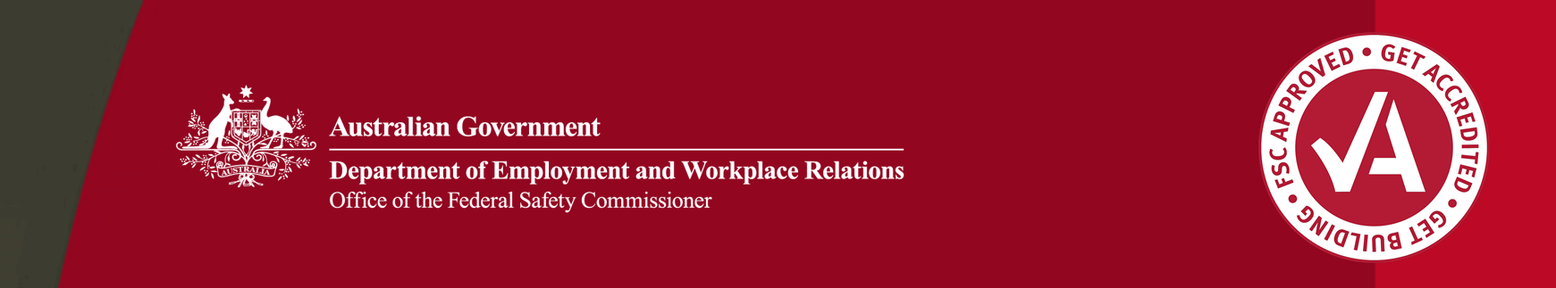

**Federal Safety Officers – scope of assistance available to Housing Australia related Scheme applicants**

Federal Safety Officers (FSOs) currently have an expanded role when engaging with Scheme accreditation applicants who are planning to become head contractors on Housing Australia-funded building and construction projects (‘applicants’) as part of the Housing Australia Future Fund Facility and the National Housing Accord Facility.

Step one – FSO conducts a Systems Validation Audit

Upon lodging their application, applicants will be assigned an FSO to conduct a Systems Validation Audit (SVA). The SVA is a desktop assessment of the applicant’s WHS Management System (WHSMS) against the FSC Audit Criteria. The FSC Audit Criteria must be met satisfactorily before the applicant can be granted Scheme Accreditation by the Federal Safety Commissioner.

Step two – FSO works with applicant through a ‘rolling SVA’ process to identify gaps in WHSMS

The SVA will result in an audit report that explains where the WHSMS does not meet the FSC Audit Criteria. The additional assistance provided by FSOs to applicants includes:

* debrief the applicant in detail about the system gaps described in the report;
* answering questions the applicant has about the SVA gap findings;
* providing general examples on what documentation is necessary to meets the FSC Audit Criteria requirements (e.g. a permit system or register etc);
* directing applicants to available resources (e.g. regulatory publications such as Codes of Practice, relevant Australian Standards or other industry guidance and tools etc), and
* reviewing updates made to the WHSMS by the applicant after the SVA and confirming if the updates have addressed issues raised.

Step three – on-site audit is scheduled

Once the applicant has satisfactorily met the FSC Audit Criteria requirements through the rolling SVA process, an on-site audit will be scheduled. The same FSO will usually conduct the on-site audit, where both practical implementation and evidence of WHSMS application on-site will be reviewed. Issues identified through the on-site audit are called Corrective Action Reports (CARs). The FSO is able to provide all of the above assistance provided during the rolling SVA to assist the applicant in closing out CARs. A follow-up on-site audit may be conducted to review on-site implementation of changes to the WHSMS at the discretion of the OFSC Audit teams under advice from the FSO.

Scope of FSO’s role

During this three-step process, the following actions are outside of the scope of the FSO’s role:

* giving prescriptive advice to applicants on how to design their WHS management system (system), and
* drafting a system, work processes or safety procedures for the applicant or otherwise providing consultancy-like work for the applicant.