

FSC Online: Contact Management feature

FSC online contains functionality to enable you to manage your company’s FSC Online ‘contact’ details. This includes updating the details of existing users, adding new users on commencement, and removing users who no longer require access. Please note, only existing users will be able to access this feature.

**Adding new company contacts**

1. In order to add new FSC Online users to your company profile, after logging in with your myID, start by clicking on the ‘Contact Manager’ button on the navigation ribbon at the top of the page:

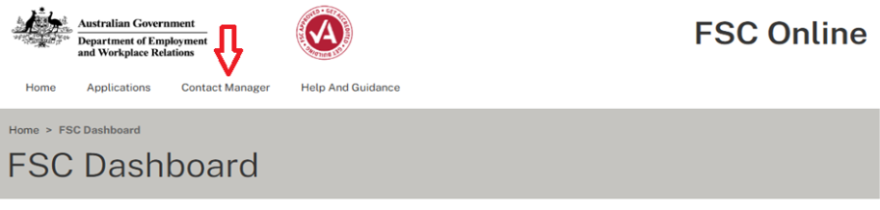

1. You can then create a new company profile contact by selecting **‘Create New’** on the Contact Manager page, above the contact list:

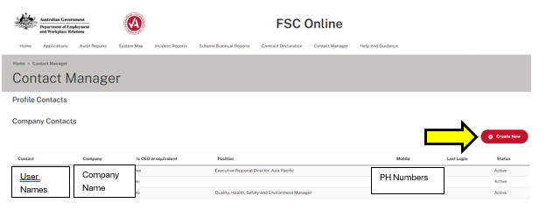

1. A new contact record can then be created by completing all of the mandatory fields indicated by an asterisk (*).

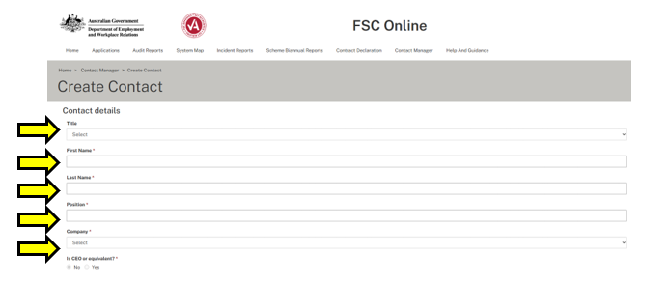

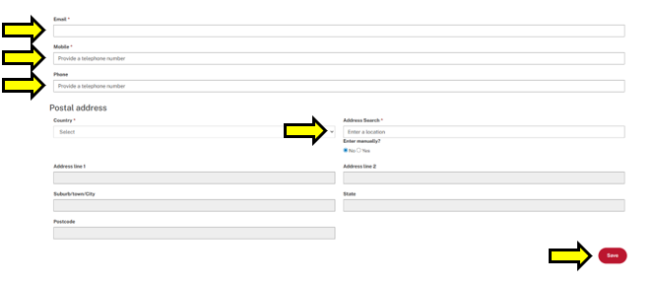

1. You must select **‘Save’** in order to have the new contact created and associated with the company profile.
   * Together with the user’s RAM authorised myID, these contact details will serve to enable users to access FSC Online as company contacts.
   * New contacts will receive a unique invitation code via the email address applied to their contact details. This email will assist with their first log-in attempt.

**Tip:** Please ensure you use a contact’s full legal name, as also relied upon by myID. Include the users’ middle name in the ‘First Name’ field, if applicable.

**Tip:** Please note that contacts established in this manner are not linked to a particular application for accreditation (Profile Contact). Accreditation application forms include additional steps to nominate specific contacts for the following purposes:

* Application Contact
* Audit Contact &
* Reporting Contact
* The above contact roles will become editable once there are no pending applications as per step 5 below.

1. You can also ‘**Edit’** existing contacts by clicking on a row in the contacts table, to select the contact detail you want to update:

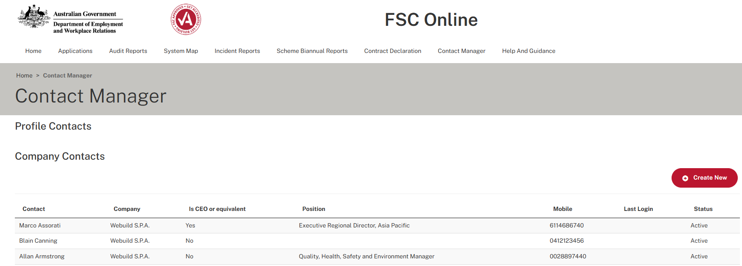

Phone Numbers

User Names

Company Name

1. This will open up the **‘Edit Contact’** page:
   * Review and update all relevant details, ensuring any mandatory fields marked with an asterisk (*) are complete, and then click **‘Save’**.
   * You can also **‘Deactivate’** an existing contact by clicking **‘Deactivate’**.

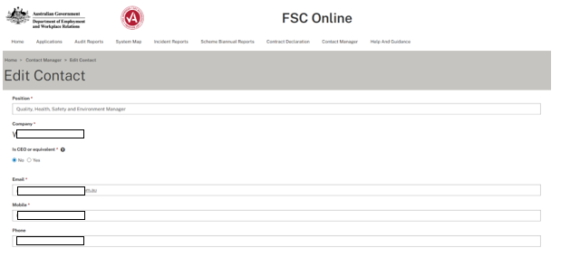

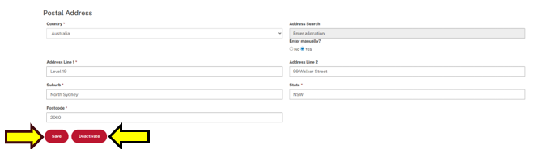

**- End Process -**