

FSC Online: Contract declaration feature

It is a condition of accreditation that all Scheme Projectsare reported to the OFSC by way of a Contract Declaration. Scheme Projects are defined as any contract with a value of $4 million or more. The FSC Online Contract Declaration feature enables users to securely disclose any new contracts for Scheme Projects to the OFSC.

#### Before you Begin

**Contract declarations**, once made, will auto-populate within your Scheme Biannual Reporting template in FSC Online for the relevant reporting periods. It is critical that **Contract Declarations** are entered into FSC Online **before** you commence your scheme biannual reporting every six months.

If you experience any issues with the Contract Declaration feature, please contact [STARHelpDesk@dewr.gov.au](mailto:STARHelpDesk@dewr.gov.au) for assistance.

1. After logging into FSC Online with your myID, you can initiate a new **‘Contract Declaration’** by selecting **‘Contract Declaration’** from the control ribbon at the top of the FSC Online dashboard:



1. From the Contract declarations list, you will be able to see (and sort) historical contract declarations with the following information:

* Scheme Project Name
* OFSC Contract Number
* Date Building Work Commenced
* Contract End Date
* Date Submitted
* Contract Status
* Profile Name / Project Name

1. To create a new contract declaration, you will click on the **‘New Contract Declaration’** button:

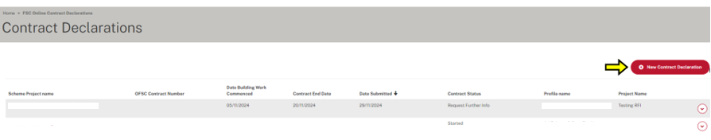

1. When you select **‘New Contract Declaration’**, a pop-up message will appear asking if the contract is worth more than $4 million:
   * If you select **‘No’**, the pop-up message will vanish as there is no requirement to report contracts below $4 million.
   * If you select **‘Yes’**, this is considered a **‘Scheme Project’** and you will progress to the next stage of the contract declaration form.

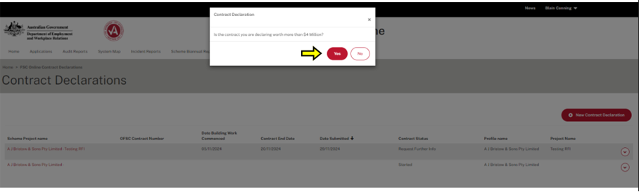

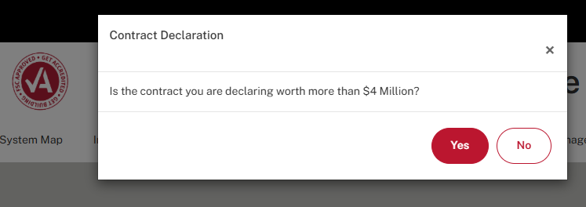

1. You will then be directed to the contract declaration form, where you must complete all mandatory fields on the **‘Project Details’** page indicated by an asterisk:
   * The **‘Project Details’** page on the left side-bar will display a tick when correctly completed.

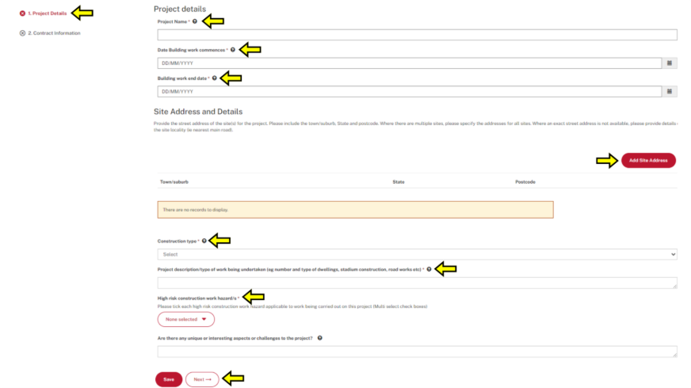

1. Site details can be added through the address dialogue pop-up window:
   * Address details can be added manually or through the address look-up tool. Please note the address look-up tool will only work for Australian addresses and will appear upon selecting **‘Australia’** in the **‘Country’** field
   * For greenfields projects without a defined address, please add site address details manually.
   * You must save the address details by selecting **‘submit’**.

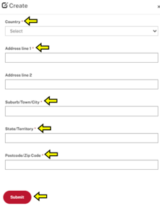

1. After selecting **‘Save’** and **‘Next’** you will proceed to the **‘Contract Information’** stage of the contract Declaration:



1. On the ‘Contract Information’ page you will be required to provide detailed information relating to the new Contract being declared:
   * If the previous **‘Project Details’** page has been correctly completed, it will display a tick.
   * All fields within the **‘Contract Information’** page are mandatory fields. These include the source of Funding, contact details for the funding provider, contract value and date entered into, and details relating to the contracted entity.

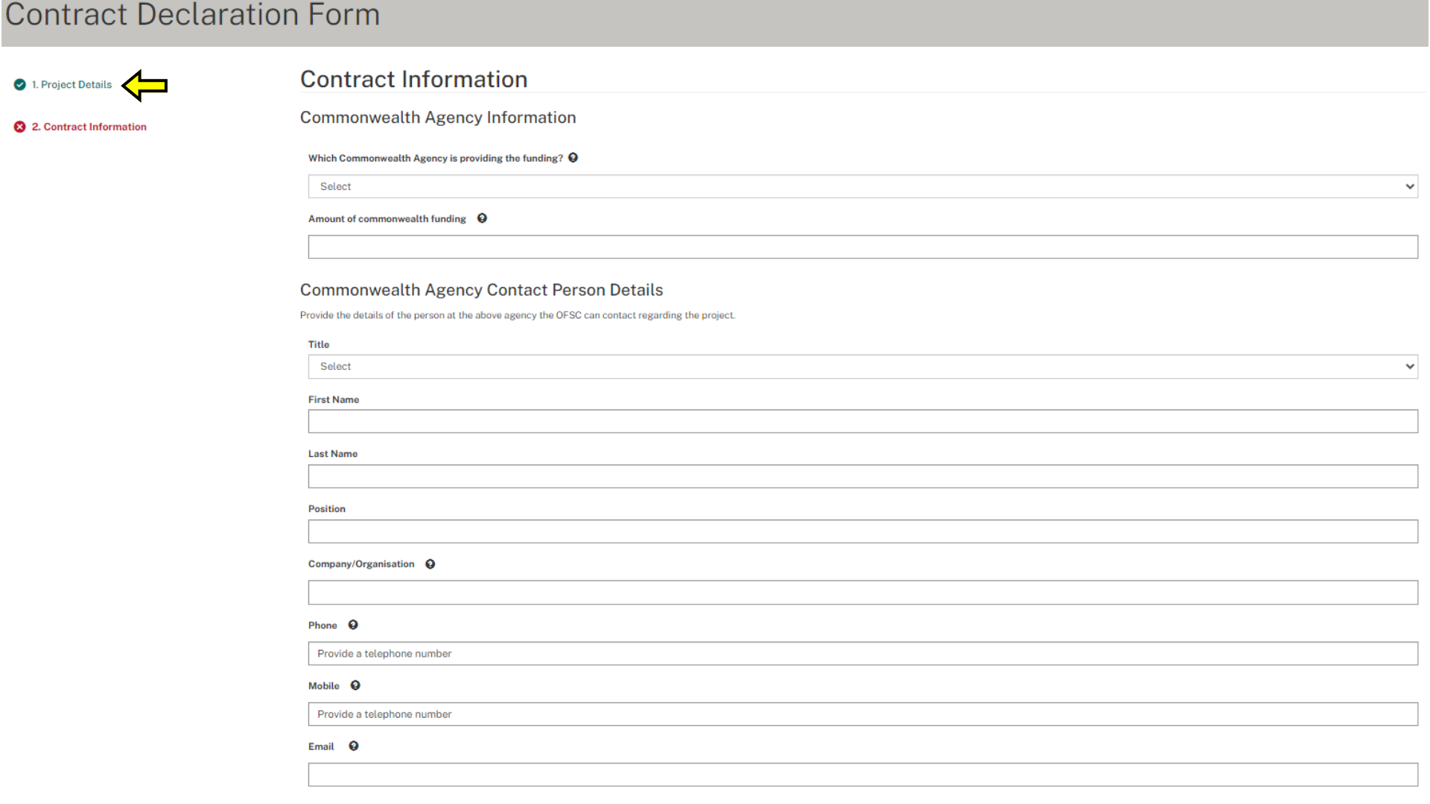

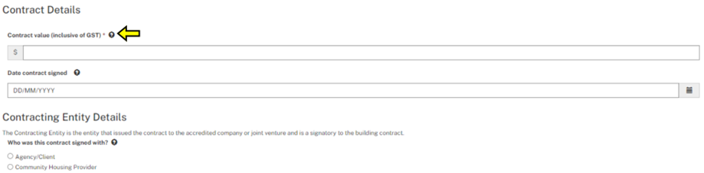

1. After completing all details within the **‘Contract Information’** screen, select **‘Save’** to capture the information provided:

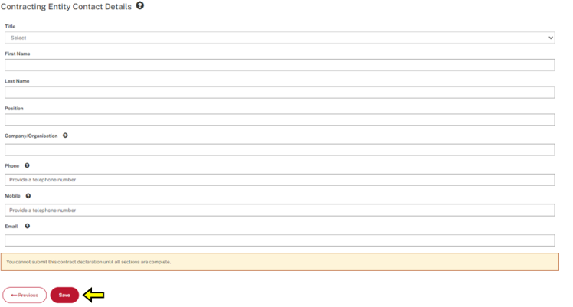

1. After successfully saving the **‘Contract Information’** a **‘Submit’** button will appear following validation of the form details:
   * In order to finalise the contract declaration and communicate the contract declaration to the OFSC, please select **‘Submit’**.

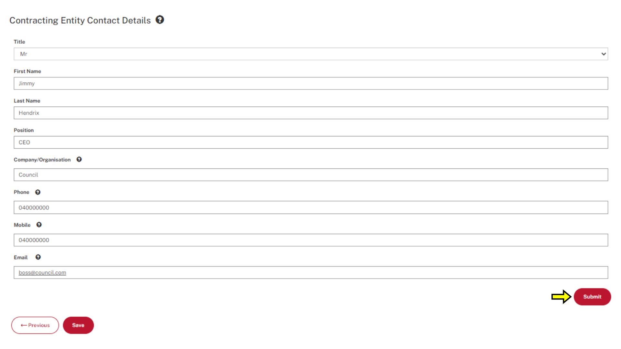

1. You will then be returned to the **‘Contract Declaration List’**, where you will receive a pop-up message in a banner along the top of the page, notifying you that the **‘Contract Declaration’** has been successfully submitted to the OFSC:
   * You will now be able to view the new and previous contract declarations within the contract declaration list.

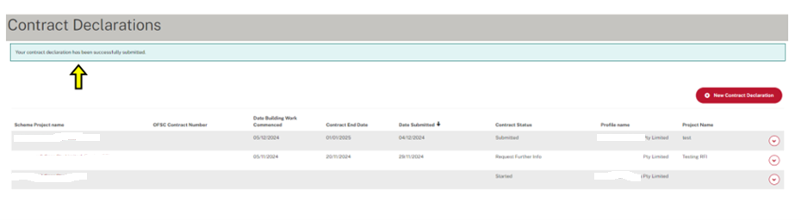

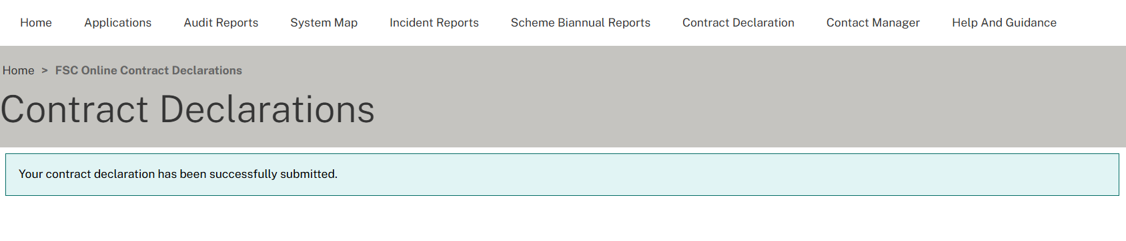

**- End process -**