

FSC Online: Incident Reporting Feature

The FSC Online Portal affords users a secure and efficient means of lodging incident reports with the OFSC. The incident report feature ensures that all information relevant to an incident is captured on submission, seeking to limit any need for subsequent follow-up between the OFSC and accredited companies. The portal also affords a secure means of communicating this information to the OFSC, ensuring that this data is only available to those with a defined ‘need to know’.

1. After logging into the FSC Online portal with your myID, the incident report feature can be accessed from the FSC Online dashboard.
   * Click on the **‘Incident Report’** button to open up the feature

1. Once **‘Incident Reports’** has been selected, you will navigate to the incident report feature:
   * You will be able to see a list of all previously submitted incident reports linked to the Accreditation Profile
   * The list table includes (and can be sorted by) relevant contract number, project name, date/time of incident, incident type, date submitted, and incident status (i.e. OFSC incident status)
   * You will be able to create a new incident report by selecting **‘New Incident Report’.**

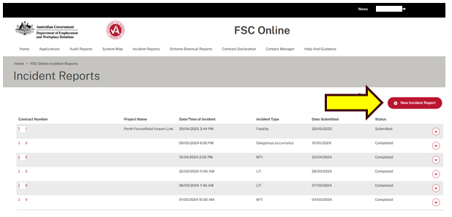

1. When you select “new incident report” you will be able to create a new incident report and choose the “Incident Type” from the following options

* Dangerous occurrence
* Medically Treated Injury (MTI)
* Lost Time Injury (LTI)
* Fatality

1. You will also need to advise if the incident is a **‘Notifiable Incident’** or not:
2. The definition of a notifiable incident relevant to the State or Territory in which the incident occurred is applicable for the purpose of determining if an incident is notifiable in relation to an entity’s WHS scheme accreditation.

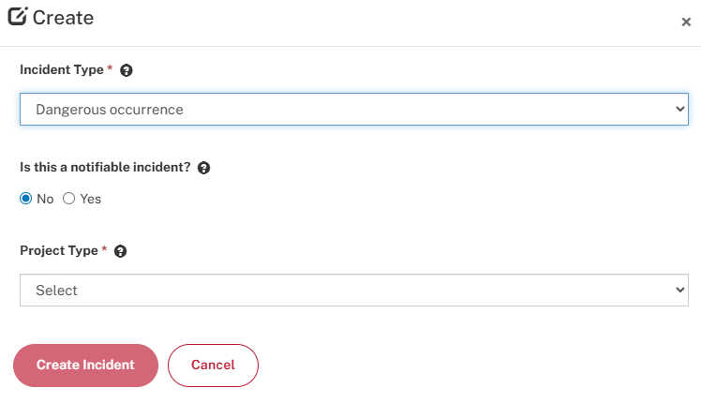

1. Once you have completed both **‘Incident Type’** and **‘Project Type’** fields, you will have the option of selecting if the incident occurred on a **‘Scheme Project’** or **‘Non-Scheme Project’**
2. Dangerous occurrences and Medically Treated Injuries (MTIs) do not need to be reported to the OFSC for non-scheme projects and the system does not cater for such reporting

1. After selecting scheme or non-scheme project, you can enter the name of the project:
   * Scheme projects will pre-populate from a drop-down list for selection

1. Non-scheme projects can be named via free-text

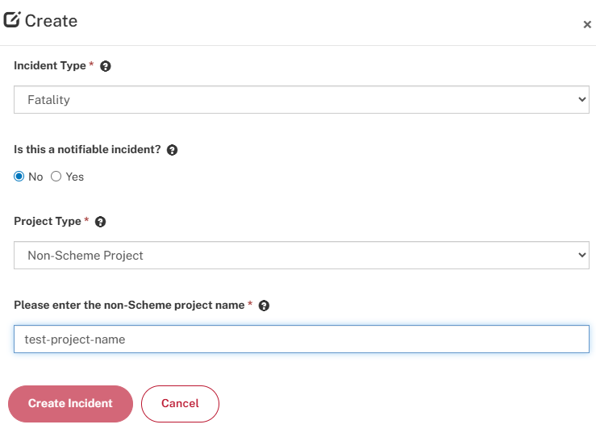

1. If you are creating a **‘Non-notifiable Incident’** on a **‘Non-Scheme’** project site, you will be directed to an **‘Incident Report Form’** which consists of three distinct stages:
   * Project details, Incident Details, & Incident Description

1. If you are creating a **‘Notifiable Incident’** on a **‘Scheme’** project site, you will be directed to the **‘Incident Report Form’** which consists of four distinct stages:
   * Project details, Incident Details, Worker(s) involved & Incident Description
   * Each stage needs to be completed and demonstrate a tick before the incident report is complete and can be submitted.

1. To complete the project details section of the Incident Report Form, you must select the type of construction from the options below for the “Construction Type” field

* Civil Construction
* Commercial Construction
* Residential Construction

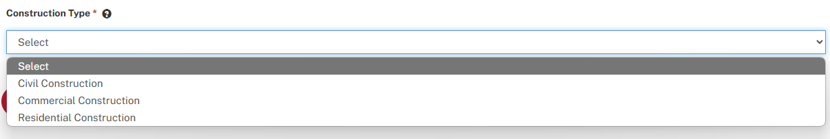

1. Once you have selected a Construction type, select **‘Save’**
   * The **‘Project Details’** stage will then display a tick, indicating you have completed this section of the form
   * Then click **‘Next’** to proceed to the incident details section.

1. To complete the **‘Incident Details’** section of the form, you must complete all of the mandatory fields indicated by an asterisk (*) relating to the incident:
2. This includes the date and time, Breakdown Agency, and applicable high risk construction category.

1. You must then select **‘Save’** before selecting **‘Next’** in order to proceed to the next stage of the incident report:

* After selecting **‘Save,’** the **‘Incident Details’** will now show a tick demonstrating that this section has been completed and saved

1. If you are completing an incident report for a **‘Notifiable Incident’** on a **‘Scheme Project,’** you will then proceed to the **‘Worker(s) involved’** section of the form, where you can add the details relating to the workers involved in the incident:
   * If you are completing an incident report for a **‘non-notifiable’** incident on a **‘non-scheme’** project, please skip ahead to step 18.
   * You can add the details by selecting **‘Add worker injury details’**
2. You can add multiple records if more than one worker was involved in the incident
   * These details will then be saved in a list within the **‘Worker(s) involved’** section of the form.

1. Click on the **‘Add worker injury details’** button to create a worker injury details entry:



1. You must then complete all of the mandatory fields indicated by an asterisk before selecting **‘Save worker injury details’** in order to correctly save the affected worker’s details:

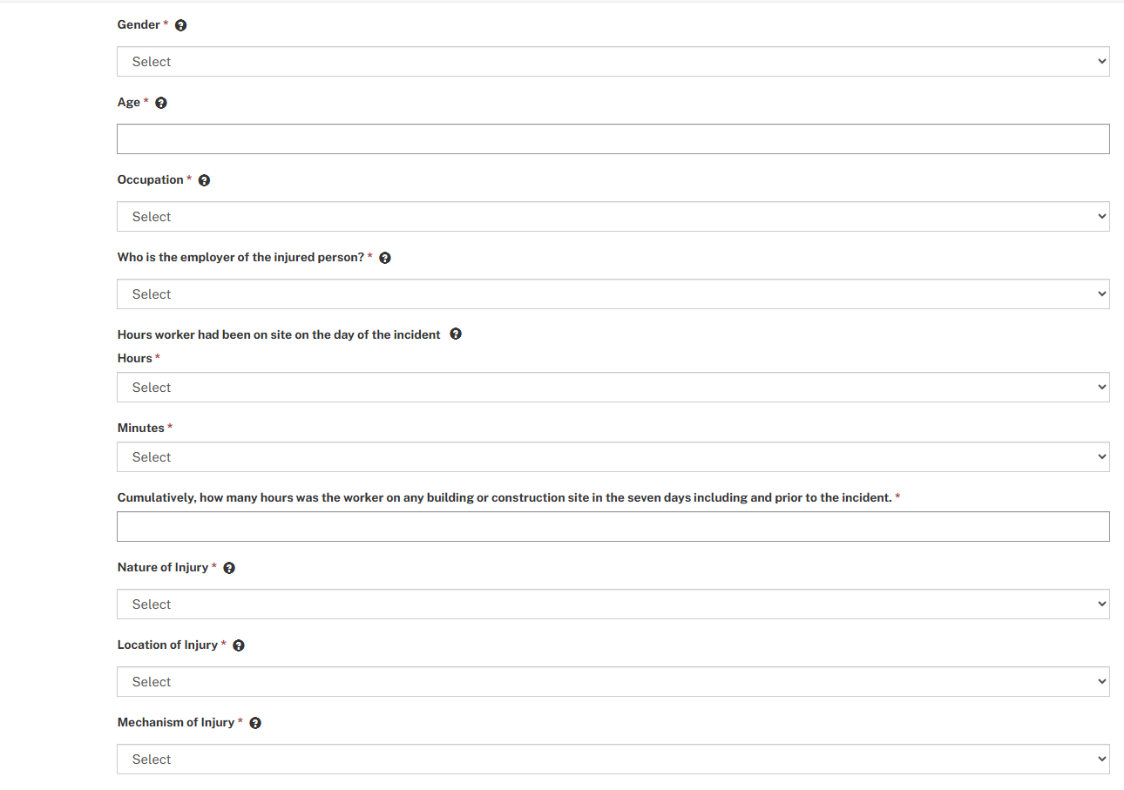

* This process should be repeated for all affected workers.

1. After saving the **‘Worker Injury Details’** you must also click **‘Save’** and then click **‘Next’** to proceed to the ‘**Incident description’** section of the form:

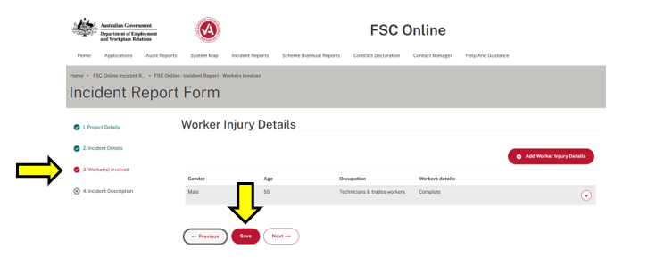

1. You must complete all mandatory fields marked by an asterisk within the **‘Incident Description’** section in order to proceed with lodging the incident report:
   * The incident description should include as much detail as possible, without disclosing the personal details of the individual/s affected
   * The ‘where, when, what, why and how’ of an incident are relevant to OFSC considerations. Providing a comprehensive explanation within the form will limit the requirement for OFSC follow up relating to specific incidents
2. If you are providing notification of a **‘Medically Treated Injury’ (MTI)**, please note it is mandatory to provide advice regarding the specific medical treatment received by the worker within the incident description
   * The **‘Incident Description’** label in the left hand sidebar will display an ‘X’ until all mandatory fields within the section have been completed and the responses saved.

1. If the incident was a **‘notifiable incident’** such as a fatality, you will be prompted to advise if an investigation has been undertaken into the cause of the incident
   * If you indicate that an investigation report has been prepared, a field will enable you to upload a copy of any associated record of the investigation.
   * Click **‘Add Files’** and follow the on-screen prompts to upload a copy of the WHS investigation report as well as any wider available evidence linked to the incident

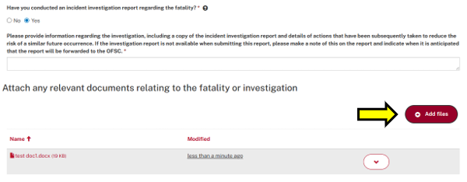

1. Once you have completed all mandatory fields and saved the responses, the form will be ready for submission and the **‘Submit’** button will appear to the right of the page:
   * Please review the incident report prior to submission
   * After updating any of the values contained in mandatory fields, you will need to again select **‘Save’** at the bottom of the page, in order to capture those changes for final submission.

1. After successful submission, you will now be able to view the submitted incident report in addition to previously submitted incident reports on the main **‘Incident Report’** list:

###### Frequently Asked Questions (Incident reporting):

**Question:** The incident report data will not save. I get an error message telling me I do not have sufficient permissions to save the report.

**Answer:** This generally means you have been signed out by the system due to inactivity. Please log back in with your myID and you should be able to save content as required. Any data you have added, after being signed out will not be captured and will need to be re-entered after logging back in.

**Question:** The incident report data will not save. A spinning save icon is spinning indefinitely.

**Answer:** This could be caused by a system availability issue. Please log back in with your myID and you should be able to save content as required.

If you experience any difficulties using the Incident Report features within FSC Online, please contact [STARHelpdesk@dewr.gov.au](mailto:STARHelpdesk@dewr.gov.au). Alternatively, please call the FSC Assist line on 1800 652 500.