

FSC Online: Scheme Biannual Report feature

Scheme Biannual Reports (SBRs) are essential for maintaining a company’s accreditation under the WHS Accreditation scheme. Data relating to the January through June and July through December reporting periods is reportable twice a year, in February and July. Failure to lodge SBRs could result in compliance action which may affect a company’s accreditation.

#### Before You Begin

In the new FSC Online Portal, SBRs rely on the details of **incident reports** and **contract declarations** made by a company within the relevant reporting period. In order to ensure that your SBR validates correctly, to enable submission, all incident reports and contract declarations need to be lodged and processed by the OFSC **before** you create your SBR for the reporting period in question. Ensuring these objects (i.e. incident reports and contact declarations) are already lodged and processed prior to the creation of your SBRs will minimise any follow-up activity required with the OFSC.

If you experience any issues with submission of your SBRs, please engage with [STARHelpDesk@dewr.gov.au](mailto:STARHelpDesk@dewr.gov.au) to seek assistance or contact the FSC Assist line on 1800 652 500.

1. After logging into the FSC Online portal with you myID, the **‘Scheme Biannual Reports’** feature can be accessed from the FSC Online dashboard:

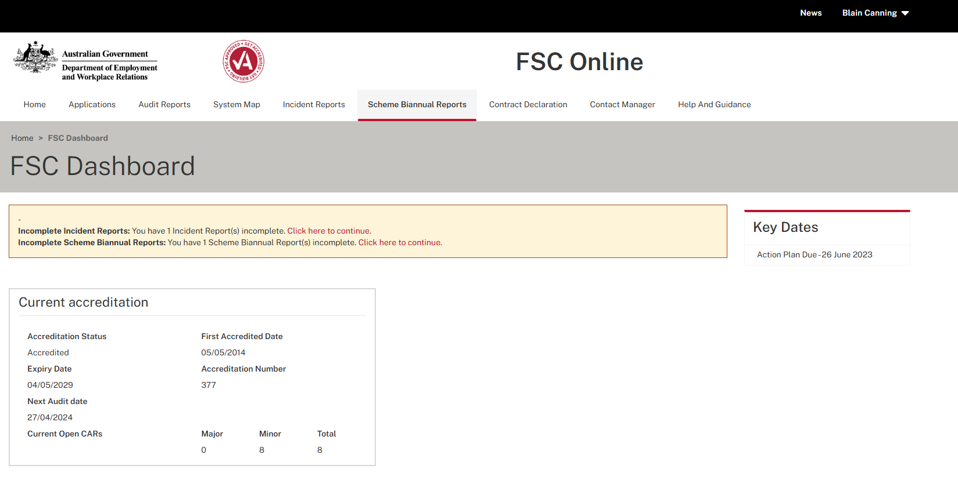

1. After selecting **‘Scheme Biannual Reports’** from the ribbon at the top of the page, you can view previous SBRs lodged and lodge a new SBR by selecting **‘Create a New Scheme Biannual Report’:**

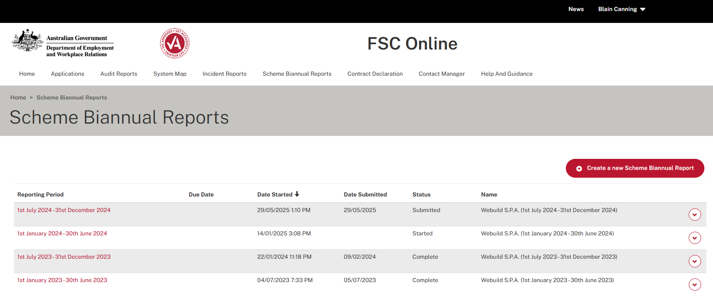

1. You will then view a pop-up message asking you to choose a specific reporting period from available selections within a dropdown field:
   * If a specific reporting period is not available on the list, this means that an SBR report has previously been created using the desired reporting period. Please review the SBR list to determine that status of the SBR report for the period in question.

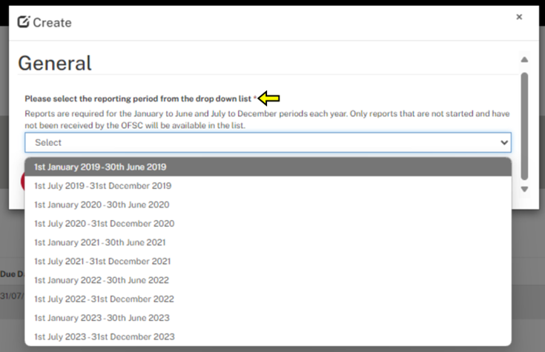

1. After selecting a reporting period, you will start the **‘Workers Compensation and WHS information’** stage of the Scheme Biannual Report Form:
   * All mandatory fields marked by an asterisk within the **‘Workers’ compensation and WHS information’** section must be completed
   * You must select **‘Save’** and **‘Next’** in order to proceed to the next stage of the Scheme Biannual Report.

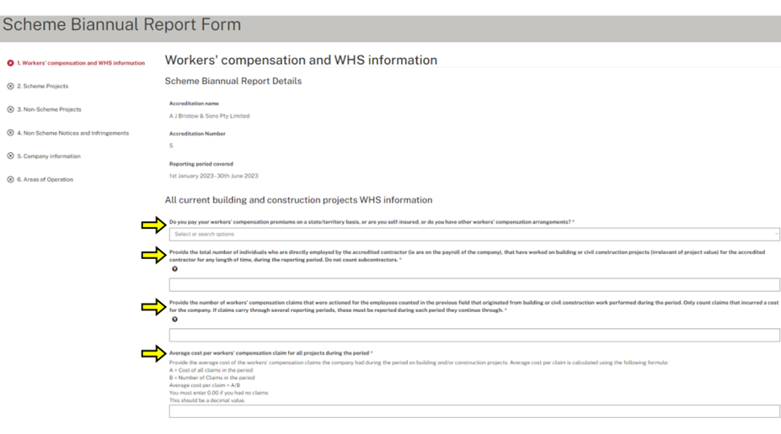

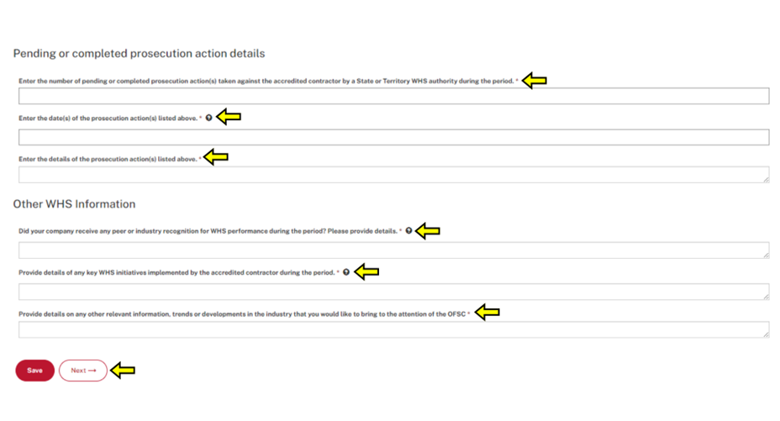

1. After completing all mandatory fields and clicking **‘Save’** and **‘Next’**, you will proceed to the **‘Scheme Projects’** stage of the Scheme Biannual Report Form:
   * The previous **‘Workers’ compensation and WHS Information’** stage will be complete and demonstrate a green tick
   * If you select **‘No’** to having any Scheme projects during the reporting period, you can select **‘Save’** and **‘Next’** in order to proceed to the **‘Non-Scheme Projects’** stage of the SBR
   * You must also ensure all projects listed have **Completed’** status in order to proceed.

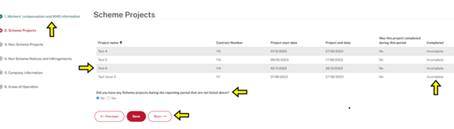

1. If you select **‘yes’** to having any Scheme projects during the reporting period which are not listed, the following pop-up message will appear:

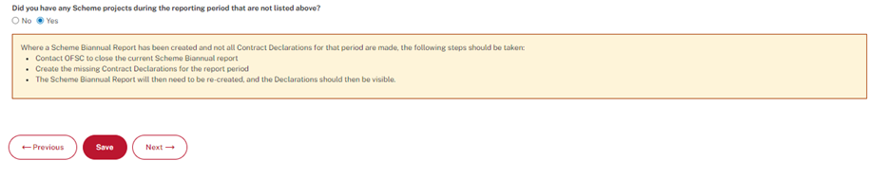

* + This message indicates that the relevant **‘contract declaration’** is not available in FSC Online
  + All contract declarations relevant to a reporting period should be lodged with the OFSC, through FSC Online, **before** you create your new SBR, as discussed in the ‘Before you begin’ section above
  + If you have created a SBR that does not auto-populate the details of all contract declarations that arose in the reporting period (within the list of scheme projects), please contact the [STARHelpdesk@dewr.gov.au](mailto:STARHelpdesk@dewr.gov.au) to request that the SBR is closed, so that the contract declarations can be made
  + Upon making the missing contract declarations, you can then re-create the SBR and these contracts declarations will be reflected within the new SBR that is created.

1. If all Scheme Projects are available within the SBR, you need to ensure that these are marked as **‘Complete’** in order to submit your SBR. In order to transition a project status in the scheme project list to **‘complete’**, double click on an incomplete project row to open up the details, and ensure all of the mandatory fields indicated by an asterisk are completed:

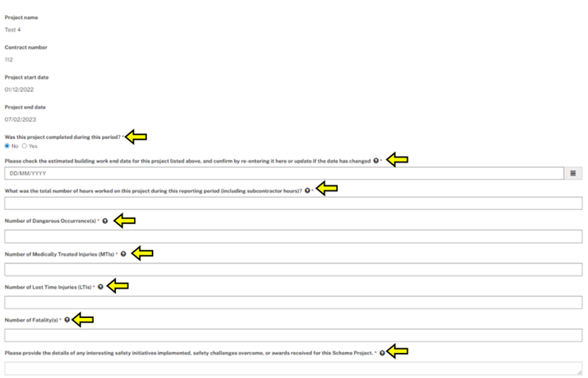

1. You can also upload any improvement, prohibition, infringement (or other notices) against a scheme project by selecting the **‘Add Notice’** icon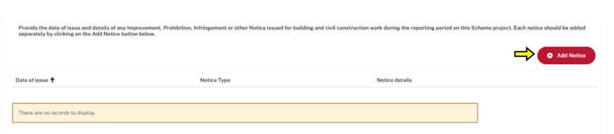
2. When uploading evidence of any form of Notice, you must complete all of the mandatory fields and select **‘Submit’** in order to successfully upload a notice record:

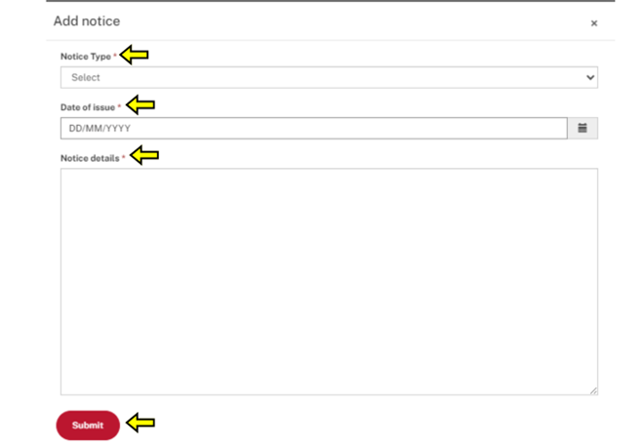

1. To complete the **‘Scheme Projects’** section of the SBR you must then select **‘Save’** and the**n ‘Next’** in order to progress to the **‘Non-Scheme Projects’** stage of the Scheme Biannual Report:

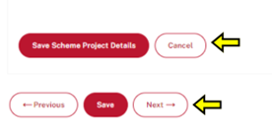

1. After clicking **‘Save’** and **‘Next’**, you will proceed to the **‘Non-Scheme Projects’** stage of the Scheme Biannual Report Form:

* The previous **‘Scheme Projects’** stage will be complete and demonstrate a green tick.

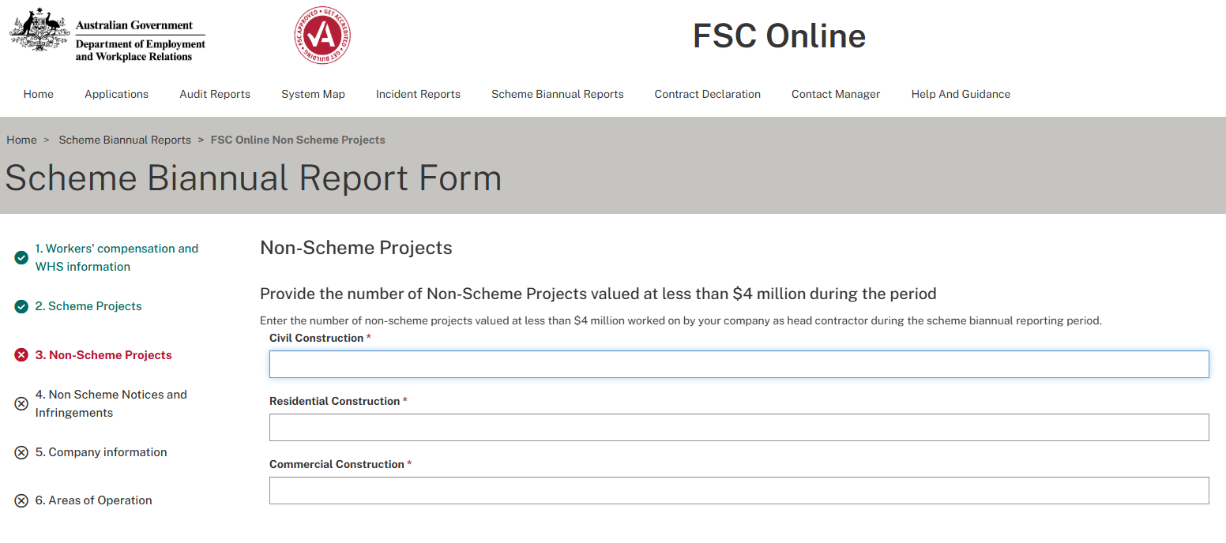

1. You must complete all of the mandatory fields within the **‘Non-Scheme Projects’** stage of the Scheme Biannual Report:

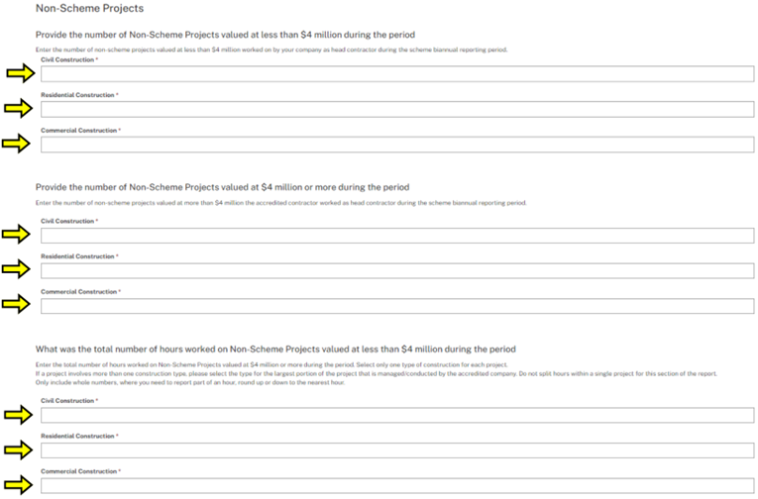

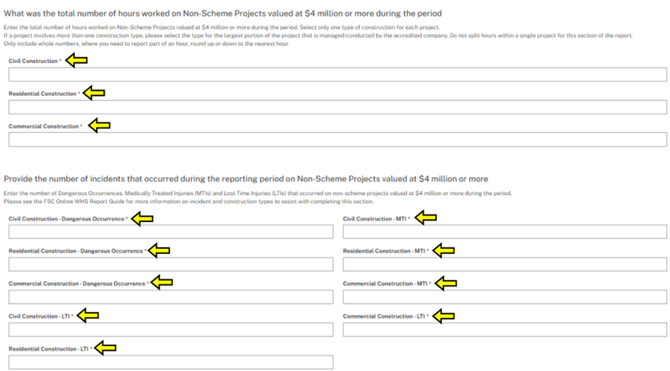

1. After completing all mandatory fields indicated by an asterisk, select **‘Save’** and **‘Next’** in order to proceed to the **‘Non-Scheme Notices and Infringements’** stage of the Scheme Biannual Report submission:
   * All mandatory fields marked with an asterisk (*) must be completed
   * Select ‘Save’ and ‘Next’ to continue to the **‘Non-Scheme Notices and Infringements’** stage.

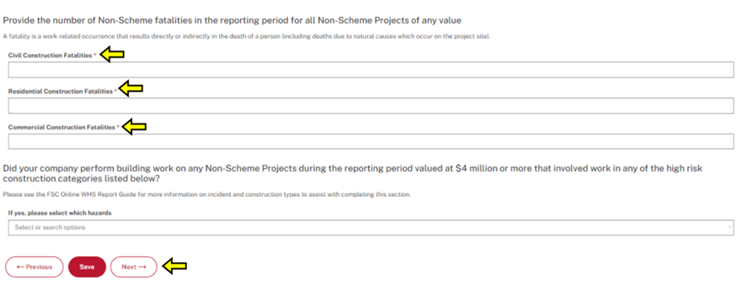

1. After clicking **‘Save’** and **‘Next’**, you will proceed to the **‘Non-Scheme Notices and Infringements’** stage of the Scheme Biannual Report Form:
   * The previous **‘Non-Scheme Projects’** stage will be complete and demonstrate a green tick.

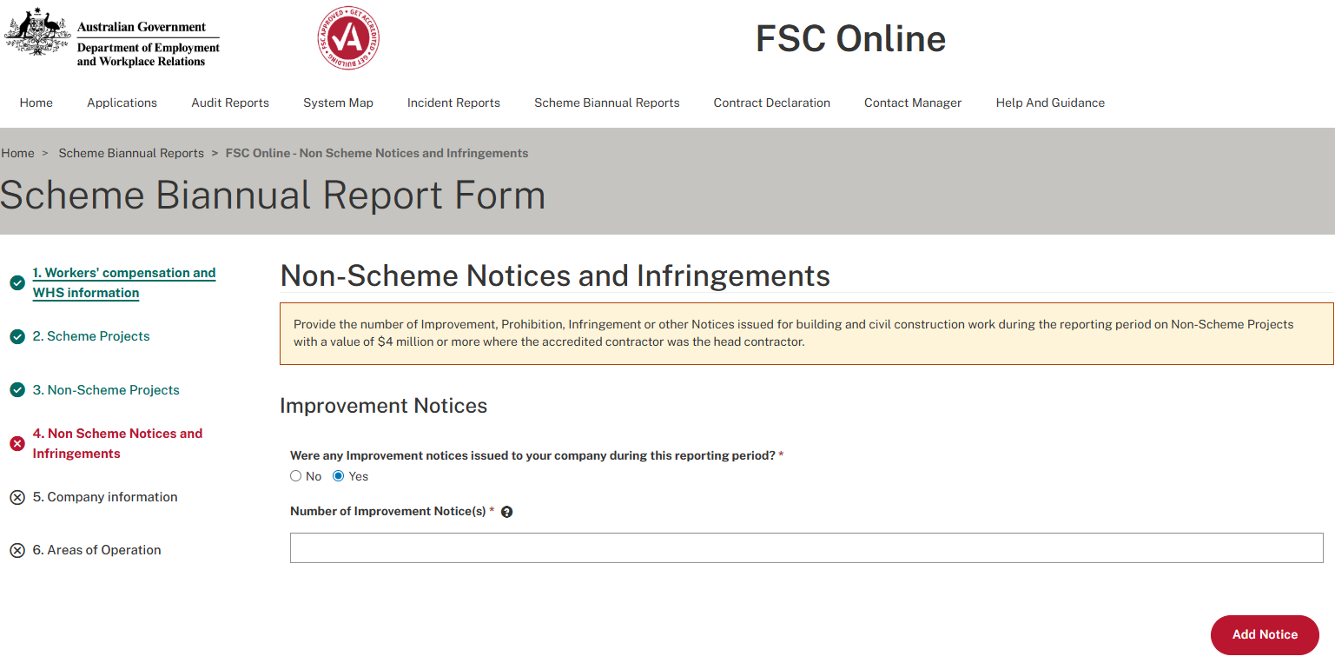

1. You can report any notices and infringements for Non Scheme projects within the **‘Non Scheme Notices and Infringements’** stage of the SBR Form:
   * You must complete all mandatory fields indicated by an asterisk (*)
   * If you select yes to having received any notices or infringement types, you will be able to enter an additional field for the number of notices received.

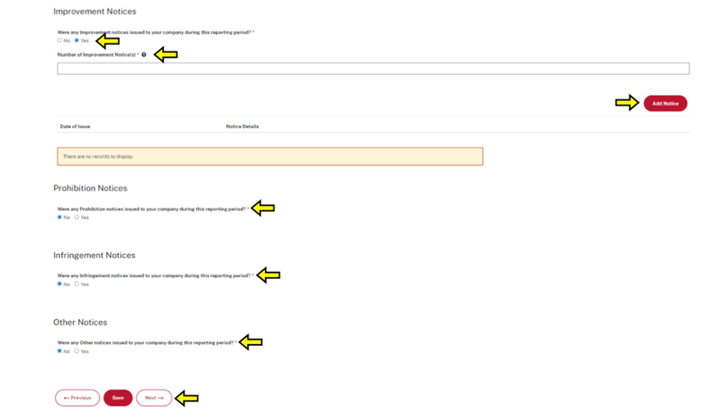

1. After advising of the number of respective notices received in the reporting period, you will also be prompted to upload a copy of the Notice itself as well as any records relating to each Notice.
   * Click on **‘Add Notice’** to upload a copy of the Notice itself, or any wider supporting documents.
   * Please note that certain file types will not be able o be uploaded, for example .exe or .bat file types.
   * If you advise of any notices received in the period, you will need to upload copies of the notices in question in order for the field to validate and enable final submission of the SBR form. i.e. if you advise of two infringement notices, two infringement notices must be uploaded for the form to validate.

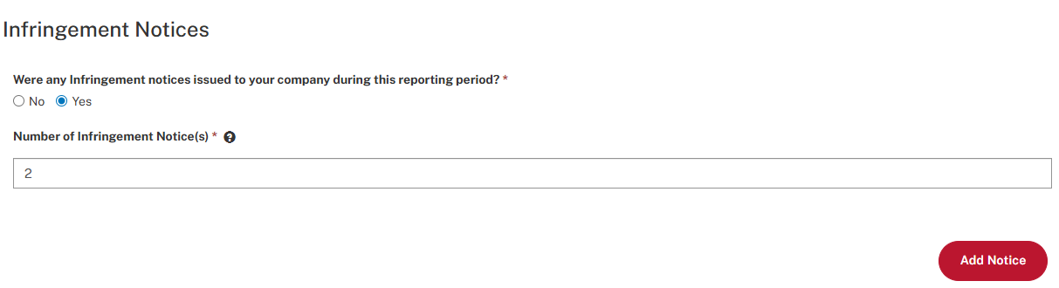

1. After selecting **‘Add Notice’**, you need to enter the details of the Notice, including date of issue and any relevant details:
   * Click **‘Submit’** to save these details

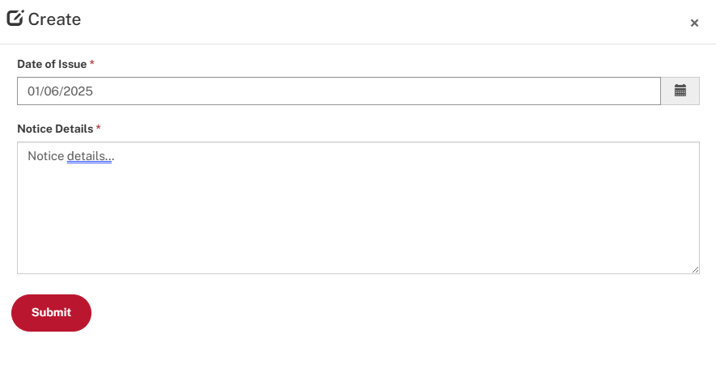

1. After clicking **‘Submit’** in the Notice details window, you will be prompted to upload a copy of the Notice itself:
   * Select **‘Add Files’** to open up the file upload dialogue

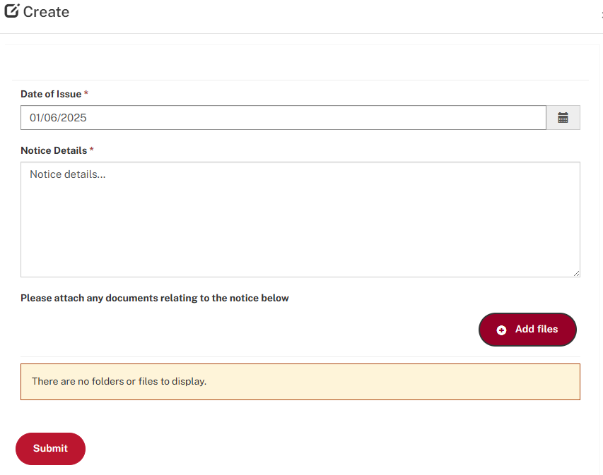

1. Once the **‘File Upload’** dialogue opens:
   * First click on **‘Choose files’**.
   * After selecting a copy of the notice from your computer, you will be able to see the title of the file adjacent to the ‘Choose files’ button
   * To upload the file to FSC Online, select **‘Add Files’** from within the file upload dialogue.

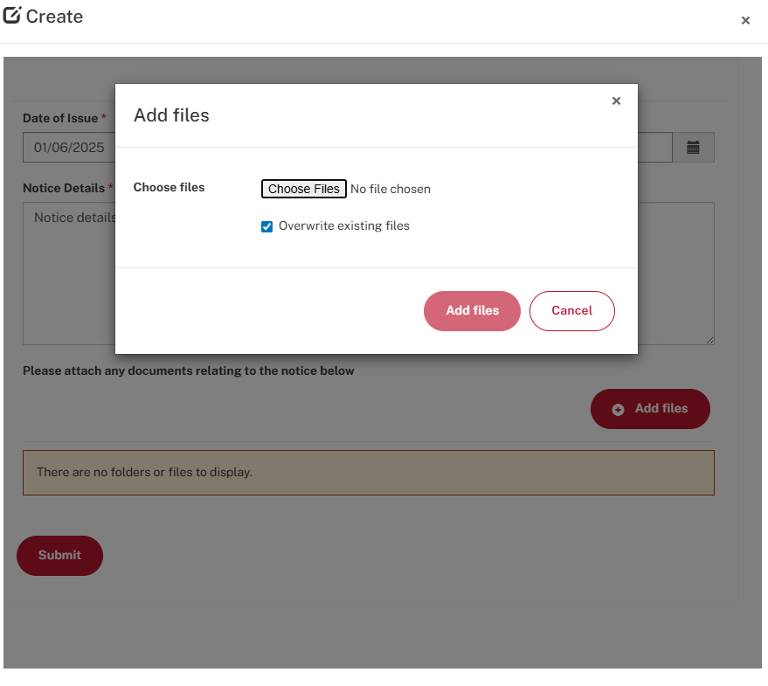

1. You will then be able to review all uploaded files related to the notice/s:
   * If you are satisfied with the records that have been added to the Notice type, select **‘Submit’** to finalise the Notice advice.

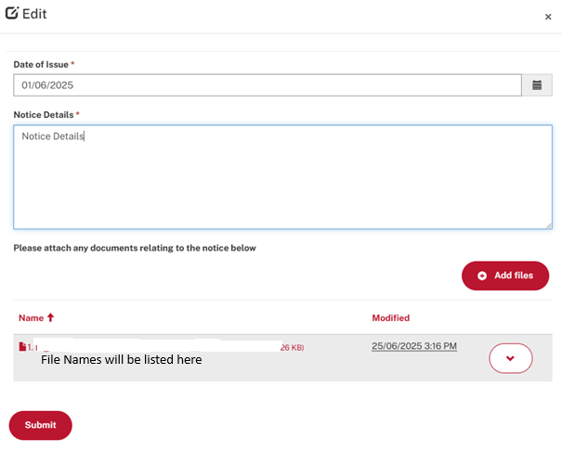

1. After adding all relevant details regarding Notices received in the period, select **‘Save’** and **‘Next’**, to proceed to the **‘Company Information’** section of the SBR:

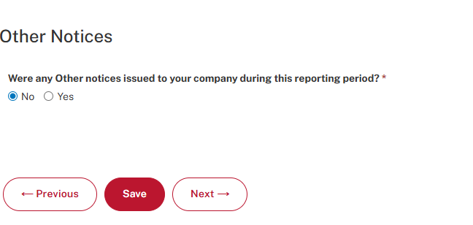

1. After clicking **‘Save’** and **‘Next’**, you will proceed to the **‘Company Information’** stage of the Scheme Biannual Report Form:
   * The previous **‘Non-Scheme Notices and Infringements’** stage will be complete and demonstrate a green tick.

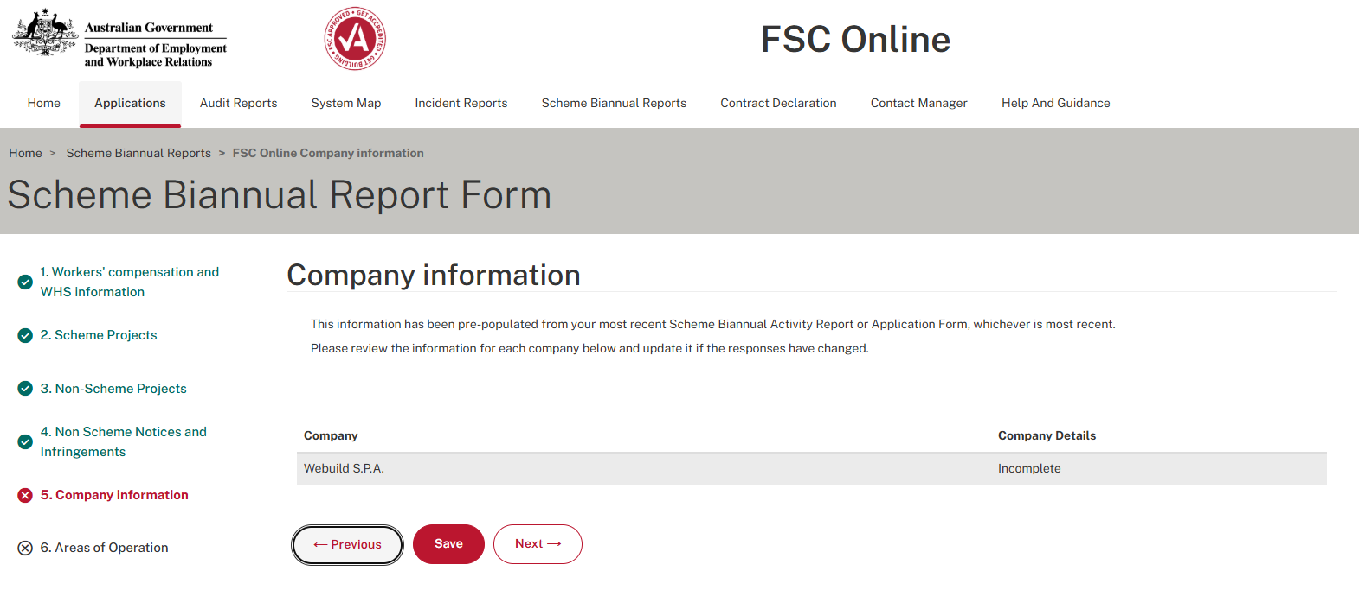

Company name

1. You will now review the **‘Company Information’**, which has been auto-populated from the most recent Scheme Biannual Report or Accreditation Application Form received by the OFSC. Please review this information to ensure it is correct:
   * Click on the company name hyperlink to open up the pre-populated **‘Company Information’**
   * Update details as necessary and click **‘Save Company Information’** to capture any changes

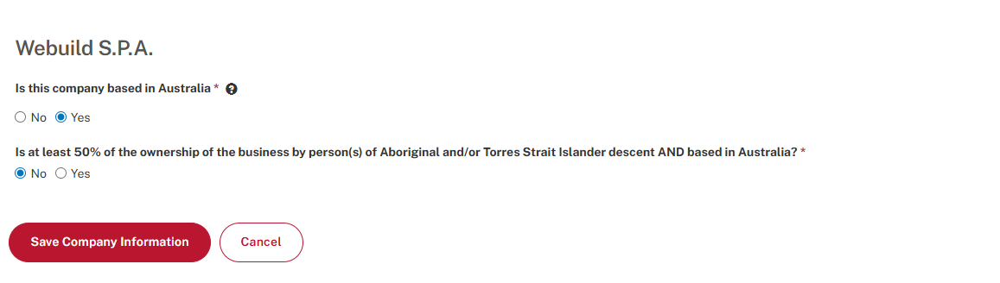

Company Name

1. Then select **‘Save’** and **‘Next’** in order to proceed to the **‘Areas of Operation’** stage of the Scheme Biannual Report:

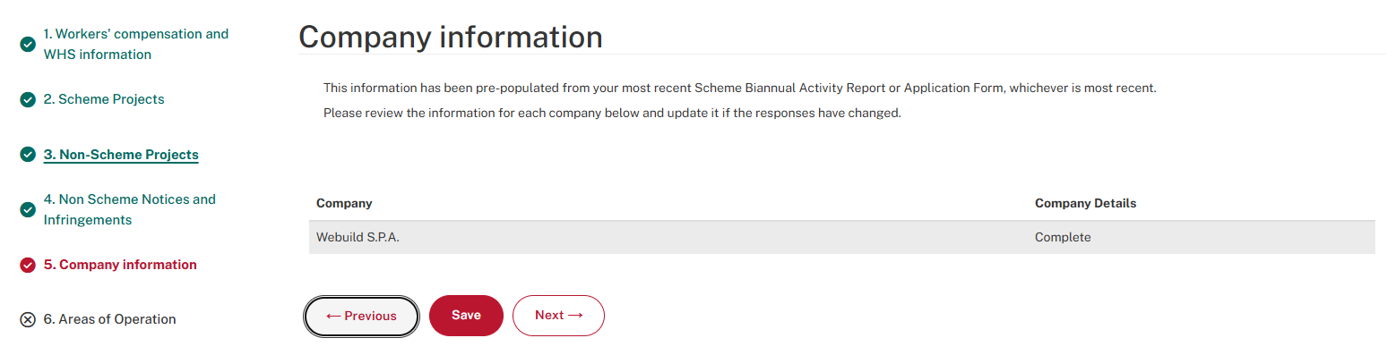

1. After clicking **‘Save’** and **‘Next’**, you will proceed to the **‘Areas of Operation’** stage of the Scheme Biannual Report Form:
   * The previous **‘Company Information’** stage will be complete and demonstrate a green tick

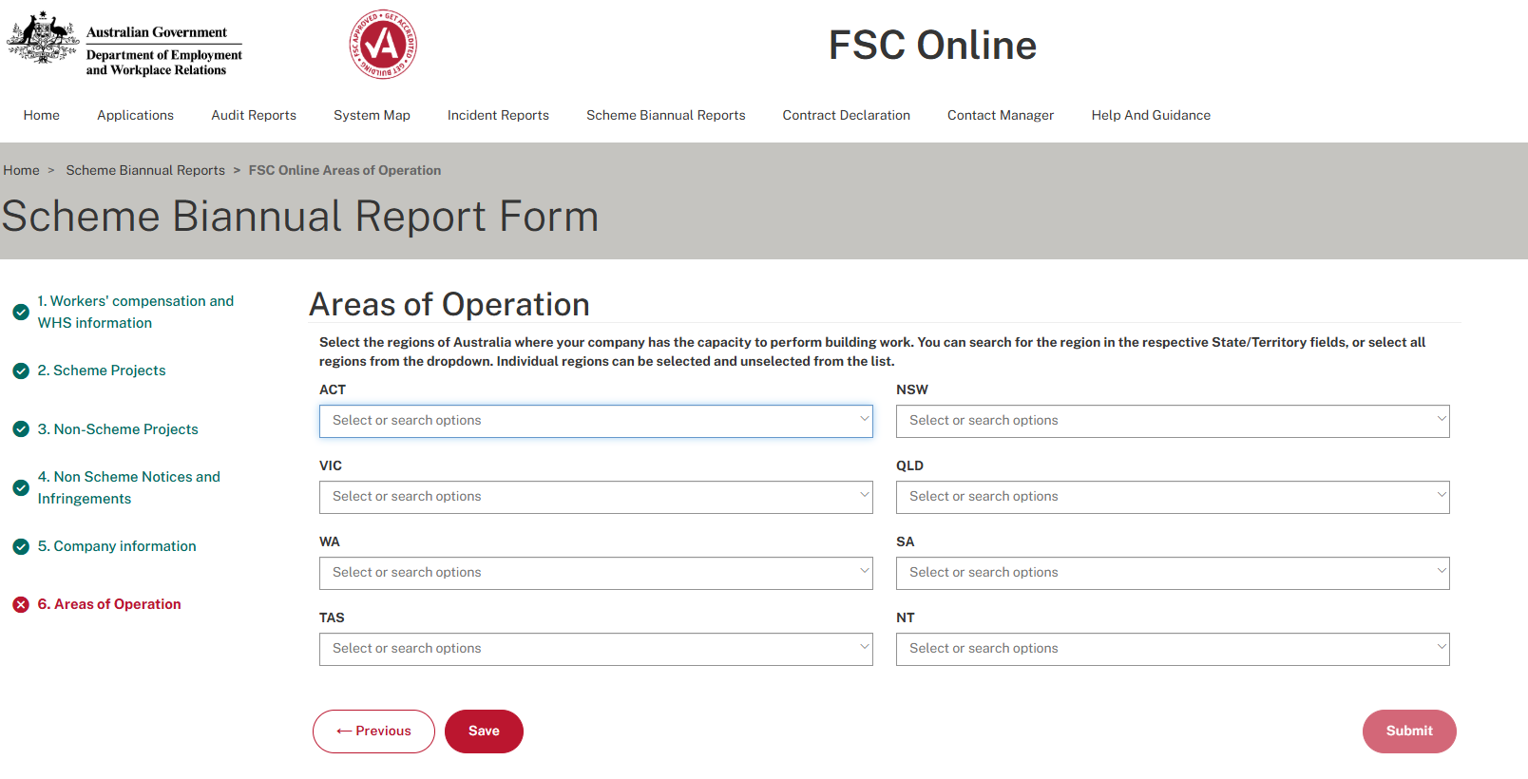

1. To complete the **‘Areas of Operation’** section of the SBR, please select all regions of Australia in which the company operates, from the available fields, and select **‘Save’** to retain these responses:
   * You will then select **‘Submit’** in order to finalise the Scheme Biannual Report.
   * Please note this is final submission of your SBR. Please review earlier sections of the SBR prior to final submission.

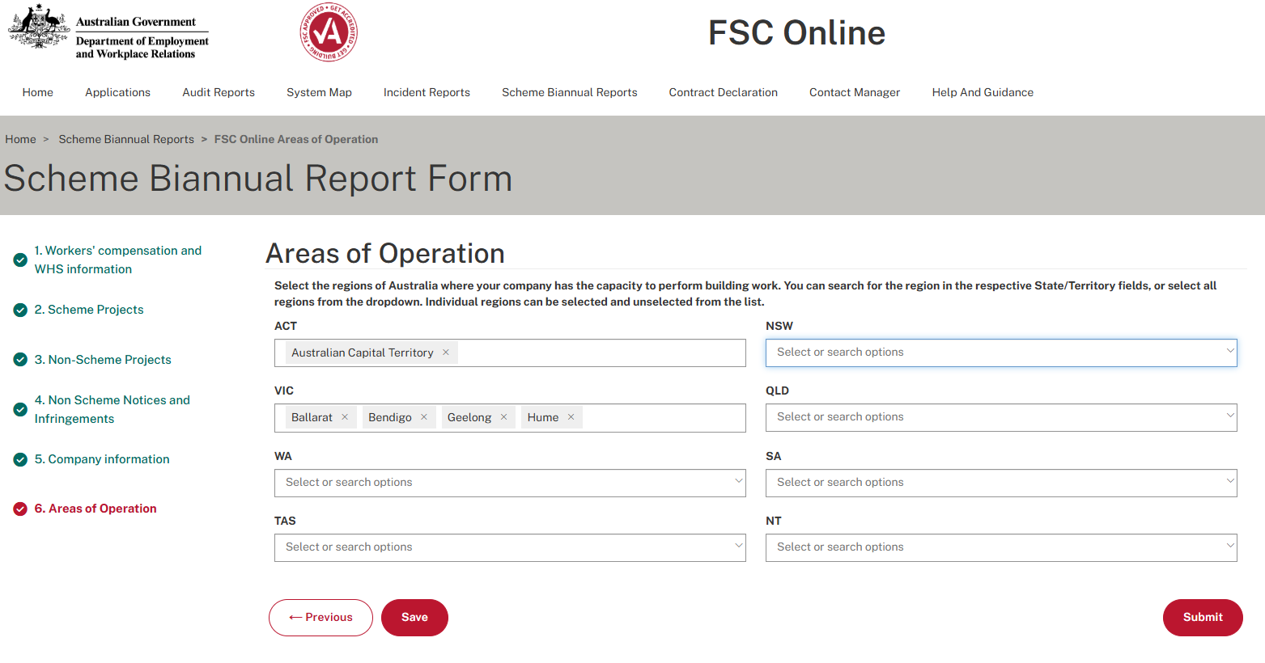

1. You will then be returned to the list of company SBRs, as available in FSC Online:
   * The status of the SBR for the reporting period will transition to **‘Submitted’**

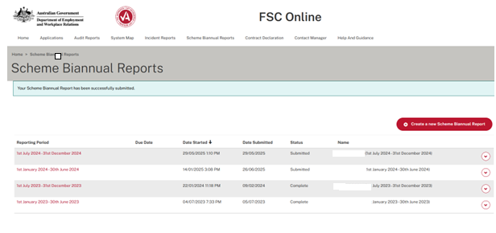

**- End process -**