ANNUAL DATA REPORT
FEDERAL SAFETY COMMISSIONER’S

2024-25

Contents
Overview 4
Accreditation Scheme 6
Accredited Companies 6
Indigenous Businesses 7
Fast-track Accreditation for Residential Builders 7
Accredited Companies by Size and Capability 7
Accredited Companies by Capability and State 8
Scheme Projects 8
Scheme Audits 11
Audit Overview 11
Map of Scheme Audit Locations 2024-25 11
Audit Counts 12
Audit Breakdown 12
Corrective Action Report Breakdown 13
Audit Head Criteria Issue Rates 14
Audit Subcriteria Issue Rates 15
Scheme Reporting 19
Fatalities 19
Fatality Frequency Rates 19
Injury Frequency Rates 19
Lost Time Injuries 20
Medically Treated Injuries 21
Total Reported Injuries 22
Nature of Injuries 23
Mechanism of Injuries 24
Injury Rates Over Time 26
Workers Compensation Premium Rates Over Time 27
FSC Annual Census 29
Education 31
Resources for Residential Builders 31
Safe Work Month 2024 33
Scaffolding safety 34
Engaging Traditional Owners 35
Data Source 37
Glossary 38

Overview

The Federal Safety Commissioner (FSC) and their Office (OFSC) act to improve workplace health and safety (WHS) practices on building and construction sites across Australia through the administration of the Australian Government’s (the government) Work Health and Safety Accreditation Scheme (the Scheme) and by promoting safety across the building and construction industry.
There are over 600 accredited companies in Australia performing commercial, civil and residential building and construction projects. These companies are eligible to be contracted for projects funded by the government, and benefit from improved WHS performance, and reduced insurance and workers’ compensation costs.
Accredited companies are subject to an ongoing, on-site audit program. These on-site audits provide the government and the community with assurance that the construction work being undertaken by accredited companies is being carried out to the highest of safety standards. The Scheme Audits section addresses some results and trends of the Scheme audit program during the 2024-25 financial year.
A condition of accreditation is that accredited companies comply with the reporting requirements of the Scheme. Accredited companies are required to provide information to the OFSC on their WHS performance, including incident reports, hours worked and workers' compensation premium rates. Data and analysis from this information is available throughout this report, with specific incident reporting data found in the Scheme Reporting section.
In 2024 the OFSC increased its engagement with the residential sector of the building and construction industry to support the government’s social and affordable housing commitments. From May 2024, the OFSC implemented a fast-track accreditation program for builders intending on becoming the principal contractor on government funded residential development.
In 2025 the OFSC further strengthened its engagement with the indigenous sector of the building and construction industry. From March 2025, a dedicated fast-track accreditation pathway was implemented for indigenous-owned builders.
The OFSC conducts a voluntary, anonymous census of Scheme accredited companies every year, with on average approximately two-thirds of accredited companies responding in recent years. Outcomes of the 2024 FSC Annual Census are in the FSC Annual Census section.
A key function of the FSC is the promotion of WHS in relation to building work. On-site audits and reporting on WHS performance enables the OFSC to assess the impact of the Scheme on industry safety, the ongoing suitability of companies to remain accredited under the Scheme, and to determine WHS trends and benchmarks. This in turn allows the OFSC to provide relevant, useful best practice advice to aid in the improvement of WHS awareness and culture in the building and construction industry. The OFSC produces a range of educational resources targeting identified key safety issues. Key 2024-25 resources including WHS Webinars, Case Studies, Fact Sheets, Checklists and various safety data reports can be found in the Education section.

Accreditation Scheme

Accredited Companies
At the end of the 2024-25 financial year, 635 unique companies held accreditation by the FSC under the Scheme.
In the 2024-25 financial year there was a net increase of 56 accredited companies, rising from 579 at the end of the 2023-24 financial year to 635 companies. This reflects the combined effect of new accreditations, and accreditations that expired, were withdrawn or were suspended.
The 635 unique accredited companies made up 485 accreditations. Nineteen per cent of accreditations comprised two or more companies. Jointly accredited companies are counted as one accreditation in Table 1 below and throughout this report. In the 2024-25 financial year, the net number of accreditations increased by 47, rising from 438 accreditations on 30 June 2024 to 485 accreditations on 30 June 2025.
During the 2024-25 financial year, the FSC approved 61 new accreditations (involving 73 companies). The annual average number of new accreditations over the past five calendar years is 37.
Table 1: Number of Accreditations and Companies, 2020-21 to 2024-25
Financial Year | 2020-21 | 2021-22 | 2022-23 | 2023-24 | 2024-25
Accreditations | 409 | 431 | 434 | 438 | 485
Companies | 533 | 563 | 567 | 579 | 635
New accreditations during financial year | 40 | 39 | 26 | 34 | 61
New companies during financial year | 47 | 43 | 29 | 42 | 73

Figure 1: Number of OFSC accreditations as at June 30, 2020-21 to 2024-25

Indigenous Businesses
As at 30 June 2025, 40 accredited companies reported being Indigenous owned, accounting for approximately six per cent of all companies accredited under the Scheme.

Fast-track Accreditation for Residential Builders
To support the delivery of the government’s investment in social and affordable housing, residential builders tendering for Housing Australia funded building work can access the OFSC’s fast-track accreditation process, allowing them to gain accreditation in a little as 5 months, as well as receiving up to 40 hours of assistance from a dedicated Federal Safety Officer (FSO) during the accreditation process.

As at 30 June 2025, a total of 46 companies had applied for accreditation under the fast-track accreditation process for residential builders.

Of these, 26 companies (covering 24 accreditations) had been accredited, with a median processing time of 153 calendar days (approximately five months).

Accredited Companies by Size and Capability
As shown in Table 2, the majority of accredited companies report that they undertake civil and/or commercial construction and are medium employers.

Table 2: Number of accredited companies by company size by construction type
Company Size | Civil | Commercial | Residential
Large (200+ employees) | 100 | 73 | 19
Medium (20-199 employees) | 204 | 232 | 85
Small (less than 20 employees) | 91 | 117 | 37
Total companies | 395 | 422 | 141
Note: Accredited companies can undertake more than one type of construction

Accredited Companies by Capability and State
Table 3 depicts the construction capability (i.e. civil, commercial and residential) and area of operation reported for accredited companies.

Table 3: Number of accredited companies by state/territory by construction type
State | Civil | Commercial | Residential
NSW | 252 | 257 | 68
VIC | 212 | 236 | 62
QLD | 276 | 249 | 65
WA | 203 | 181 | 40
SA | 179 | 168 | 39
TAS | 130 | 105 | 21
NT | 176 | 146 | 45
ACT | 162 | 184 | 44
Total companies | 395 | 422 | 141
Note: Accredited companies can undertake more than one type of construction across multiple states/territories. Accredited companies can operate in more than one state and territory.

Scheme Projects
Building commenced on 169 new Scheme projects (refer Glossary for description) in the 2024-25 financial year. These new projects make up just under one third of the 544 Scheme projects that were active during 2024-25. The 544 Scheme projects active during 2024-25 had a combined value of $132 billion. Table 4 and Figure 2 provide the number of projects active during the last five financial years.

Table 4: Number of scheme projects active during each financial year, 2020-21 to 2024-25
Financial Year | 2020-21 | 2021-22 | 2022-23 | 2023-24 | 2024-25 | 5-year average
Total New Scheme projects | 222 | 245 | 177 | 175 | 169 | 198
Total Ongoing Scheme Projects | 303 | 351 | 412 | 394 | 375 | 367
Total Active Scheme Projects | 525 | 596 | 589 | 569 | 544 | 565

Figure 2: New Scheme Projects vs Ongoing Scheme Projects, 2020-21 to 2024-25

As at 30 June 2025, accredited companies had acted as head contractor on 3,120 Scheme projects since the Scheme commenced in 2006. These projects have a combined value of $273.2 billion as at 30 June 2025. Table 5 and Figure 3 present the cumulative counts since the commencement of the Scheme. They show the total number of active and completed scheme projects and their value as at the end of each financial year over the past five years.

Table 5: Cumulative count of Scheme Projects and their value ($bn)
Financial Year | 2020-21 | 2021-22 | 2022-23 | 2023-24 | 2024-25
Count of Scheme Projects | 2,354 | 2,599 | 2,776 | 2,951 | 3,120
Value (Billions) | $157.2 | $188.8 | $210.6 | $240.4 | $273.2

Figure 3: Cumulative count of Scheme projects and their value ($bn)
DATA HIGHLIGHTS

- The OFSC reached a new high of accredited companies (635) by the end of 2024-25, reflecting a net growth of 56 companies over the year (579), driven by strong participation from medium-size civil and commercial contractors.
- Accreditation activity surged in 2024-25, with 61 new accreditations approved, representing the largest annual growth in five years, and well above the long-term average of 37 accreditations per year.
- Indigenous business representation continued to grow, while early uptake of the Housing Australia fast-track pathway showed promising momentum.
- Accredited companies maintained a broad national footprint across all jurisdictions, reflecting the Scheme’s established role across the construction sector.
- Project activity remained robust, with active Scheme projects valued at more than $130 billion in 2024-25 and long-term cumulative project value passing $270 billion, underscoring the ongoing scale and economic contribution of accredited work under the Scheme.

Scheme Audits

Audit Overview

Scheme accredited companies undergo regular on-site safety audits as a requirement of accreditation. These audits are conducted by FSOs against the FSC Audit Criteria. Company audit performance informs the OFSC risk management approach, which guides the frequency and focus of future audits and potential compliance action. Figure 4 below shows a map of the 2024-25 on-site OFSC audit locations.

Map of Scheme Audit Locations 2024-25

Figure 4: Map of completed OFSC Audits: 2024-25
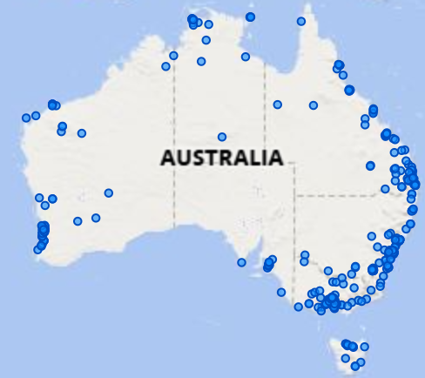

Audit Counts
From Tables 6 and 8, the OFSC conducted 698 safety audits in 2024-25 across 963 days on-site testing compliance. Arising from these audits:
• 3,474 Corrective Action Reports (CARs) were issued,
• 1,050 or 30 per cent of CARs were classified as Major CARs, and
• 2,424 or 70 per cent of CARs were classified as Minor CARs.
The number of OFSCs Audits and on-site audit days by year is provided in Table 6 below.

Table 6: Number of OFSC Audits and on-site audit days, 2020-21 to 2024-25
Financial Year | 2020-21 | 2021-22 | 2022-23 | 2023-24 | 2024-25
Audits | 489 | 462 | 553 | 566 | 698
Audit days on-site* | 665 | 665 | 780 | 797 | 963
*Rolling Systems Validation Audits (SVAs) have been excluded from the Audit days on site count, however, are counted in the total Audit counts

Audit Breakdown
On-site audits assess the WHS Management System (WHSMS) implementation of companies applying for Scheme accreditation. Once accredited, it is a requirement of maintaining accreditation to also undergo regular on-site audits. In late 2020 the OFSC introduced System Validation Audits (SVAs), which are a desktop audit process conducted prior to the initial pre-accreditation on-site audit to assist applicants in identifying areas of their WHSMS that do not currently meet Scheme standards. This allows applicants to be more prepared before their first on-site audit as they aim to achieve accreditation. This has decreased the number of on-site audits being conducted on applicants and created capacity for more on-site audits of accredited companies. Table 7 and Figure 5 below show the breakdown of OFSC audits by type for the last five financial years.

Table 7: Breakdown of OFSC Audits by Type, 2020-21 to 2024-25
Financial Year | 2020-21 | 2021-22 | 2022-23 | 2023-24 | 2024-25
Accredited Company Audits | 362 | 324 | 408 | 413 | 427
Non-accredited Company Audits | 123 | 72 | 58 | 64 | 112
System Validation Audits* | 4 | 66 | 87 | 89 | 159
*Rolling System Validation Audits (introduced in April 2024) are included in the System Validation Audit counts

Figure 5: Breakdown of OFSC Audits by Type, 2020-21 to 2024-25

Corrective Action Report Breakdown
Table 8 and Figure 6 below show the breakdown of CARs by type from 2020-21 financial year to 2024-25. Following a high total of CARs issued during 2020-21, the total number of CARs in 2022 dropped below 3,000, before climbing slightly to 3,474 for 2024-25. This is due to the impact of the SVAs that were introduced full-time in mid-2021 to assist companies applying for accreditation for the first time in implementing more robust WHSMS prior to their initial on-site audit. Companies are informed about areas of their WHSMS that do not meet Scheme requirements, but CARs are not issued.
From 2020-21 to 2024-25, the number of major CARs decreased by almost half for companies being accredited and by 82 per cent for companies in the process of accreditation. For reference, these groups are referred to in this report as accredited and non-accredited companies respectively.
Table 8: Breakdown of CARs by type, 2020-21 to 2024-25
Financial Year | 2020-21 | 2021-22 | 2022-23 | 2023-24 | 2024-25
Accredited Major | 737 | 496 | 649 | 390 | 367
Accredited Minor | 1,620 | 1,541 | 1,952 | 1,967 | 2,056
Non-accredited Major | 1,412 | 249 | 126 | 222 | 259
Non-accredited Minor | 914 | 318 | 427 | 509 | 792
Totals | 4,683 | 2,604 | 3,154 | 3,088 | 3,474

Figure 6: Major and Minor CARs – Accredited vs non-accredited companies, 2020-21 vs 2024-25

Audit Head Criteria Issue Rates
Table 9 below displays the five WHS Accreditation Scheme Audit Criteria, referred to as Head Criteria in this report, with the highest CAR issue rates (over 25 per cent).

Table 9: Highest five CAR issue rates by Audit Head Criteria (for all Audits), 2024-25
Head Criteria | CARs Issued | Times tested | Issue rate (%)
FP1 - Senior Management Commitment | 203 | 634 | 32
WH17 - Health & Safety Management System Audit | 130 | 460 | 28
H5 - Structural Alterations/ Temporary Support Structures | 163 | 581 | 28
WH14 - Health Surveillance and Exposure Monitoring | 172 | 643 | 27
WH3 - Legal Requirement | 112 | 433 | 26
Note: Minimum 20 subcriteria tested.
Table 10 below displays the five head criteria with the largest improvement in CAR issue rates between 2023-24 and 2024-25.

Table 10: Most improved Audit Head Criteria (for all Audits), 2023-24 vs 2024-25
Head Criteria | Issue rate 2023-24 | Issue rate 2024-25 | Change %
H4 - Asbestos | 19% | 1% | -18%
H6 - Confined Space | 14% | 1% | -13%
WH17 - Health & Safety Management System Audit | 40% | 28% | -12%
WH15 - Incident Investigation and Corrective Action | 29% | 19% | -10%
FP1 - Senior Management Commitment | 39% | 32% | -7%
Note: Minimum 20 subcriteria tested.

Audit Subcriteria Issue Rates
Tables 11 and 12 show the subcriteria CAR issue rates for audits conducted during the
2024-25 financial year, broken down into applicants who are not accredited but have undergone on-site audits in the process of applying for accreditation, and Scheme accredited builders respectively. Subcriteria reviewed less than 20 times have been excluded.
FP1.2, which requires a documented process ensuring WHS reports are regularly reviewed by senior management, has the highest 2024-25 CAR issue rate for non-accredited companies, with an issue rate of 42 per cent, up from 41 per cent in 2023-24.

Table 11: Ten Highest CAR Issue Rates by Audit Subcriteria for Non-accredited companies applying for Scheme accreditation, 2024-25
Subcriteria | CARs issued | Times tested | Issue rate %
FP1.2 There is a documented process to ensure WHS reports are produced that monitor performance against the WHS objectives and targets defined by the organisation; are regularly reviewed by senior management and are communicated to site management. | 30 | 71 | 42%
FP1.4 There is a documented process that ensures senior managers regularly visit the site and discuss WHS issues with site management and workers. | 30 | 72 | 42%
H7.6 The system ensures that the excavation is regularly inspected by a competent person to monitor the effectiveness of controls in accordance with the drawing/plan/permit. | 9 | 23 | 39%
WH13.4 There is a documented process to ensure designated emergency personnel for the project have been inducted in the site-specific emergency procedures/plans; and have obtained any qualification or formal training defined by the company as required to fulfill the role. | 25 | 71 | 35%
WH17.3 There is a documented process to ensure that formally trained personnel undertake audits in accordance with the schedule. | 25 | 72 | 35%
H16.9 The system ensures there is an inspection program that is specific to the needs of the type of mobile plant, taking into account regulatory inspections and registration, manufacturers’ inspection requirements; pre-start inspections; and commissioning prior to use on site. | 21 | 61 | 34%
FP1.3 There is a documented process to ensure senior managers, site managers and supervisors are trained in WHS obligations/due diligence, and the company’s WHS management system requirements relevant to their role. | 24 | 71 | 34%
FP2.3 There is a documented process to ensure residual buildability hazards identified in FP2.1 and FP2.2 are transferred and addressed in the project specific risk assessment process. | 24 | 71 | 34%
WH14.3 There is a documented process to ensure that worker health surveillance/monitoring is carried out in accordance with identified health hazards; is carried out in accordance with relevant legislation, codes of practice and Australian standards; and includes a process for management and communication of health monitoring results and records. | 24 | 71 | 34%
H1.3 Safe systems of work have been developed to ensure fall prevention systems/structures are verified as installed in accordance with the manufacturers’ instructions and relevant legislation, codes of practice and Australian standards; and subject to regular documented inspection as per the relevant legislation, codes of practice and Australian standards. | 12 | 36 | 33%
Note: Issue rates are rounded.
H5.6, which requires temporary structures to be designed and installed by competent people has the highest issue rate CAR for Scheme accredited companies with an issue rate of 49 per cent, down from 50 per cent in 2023-24.

Table 12: Ten Highest CAR Issue Rates by Audit Subcriteria, accredited companies,
2024-25
Subcriteria | CARs issued | Times tested | Issue rate %
H5.6 The system ensures that structural support systems and temporary structures are installed by a competent person and verified as correctly installed prior to use in accordance with relevant legislation, codes of practice and Australian standards manufacturers’ requirements; or where applicable the drawing/plan. | 36 | 74 | 49%
WH3.1 There is a documented process to ensure all health and safety legislation, codes of practice and Australian standards are identified relevant to the company operations and the project/site activities. | 31 | 73 | 42%
FP3.1 There is a documented process for the establishment of WHS consultation, cooperation and coordination arrangements, including agreement on the establishment of consultation arrangements with workers on site, consultation with workers or their representatives when WHS issues arise; a program to ensure regular meetings with minutes of the meetings available to all workers, and training for health and safety representatives/WHS committee members where requested/required. | 34 | 81 | 42%
H5.4 The system ensures that a scaffold plan has been developed by a qualified person; and changes to the installation design are authorised and signed off by a qualified person or a risk assessment has been conducted to determine the need for a Scaffold Plan. | 30 | 72 | 42%
H15.2 The system ensures there is a Traffic Management Plan prepared by a qualified and licensed person that is in accordance with the relevant legislation, codes of practice, Australian standards, or other requirements; includes location specific traffic control plans; details the methodology for implementing and dismantling traffic control devices; and is approved as required by the relevant authority prior to implementation. | 40 | 100 | 40%
H5.3 The system ensures that structural support systems (including formwork, falsework, shoring, panel bracing, edge protection, propping and other structural support systems) have been designed by a qualified designer, detailed on up-to-date drawings/plans and changes to the design or installed system are authorised and signed off by a qualified designer. | 16 | 40 | 40%
WH3.3 There is a documented process to ensure changes to health and safety legislation, codes of practice and Australian standards relevant to the company and project, are reviewed and processes updated as required. | 29 | 74 | 39%
H5.7 The system ensures that structural support systems and temporary structures are regularly inspected to monitor the effectiveness of the system/structure in accordance with relevant legislation, codes of practice and Australian standards; manufacturer’s requirements or where applicable the drawing/plan. | 28 | 72 | 39%
WH13.4 There is a documented process to ensure designated emergency personnel for the project have been inducted in the site-specific emergency procedures/plans; and have obtained any qualification or formal training defined by the company as required to fulfill the role | 30 | 79 | 38%
H15.3 The system ensures that traffic management is implemented in accordance with the Traffic Management Plan. | 37 | 100 | 37%
Note: Issue rates are rounded.
Table 13 below shows the trend over the last five years for the subcriteria with the five highest CAR Rates for 2024-25 for audits on accredited companies.
The CAR issue rates for four of the five subcriteria with the highest issue rates on accredited company audits in 2024-25 have trended up over the last five years. Only one (FP3.1) has trended down.

Table 13: Performance of Subcriteria with the five highest 2024-25 issue rates (CARs) for accredited companies, 2020-21 to 2024-25
Subcriteria | Issue Rates as a percentage
Subcriteria | 2020-21 | 2021-22 | 2022-23 | 2023-24 | 2024-25
H5.6 The system ensures that structural support systems and temporary structures are installed by a competent person and verified as correctly installed prior to use in accordance with relevant legislation, codes of practice and Australian standards, manufacturers’ requirements or where applicable, the drawing/plan. | 46% | 35% | 44% | 50% | 49%
WH3.1 There is a documented process to ensure all health and safety legislation, codes of practice and Australian standards are identified relevant to the company operations and the project/site activities. | 38% | 47% | 35% | 35% | 42%
FP3.1 There is a documented process for the establishment of WHS consultation, cooperation and coordination arrangements, including agreement on the establishment of consultation arrangements with workers on site, consultation with workers or their representatives when WHS issues arise, a program to ensure regular meetings with minutes of the meetings available to all workers and training for health and safety representatives/WHS committee members where requested/required. | 44% | 46% | 56% | 60% | 42%
H5.4 The system ensures that a scaffold plan has been developed by a qualified person; and changes to the installation design are authorised and signed off by a qualified person or a risk assessment has been conducted to determine the need for a Scaffold Plan. | 39% | 41% | 45% | 33% | 42%
H15.2 The system ensures there is a Traffic Management Plan prepared by a qualified and licensed person that is in accordance with the relevant legislation, codes of practice, Australian standards, or other requirements, includes location specific traffic control plans, details the methodology for implementing and dismantling traffic control devices and is approved as required by the relevant authority prior to implementation. | 38% | 29% | 37% | 37% | 40%

DATA HIGHLIGHTS
- Audit activity increased significantly, with a 23 per cent increase undertaken in the previous financial year, reflecting both higher accreditation volumes and a continued focus on monitoring accredited companies.
- Major CARs have fallen sharply over the five-year period and almost halving for accredited companies, declining 80 per cent for non-accredited companies while total CARs have stabilised.
- Audit results continued to highlight persistent challenges in structural support systems, traffic management, and ensuring relevant WHS laws and codes are identified and reflected in WHS systems, while issue rates improved across several high-risk criteria, including, asbestos management and incident investigation.
- Overall, the audit program continued to mature, with improved applicant preparedness and more efficient use of on-site audit effort supporting stronger WHS management system performance across the Scheme.

Scheme Reporting

Fatalities
In 2024, three fatal incidents were reported on Scheme accredited companies’ building sites. Of the three fatalities, one related to machinery and fixed plant, and the other two related to materials, substances, or agencies of any kind. Comparisons between OFSC fatalities and the whole of the construction industry for the last five years are in Table 14 below.

Table 14: OFSC Fatalities vs Industry fatalities by calendar year, 2020-24
Financial Year | 2020 | 2021 | 2022 | 2023 | 2024
Scheme Fatalities | 4 | 4 | 4 | 7 | 3
Total Industry Fatalities* | 36 | 25 | 27 | 41 | 30
* The total industry fatalities from Safe Work Australia (SWA) are only available by calendar year.

Fatality Frequency Rates
Table 19 below shows that the fatality frequency rate (FFR) per 1 million hours worked for Scheme accredited companies from 2020-21 to 2024-25.
DATA HIGHLIGHTS

The overall Fatality Frequency Rate (FFR) for 2024-25 of 0.61 is down over 40 per cent from 1.02 in the five years from 2020-21, and down 7.4 per cent from 0.66 in 2023-24.

Table 19: Fatality Frequency Rates (per 100,000,000 hours worked), 2020-21 to 2024-25
Financial Year | 2020-21 | 2021-22 | 2022-23 | 2023-24 | 2024-25
Fatality Frequency Rate (FFR) | 1.02 | 1.00 | 1.35 | 0.66 | 0.61
* One biannual data submission was excluded from this period due to data issues

Injury Frequency Rates
The Total Recordable Injury Frequency Rate (TRIFR) for Scheme accredited companies is calculated by combining Lost Time Injury Frequency (LTIFR) and Medically Treated Injury Frequency Rate (MTIFR) and the rates from 2020-21 to 2024-25 are shown in Table 15 and Figure 7 below.

DATA HIGHLIGHTS

- The TRIFR for 2024-25 of 6.17 is down 13.8 per cent from 7.16 in 2023-24, and down 14 per cent from 7.17 in the five years from 2020-21.
- This overall decrease is driven by the 15.4 per cent decrease in MTIFR from 2020-21 to 2024-25.

Table 15: Overall Injury Frequency Rates, 2020-21 to 2024-25
 | 2020-21 | 2021-22 | 2022-23 | 2023-24 | 2024-25*
LTIFR | 1.55 | 1.42 | 1.30 | 1.70 | 1.42
MTIFR | 5.62 | 5.28 | 4.75 | 5.45 | 4.76
TRIFR | 7.17 | 6.70 | 6.05 | 7.16 | 6.17
From the 2023 Annual Data Report onwards, all combined Injury Frequency Rates include Civil, Commercial and Residential construction.
* One biannual data submission was excluded from this period due to data issues
Figure 7: Injury Frequency Rates, 2020-21 vs 2024-25

Lost Time Injuries
Table 16 and Figure 8 below show the LTIFR for Scheme accredited companies, by construction type and overall.
DATA HIGHLIGHTS

The overall for 2024-25 of 1.42 is down 8.9 per cent from 1.55 in the five years from 2020-21, and down 16.9 per cent from 1.70 in 2023-24.

Table 16: LTIFR by Construction Type, 2020-21 to 2024-25
 | 2020-21 | 2021-22 | 2022-23 | 2023-24 | 2024-25*
Civil Construction | 0.79 | 0.84 | 0.72 | 1.00 | 0.79
Commercial Construction | 2.41 | 2.15 | 2.25 | 2.81 | 2.27
Residential Construction | 2.74 | 2.88 | 1.70 | 1.70 | 2.42
Overall LTIFR | 1.55 | 1.42 | 1.30 | 1.70 | 1.42
All combined Injury Frequency Rates include Civil, Commercial and Residential construction
* One biannual data submission was excluded from this period due to data issues

Figure 8: LTIFR for civil, commercial and residential construction, 2020-21 vs 2024-25

Medically Treated Injuries
Table 17 and Figure 9 below show the MTIFR for Scheme accredited companies, by construction type and overall.
DATA HIGHLIGHTS

- The MTIFR for 2024-25 of 4.76 is down 15.3 per cent from 5.62 in the five years from 2020-21 and down 12.8 per cent from 5.45 in 2023-24.
- This decrease is driven by the over 20 per cent decrease in the civil construction MTIFR between 2020-21 and 2024-25, and a 14 per cent decrease in the residential MTIFR over the same period.

Table 17: MTIFR by Construction Type, 2020-21 to 2024-25
 | 2020-21 | 2021-22 | 2022-23 | 2023-24 | 2024-25*
Civil Construction | 2.95 | 2.62 | 1.99 | 2.83 | 2.35
Commercial Construction | 8.65 | 8.77 | 9.01 | 8.75 | 8.10
Residential Construction | 9.13 | 9.44 | 9.40 | 13.79 | 7.86
Overall MTIFR | 5.62 | 5.28 | 4.75 | 5.45 | 4.76
From the 2023 Annual Data Report onwards, all combined Injury Frequency Rates include Civil, Commercial and Residential construction
* One biannual data submission was excluded from this period due to data issues

Figure 9: MTIFR for civil, commercial and residential construction, 2020-21 vs 2024-25

Total Reported Injuries
Table 18 and Figure 10 below show the TRIFR for Scheme accredited companies, by construction type and overall.
DATA HIGHLIGHTS

- The overall TRIFR for Commercial Construction in 2024-25 of 10.38 is down 6.2 per cent from 11.06 in the five years from 2020-21 and down 10.3 per cent from 11.57 in 2023-24.
- This decrease is driven by the over 16 per cent decrease in the civil construction TRIFR between 2020-21 and 2024-25, and a 13 per cent decrease in the residential TRIFR over the same period.

Table 18: TRIFR by Construction Type, 2020-21 to 2024-25
 | 2020-21 | 2021-22 | 2022-23 | 2023-24 | 2024-25*
Civil Construction | 3.74 | 3.46 | 2.70 | 3.83 | 3.14
Commercial Construction | 11.06 | 10.92 | 11.26 | 11.57 | 10.38
Residential Construction | 11.87 | 12.32 | 11.10 | 15.49 | 10.28
Overall TRIFR | 7.17 | 6.70 | 6.05 | 7.16 | 6.17
From the 2023 Annual Data Report onwards, all combined Injury Frequency Rates include Civil, Commercial and Residential construction
* One biannual data submission was excluded from this period due to data issues

Figure 10: TRIFR for civil, commercial and residential construction, 2020-21 vs 2024-25

Nature of Injuries
Table 20 and Figure 11 below show the breakdown of injuries from the 2024-25 financial year reported to the OFSC by their nature of injury.
DATA HIGHLIGHTS

- Wounds, lacerations, amputations and internal organ damage represent just under 43 per cent of the injuries reported in 2024-25.
- Traumatic joint/ligament & muscle/tendon injuries represent approximately 22 per cent each of injuries reported.

Table 20: Breakdown of injuries reported to the OFSC by nature of injury, 2024-25 *
Nature of Injury | Occurrences | Percentage of all injuries reported
Wounds, lacerations, amputations and internal organ damage | 435 | 42.7%
Traumatic joint/ligament and muscle/tendon injuries | 227 | 22.3%
Fractures | 181 | 17.8%
Other injuries | 134 | 13.2%
Injury to nerves and spinal cord | 11 | 1.1%
Burns | 10 | 1.0%
Diseases and conditions | 7 | 0.7%
Intracranial injuries | 7 | 0.7%
Other injuries | 6 | 0.6%
*Only work-related fatalities, LTIs and MTIs with completed reports are included in this table. Incidents with blank nature of injury have been excluded from the percentage of all injuries.
Figure 11: Breakdown of injuries reported to the OFSC by nature of injury, 2024-25

Mechanism of Injuries
Table 21 and Figure 12 below show the breakdown of injuries from the 2024-25 financial year reported to the OFSC by their mechanism of injury.
DATA HIGHLIGHTS

- Being hit by moving objects represent just over 31 per cent of the injuries reported in 2024-25.
  - Hitting objects with part of the body represent approximately 24 per cent of injuries reported.

Table 21: Breakdown of injuries reported to the OFSC by mechanism of injury, 2024-25 *
Mechanism of Injury | Occurrences | Percentage of all injuries reported
Being hit by moving objects | 317 | 31.4%
Hitting objects with part of the body | 240 | 23.7%
Falls, trips and slips of a person | 231 | 22.8%
Body stressing | 160 | 15.8%
Heat, electricity and other environmental factors | 23 | 2.3%
Vehicle incidents and other | 18 | 1.8%
Chemical and other substances | 12 | 1.2%
Biological factors | 5 | 0.5%
Mental stress | 3 | 0.3%
Sound and pressure | 2 | 0.2%
*Only work-related fatalities, LTIs and MTIs with completed reports are included in this table. Incidents with blank mechanism of injury have been excluded from the percentage of all injuries.
Figure 12: Top 5 mechanism of injury categories, 2024-25

Injury Rates Over Time
Table 22 and Figure 13 below show an analysis of LTIFR of accredited companies measured at three-year intervals over time of accreditation in comparison to their LTIFR when first accredited.
DATA HIGHLIGHTS

• After three years of accreditation, 43 per cent of companies reduced their LTIFR by an average of 77 per cent.
• Αfter six years this increased to 56 per cent of companies having reduced their LTIFR by an average of 88 per cent.
• Αfter nine years, 48 per cent of companies had reduced their LTIFR by an average of 92 per cent.

Table 22: Average LTIFR change for accredited companies over time of accreditation (3-15 years)
 | Years Accredited under the Scheme
 | 3 years | 6 years | 9 years | 12 years | 15 years
Accredited Companies with Improved LTIFR | 43% | 56% | 64% | 74% | 72%
Average Improvement to LTIFR | 77% | 88% | 92% | 90% | 84%
*Data to June 30, 2025
Figure 13: Average LTIFR change for accredited companies over time of accreditation

Workers Compensation Premium Rates Over Time
Table 23 and Figure 14 below show the changes to Scheme accredited companies Workers’ compensation premium rates (WCPR) over time of accreditation, measured at three-year intervals in comparison to their WCPR when first accredited.
DATA HIGHLIGHTS

• After three years of accreditation, 56 per cent of companies reduced their WCPR by an average of 33 per cent.
• After six years this has increased to 58 per cent of companies having reduced their WCPR by an average of 37 per cent.
• After nine years, 66 per cent of companies reduced their WCPR by an average of 43 per cent.

Table 23: Average Worker’s Compensation Premium Rate (WCPR) change for accredited companies over time of accreditation (3-15 years)
 | Years Accredited under the Scheme
 | 3 years | 6 years | 9 years | 12 years | 15 years
Accredited Companies with Improved WCPR | 56% | 58% | 66% | 70% | 74%
Average Improvement to WCPR | 33% | 37% | 43% | 44% | 43%
*Data to June 30, 2025
Figure 14: Average WCPR change for accredited companies over time of accreditation

DATA HIGHLIGHTS

- Scheme reporting shows continued improvement in safety outcomes among accredited companies, with fatalities declining from the previous year and injury frequency rates trending downward across most measures.
- Overall TRIFR and MTIFR both fell, supported by reductions in commercial and residential injury rates, while civil construction remained the low-risk sector.
- Most common injuries involved lacerations, fractures, and joint/muscle injuries.
- Leading causes of incidents were being hit by moving objects, striking objects, and slips, trips and falls.
- Based on longer-term analysis, the longer companies remain accredited, the more their LTIFR and worker’s compensation premium rates improve, demonstrating sustained gains in WHS performance over time and reinforcing the Scheme’s ongoing impact on safety outcomes.

FSC Annual Census

Table 24: Summary of OFSC Census results for key questions, 2020-24
Companies stating that… | Percentage by year
Companies stating that… | 2020 | 2021 | 2022 | 2023 | 2024
The Scheme has improved safety practices in their company | 80% | 82% | 82% | 69% | 73%
They have achieved better safety performance by becoming accredited | 93% | 99% | 99% | 96% | 96%
The OFSC has contributed to improving overall safety in the Building and Construction industry | 95% | 97% | 98% | 96% | 88%
Accreditation represents value for money
Overall | 87% | 87% | 95% | 94% | 87%
Newly accredited companies | 97% | 100% | 89% | 100% | 97%
Recommend Scheme accreditation to non-accredited companies | 87% | 89% | 87% | 83% | 75%
They are satisfied with the service provided by the OFSC overall | 96% | 98% | 97% | 97% | 91%
OFSC staff are knowledgeable | 97% | 99% | 95% | 99% | 97%
OFSC staff are courteous | 99% | 99% | 98% | 100% | 98%
OFSC staff respond promptly to queries | 93% | 94% | 93% | 93% | 89%
OFSC contact people are accessible | 95% | 98% | 94% | 96% | 93%
OFSC staff clearly communicate responses | 96% | 98% | 95% | 97% | 94%
The guidance material provided by the OFSC is readily accessible | 97% | 98% | 95% | 98% | 97%
The guidance material provided by the OFSC is clear and easy to understand | 88% | 89% | 91% | 98% | 91%
The FSOs that have conducted audits were professional | 95% | 97% | 96% | 96% | 97%
The FSOs that have conducted audits were knowledgeable | 96% | 98% | 95% | 97% | 96%
They have undertaken a Scheme project | 68% | 67% | 72% | 69% | 60%
Survey response rate | 61% | 63% | 52% | 61% | 45%
Total number of responses | 241 | 265 | 216 | 266 | 201*
* As the 2025 OFSC Census was conducted in November 2025 (within the 2025–26 financial year), only Census results up to 2024 are presented in this table.
DATA HIGHLIGHTS

- Perceived safety improvement rebounded in 2024 to 73 per cent, after dropping to 69 per cent in 2023.
- Safety performance benefits remain consistently high, with 96 per cent to 99 per cent each year saying accreditation improved their safety performance.
- Industry – side safety impact softened in 2024 to 88 per cent, down from 95-98 per cent in early years.
- Value for money rating stable, with 87 per cent overall in 2024, accredited companies remain highly positive (97 Per cent).
- Willingness to recommend accreditation has eased over time (down to 75 per cent in 2024).
- Service satisfaction remains strong, with 91 per cent satisfied overall and staff viewed as knowledgeable (97 per cent) and courteous (98 Per cent).
- Engagement with Scheme projects has declined, with 60 per cent of respondents undertaking a Scheme project in 2024.
- Survey participation fell, with a 45 per cent response rate in 2024 (201 responses).
- Census results show that companies continue to see strong safety benefits from accreditation, although perceptions of broader industry impact and value have softened. Satisfaction with OFSC services remains high overall, particularly regarding staff professionalism and communication.

Education

In addition to administering the Work Health and Safety Accreditation Scheme, the OFSC also has an educative function. The OFSC produces a range of materials including webinars, case studies, factsheets and other guidance to encourage higher safety standards and promote innovation and best practice.
A particular focus for the OFSC in 2024-25 was on the education and engagement of residential builders tendering for projects funded by Housing Australia under the Housing Australia Future Fund, and First Nations builders interested in accessing Government-funded work.
With all of its educational work, the OFSC aims to be data driven, focusing on trends and areas of significant risk and concern, and supporting organisational priorities. Educational resources are informed by Scheme audit outcomes, analysis of Scheme data, feedback from accredited companies, and engagement with industry stakeholders.
Educational resources and guidance for the building and construction industry are available through the OFSC website and social media.

Resources for Residential Builders
To support the delivery of the Government’s investment in social and affordable housing, residential builders tendering for Housing Australia funded building work can access the OFSC’s fast-track accreditation process, allowing them to gain accreditation in a little as 5 months, as well as receiving up to 40 hours of assistance from a dedicated FSO during the accreditation process. As well as continuing the fast-track process for eligible residential builders tendering for this work during 2024-25, the OFSC released a number of resources targeted at residential builders.
WHS Accreditation Scheme Audit Criteria: Residential Builder’s Guide
In October 2024 the OFSC published the WHS Accreditation Scheme Audit Criteria: Residential Builders’ Guide to provide detailed guidance to residential builders applying for Scheme accreditation to safely deliver social and affordable housing through the Commonwealth’s Housing Australia Future Fund Facility (HAFFF) and the National Housing Accord Facility (NHAF).

The guide was developed by the OFSC in consultation with industry, emphasising the criteria that is relevant to residential builders and highlighting criteria where builders may need additional assistance. The guide provides practical information on documented processes, implementation and targeted examples of what will and won’t meet Scheme requirements.
Residential Builder website updates to fsc.gov.au
During the reporting period, the OFSC developed and published dedicated residential builder webpages on fsc.gov.au. The webpages were designed to improve accessibility of information for residential builders seeking accreditation under the Scheme.
The webpages provide guidance on:
- The fast-track accreditation process and assistance available for residential builders.
- Which projects are covered by the Scheme.
- Exemptions from the Scheme.
- The benefits of being accredited.
BowdenCorp Video Case Study
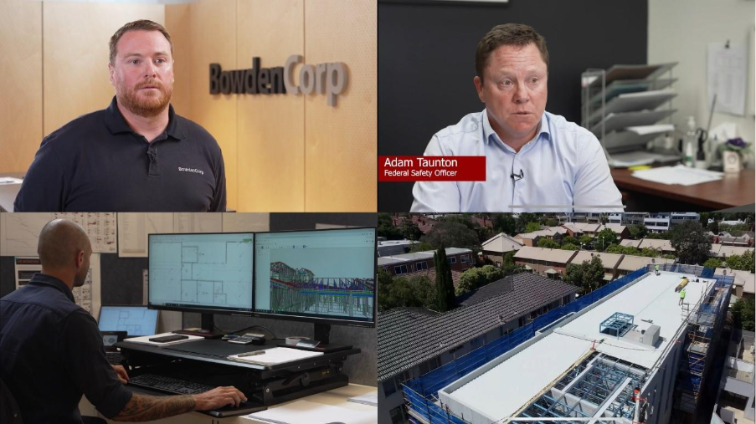
In March 2025, the OFSC published a new video case study highlighting the experience of a recently accredited residential builder, BowdenCorp. Based in Victoria, BowdenCorp participated in the residential fast-track accreditation process and were granted accreditation in September 2024.
The video outlines how BowdenCorp worked with the OFSC to achieved accreditation under the Scheme in less than half the usual timeframe whilst uplifting their safety on site. It demonstrates how the targeted support provided by the OFSC as part of the fast-track process can assist residential builders seeking to tender for, and deliver, Australian Government funded housing projects.
View the resource here.

Safe Work Month 2024
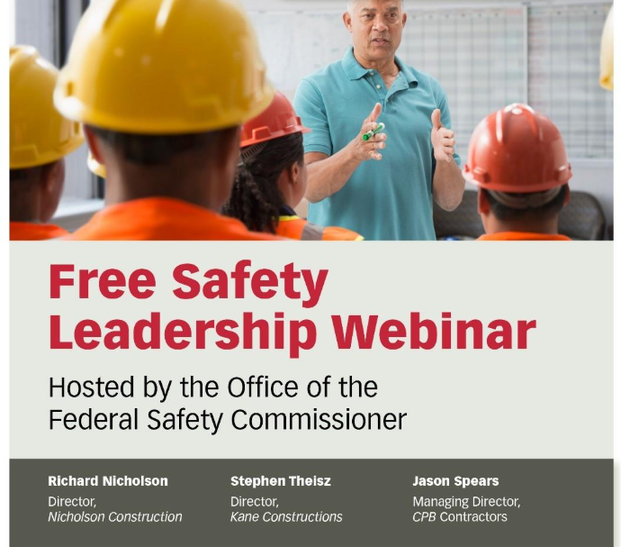
The OFSC participates in Safe Work Australia’s National Safe Work Month campaign each October. In 2024, the OFSC focused on ‘safety leadership’ and highlighted senior managers from accredited companies who are driving positive safety culture.
In 2024, the ‘Senior Management Commitment’ audit criteria (FP1) was the worst performing with a36.3 per cent Corrective Action Report issue rate. The OFSC produced two different video resources for the 2024 campaign to support broad engagement across the industry.
The ‘Safety Leadership’ webinar featured senior executives from accredited companies including Richard Nicholson from Nicholson Construction, Stephen Theisz from Kane Constructions and Jason Spears from CPB Contractors in conversation with FSC David Denney.
View the resource here.

The OFSC also produced a short video with Michelle Nation from Seymour Whyte, Stephanie Graham from Lendlease, and Anna Flynn from Black Cat Civil on how they build a strong pro-safety culture in their organisations.

Scaffolding safety
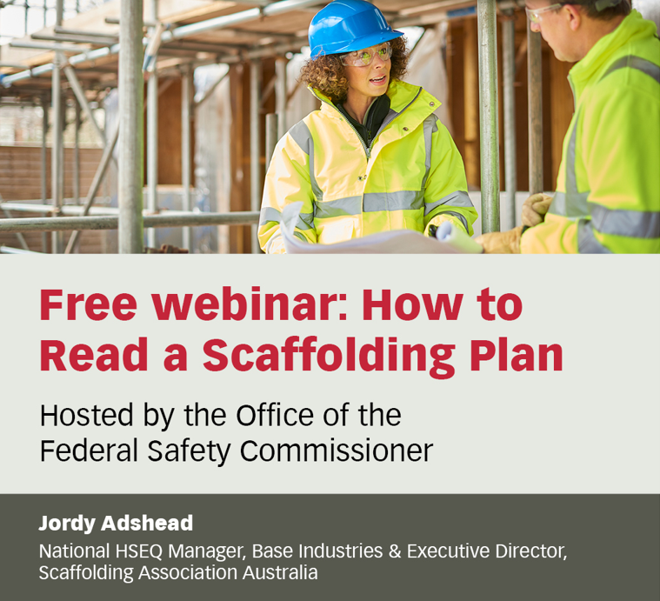
Scaffolding safety continues to be an area of ongoing risk across Scheme projects and in the broader industry. To support improved capability and compliance, the OFSC delivered a targeted educational webinar focusing on scaffold planning and design interpretation in February 2025. The topic of the webinar was determined by feedback from the OFSC’s scaffolding roundtables in 2023 and 2024.
View the resource here.

Engaging Traditional Owners

As part of its commitment to supporting Closing the Gap and improving access to the Work Health and Safety Accreditation Scheme, the OFSC launched a dedicated fast-track process for First Nations businesses in March 2025. FSC David Denney launched this new process in the OFSC’s ‘Engaging Traditional Owners’ webinar.
The webinar was designed to support First Nations companies in understanding and achieving accreditation under the Scheme. It provided information on the benefits of accreditation, the accreditation process, and how accreditation can support First Nations companies to participate in Australian Government funded- construction work. David was joined by Hayden Heta, Managing Director of accredited First Nations company Wamarra, who shared practical insights and experiences on his accreditation experience.
The OFSC partnered with Supply Nation to reach eligible construction companies for this webinar. A dedicated website page was also launched following the session.
View the resource here.

Podcast with Master Builders Australia
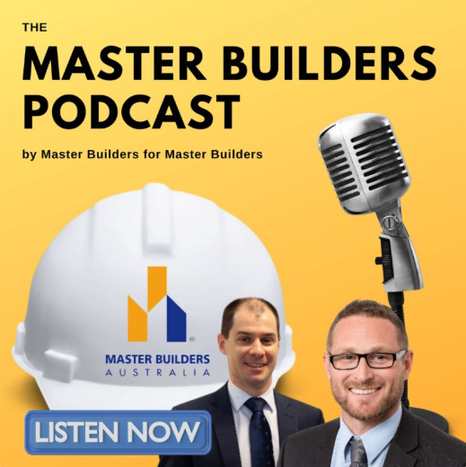
In May 2025, FSC David Denney participated in a podcast with Master Builders Australia. The podcast – a first for the OFSC – delved into the operations of the Scheme and the support provided by the OFSC for residential companies tendering for Housing Australia-funded work. The discussion also highlighted the benefits of accreditation, typical timeframes for residential builders progressing through the fast-track pathway, and improvements in safety performance observed among accredited companies.
Visit our website for more information and listen to the podcast here.

Data Source

The data presented in the 2024-25 Annual Data Report is accurate to 30 June 2025, or as otherwise indicated throughout the report, and has been sourced from the Scheme Tracking and Accreditation Reporting (STAR) - WHS Accreditation Scheme Audit Data Asset. This data asset contains WHS and Scheme related information:
• provided by accredited companies and collected by the Department of Employment and Workplace Relations,
• provided by FSO contracted by the department to carry out audits, and
• generated by the department.
This data is collected under the Federal Safety Commission Act (2022). Previous calendar year Annual Data Reports released by the OFSC until 2024 utilised data sourced from the System Tracking Organisation Reporting Mechanism (STORM) data asset. On 20 January 2025, the OFSC migrated data held within STORM to STAR. STAR has been used to derive the 2024-25 results, unless otherwise indicated.

Glossary

Accreditation – The certification by Federal Safety Commissioner of a builder's safety management system as meeting the requirements of the Scheme. This allows the builder to tender for Australian Government projects.
Accredited company – A construction company that has been accredited under the Scheme. This company may be accredited in its own right, or part of a joint accreditation.
Audit – Accredited Scheme companies are subject to an ongoing audit program, which involve periodic inspections of the Work, Health and Safety processes relevant to the construction they undertake.
Dangerous occurrence – A work-related occurrence on Scheme Projects where no person is injured, but could have been injured, resulting in serious personal injury, incapacity or death. Also commonly called a “near miss”.
Fatality – A work-related occurrence on any project where the accredited contractor is the head contractor that results directly or indirectly in the death of a person. Deaths due to natural causes that occur on the project site are reportable to the OFSC but are excluded from this report.
Lost Time Injury (LTI) – A work-related occurrence on a Scheme or a Non-Scheme Project where the project value is $4 million or more and the accredited contractor is the head contractor, that results in a permanent disability or time lost from work of one day shift or more.
Medically Treated Injury (MTI) – A work-related occurrence on a Scheme or a Non-Scheme Project where the project value is $4 million or more and the accredited contractor is the head contractor that results in the treatment by, or under the order of, a registered medical practitioner, or any injury that could be considered as being one that would normally be treated by a medical practitioner.
Injury frequency rate – Injury frequency rates are calculated by the number of incidents over a period divided by hours worked over the same period, multiplied by 1,000,000.
LTIFR (Lost Time Injury Frequency Rate) - The rate of occurrences of lost time injury that result in a permanent disability or time lost from work of one day shift or more in the period.
MTIFR (Medically Treated Injury Frequency Rate) - The rate of occurrences of medically treated injuries, which are defined as those of treatment by, or under the order of, a qualified medical practitioner, or any injury that could be considered as being one that would normally be treated by a medical practitioner.
TRIFR (Total Recordable Injury Frequency Rate) – The total number of Medically Treated Injuries, Lost Time Injuries and Fatalities. Fatalities are excluded from the calculation as they have a negligible effect on the frequency rates.
Indigenous owned business – An accredited company that identifies as being at least 50 per cent indigenous owned.
Joint accreditation – An accreditation that consists of two or more companies.
Joint ventures – A project managed by more than one accredited company.
Mechanism of incident classification
0. Falls, trips and slips of a person
1. Hitting objects with a part of the body
2. Being hit by moving objects
3. Sound and pressure
4. Body stressing
5. Heat, electricity and other environmental factors
6. Chemicals and other substances
7. Biological factors
8. Mental stress
9. Vehicle incidents and others
Nature of injury classification
A. Intracranial injuries
B. Fractures
C. Wounds, lacerations, amputations and internal organ damage
D. Burns
E. Injury to nerves and spinal cord
F. Traumatic joint/ligament and muscle/tendon injury
G. Other injuries
H. Diseases and conditions

Corrective Action Reports – Major and Minor
A Corrective Action Report (CAR) is a formal finding made by Federal Safety Officers (FSOs) during the auditing process to identify where companies need to take further action. An FSO raises a CAR when they determine that a certain aspect of the system being audited does not conform to the OFSC audit criteria. This assessment is based on their review of documentary evidence and observation of on-site activities. There are two levels of CARs that can be raised as a result of OFSC audits, major and minor non-conformances.
Scheme project – A construction project where an accredited company is the head contractor and has a value of $4m or more and
is directly funded by the Australian Government, OR
is indirectly funded by the Australian Government, AND
the value of the Australian Government contribution to the project is at least $6 million (including GST) and represents at least 50 per cent of the total construction project value OR
the Australian Government contribution to a project is $10 million (including GST) or more, irrespective of the proportion of Australian Government funding.

Non-scheme project – A construction project where the accredited company is the head contractor and has a value of $4 million or above but does not otherwise meet the Scheme project criteria above.

