


FSC ONLINE WHS Report Guide
June 2025
Work Health and Safety Accreditation Scheme



With the exception of the Commonwealth Coat of Arms, the Department’s logo, any material protected by a trade mark and where otherwise noted all material presented in this document is provided under a Creative Commons Attribution 4.0 Australia (https://creativecommons.org/licenses/by/4.0/)
The details of the relevant licence conditions are available on the Creative Commons website (accessible using the link provided above) as is the full legal code for the CC BY 4.0 AU licence (https://creativecommons.org/licenses/by/4.0/legalcode.en).
The document must be attributed as the (FSC Online WHS Report Guide).

Contents
OFSC Reporting Requirements 4
Getting Started 5
Submitting a Contract Declaration 9
Submitting a Scheme Biannual Report 15
Submitting an Incident Report 30
Definitions 46
Frequently asked questions 53

OFSC Reporting Requirements
As an accredited contractor under the Australian Government Building and Construction Work, Health, and Safety Scheme (the Scheme), you are required to submit the following reports via FSC Online during your accreditation. This user guide outlines the reports that are required, the timeframes they are required at and detailed guidance on what is required for the fields within each report.

Contract Declaration
A Contract Declaration must be submitted via FSC Online when an agreement is reached on a tender, or a contract is signed for a building project that is directly or indirectly funded by the Australian Government and meets the Scheme funding thresholds (Scheme projects).
Detailed guidance on the Contract Declaration can be found on page 9 of this guide.

Scheme Biannual Report
Scheme Biannual Reports must be submitted via FSC Online every six months with the following conditions:
- Reports are due on 14 February for the previous July to December six-month period, and 31 July for the previous January to June six-month period;
- The Scheme Biannual Report includes reporting on each individual Scheme Project the accredited contractor was undertaking during the six-month reporting period;
- All accredited contractors must submit a report, even if no Scheme Projects have been undertaken in the reporting period.
Detailed guidance on the Scheme Biannual Report can be found on page 15 of this guide.

OFSC Incident Report
There are four categories of Incident Report, each with specific requirements:
- Fatality - All fatalities on any projects where the accredited contractor is the head contractor
- Lost Time Injury (LTI) - All work-related incidents on a Scheme or Non-Scheme Project where the accredited contractor is the head contractor resulting in a LTI where the project value is $4 million or more
- Medically Treated Injury (MTI) - All work-related incidents on Scheme Projects where the accredited contractor is the head contractor resulting in an MTI
- Dangerous Occurrence - All work-related incidents on Scheme Projects where the accredited contractor is the head contractor resulting in a Dangerous Occurrence
Further detailed descriptions of each incident type and guidance on the OFSC Incident Report can be found on page 30 of this guide.

Getting Started
The reports required from companies accredited under the Work Health and Safety Accreditation Scheme (the Scheme) must be submitted and managed through FSC Online.

If you have not yet registered for an FSC Online user account, you can register through the FSC Online banner on the home page of www.fsc.gov.au.

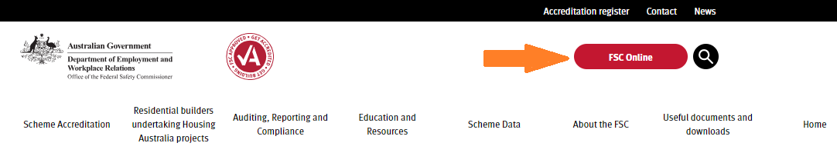

Obtaining myID and RAM access
The Department of Employment and Workplace Relations uses the Australian Government Digital ID System to verify users and keep personal information secure. You will need to use your Digital ID, such as myGovID, and Relationship Authorisation Manager (RAM) to access the FSC Online Portal.

- myID is the Australian Government's Digital ID app. myGovID provides a secure and convenient way to prove who you are when logging in to a range of government online services.
- RAM is an authorisation service that allows you to act on behalf of a business or entity online when linked with your myGovID. You will use your myGovID to log in to RAM.

Your myID will need to be authorised under the ABN of the company which employs you (i.e. the company seeking accreditation). Your employer’s Authorisation Administrator (or Principal Authority) will also need to authorise you for DEWR online services within the RAM system.





Delegating RAM Authorisations
The ATO’s RAM system initially requires either the Principal of a business (i.e. ABN holder) or a company director (ACN holder) to log into RAM and claim the entity’s ABN within RAM itself. In performing this initial step, the ABN/ACN holder will need a myID with a ‘Strong’ Identity strength. Once the ABN has been claimed in RAM, the ABN holder can then delegate this function to another authorised user, called an Authorisation Administrator in the RAM system.
The Principal Authority or the Authorisation Administrator can then authorise end-users within RAM, for the purpose of accessing FSC Online (including providing full or custom access to DEWR Online Services within RAM itself). Many businesses will already have an Authorisation Administrator set up. RAM authorisations are needed for all electronic financial reporting to the ATO, as such Authorisation Administrators will commonly work in financial reporting or legal governance teams, within an employing entity.
It is a matter for individual businesses to consider, how to best administer RAM authorisations within a business. Some ABN/ACN holders may wish to retain direct control over this function. Others, who do not have day to day responsibility for the administration of the business, may wish to appoint an Authorisation Administrator to attend to RAM authorisations in the normal course of their duties. The level of risk and appropriate risk mitigations, with regard to the delegation of RAM authorisations beyond the Principal Authority, needs to be considered by each entity on a case by case basis.
The following resources are available to assist with RAM authorisations:
Information for Principal Authorities (ABN/ACN holders): | Principal authority | Relationship Authorisation Manager
Setting up authorisations in RAM: | Set up authorisations | Relationship Authorisation Manager
Managing Authorisations for a business | Authorised users and administrators | Relationship Authorisation Manager
Frequently asked questions (DEWR online services) | Common questions and issues setting up your Digital ID (myID) - Department of Employment and Workplace Relations, Australian Government

FSC Online Registration
The first step is to register for FSC Online with your RAM authorised myID by logging in.

Existing FSC Online Users
If you are an existing user of FSC Online, who is accessing the new FSC Online for the first time, continue with the Redeem Invitation button below. Existing users will have received a unique code to link your new account to your old FSC Online profile. If this code has expired, please contact STARHelpdesk@dewr.gov.au to request a new code be issued.

New FSC Online Users
New users and new companies will need to be approved internally by the OFSC before access will be permitted. This process is initiated by logging in with your myID for the first time. If you are logging in as a new user under a new company seeking accreditation, your registration will need to be reviewed internally before you can access the portal. Upon completion of the OFSC’s review of your portal registration, and if approved, you will receive an email from the department containing a unique invitation code to assist with your next log-in.

New Users for Existing Accredited Companies
For existing accredited companies, new users can be added as company contacts to the company profile, using the ‘Contact Management’ feature contained in FSC Online. This can be performed by any existing FSC Online user employed by the company.

Existing FSC Online user for a new company seeking accreditation
As an existing FSC Online user you will already be able to log into FSC Online. If you seek to represent a new company seeking accreditation, a RAM authorisation under the new company’s ABN will enable you to log into FSC online under that company’s ABN. A log-in using a new ABN authorisation in RAM will create a new company profile in the portal for that ABN. Users with multiple ABN authorisations in RAM will be prompted to select which ABN they’d like to use during the myID log-in process.

Users with multiple RAM Authorisations against their myID
If you represent more than one company in dealings with the OFSC, a single RAM authorisation under any one of the companies you represent will provide access to the FSC Online Portal. If you have multiple RAM authorisations, you will be prompted to select the appropriate RAM authorisation prior to successful log-in.

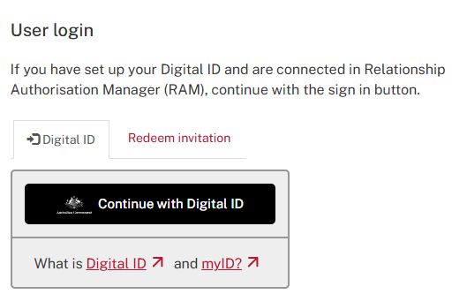

Navigating FSC Online
All FSC Online reports are displayed in sections, with each section containing fields that must be completed.

Mandatory fields
All fields marked with an asterisk* are mandatory and must be completed before a report can be submitted through FSC Online. For mandatory fields requiring a number you MUST enter either a number (not words) or 0 if your response is nil.

Question Marks
This question mark help icon can be hovered over by the user to provide helptext relating to the information required to complete that field.

Help and Guidance
Additional information, frequently asked questions, definitions of terms, and links to helpful Accreditation Scheme information can be found by clicking on the Help and Guidance section in FSC Online.



Further assistance can also be obtained by calling FSC Online Assist on 1800 652 500 or by contacting STARHelpdesk@dewr.gov.au in writing.

Submitting a Contract Declaration
A Contract Declaration must be submitted via FSC Online when an agreement is reached on a tender, or a contract is signed for a project that is directly or indirectly funded by the Australian Government that meets the Scheme thresholds. Projects that meet the following requirements are defined as Scheme Projects for the purposes of the Scheme:
Projects directly funded by the Australian Government:
Projects are considered to be directly funded when the Australian Government has responsibility for the project funding and development.
The Scheme applies to projects that are directly funded where the value of the building contract is $4 million or more (GST inclusive).
Some typical examples of directly funded projects are a new Medicare office, a Defence facility, or the refurbishment of Australian Government office accommodation.
Projects indirectly funded by the Australian Government:
Projects are considered to be indirectly funded when the Australian Government contributes funding to a third-party recipient, for example a State government, through mechanisms such as funding agreements, grants, or other programs. The following thresholds apply for indirect funding:
- a head contract under the project includes building work of $4 million or more (GST inclusive) AND
  - the value of the Australian Government contribution to the project is at least $6 million (including GST) and represents at least 50 per cent of the total funding; OR
  - the Australian Government contribution to a project is $10 million (including GST) or more, irrespective of the proportion of Australian Government funding.
Some typical examples of indirect funding are where the Australian Government provides funding to a state or territory government to build a new school, a hospital, or roads. Preconstruction agreements, such as pre-commitment leases, public private partnerships (PPPs), build-own-operate (BOO) and build-own-operate-transfer (BOOT) agreements also fall within the scope of the Scheme.
If you are unsure whether a project is a Scheme Project, please contact the FSC Assist Line on 1800 652 500 or email fscreporting@dewr.gov.au for advice.

The Contract Declaration is located in the Reporting Menu in FSC Online.

Step one – Contract Declarations



Step two – Click the New Contract Declaration button to open a new report. You can also Continue or View previously created Contract Declarations on this main screen page. You will also be able to delete Contract Declarations that have not yet been submitted to the OFSC if required. If you have a Contract Declaration that has been submitted to the OFSC that needs to be deleted, please contact the FSC Assist Line on 1800 652 500.

Step three – A pop-up window will appear requesting information on the value of the contact, and if the contract’s value is more than $4 million

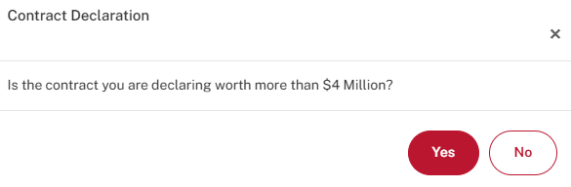
-If the user selects No: The user will be returned to the contract declaration page, and no further information will be required.
- If the user selects Yes: The user will proceed to the Contract Declaration form where they will be able to provide information relevant to the project.

Project Details

1.1 Project details

Project Name
Provide the project name as it was stated on the contract signed with the client. Please provide the whole project title with no acronyms.

Date building work commences (DD/MM/YYYY)
Provide the date that the building work commenced on this project in the format Date/Month/Year. If the building work has yet to commence, please provide an estimated start date. This field can be entered manually or using the date finder.

Building work end date (DD/MM/YYYY)
Provide the date the project’s building work will finish on the project in the format Date/Month/Year. If an exact date is not known, please provide an estimated end date. If this date changes throughout the life of the project, please contact the OFSC on 1800 652 500 so that the project record can be updated or update the date in the next Scheme Biannual Report. This field can be entered manually or using the date finder.

Site address and details

Please note, the ‘Add Site Address’ button must be clicked to add address details, and all required fields within this section must be completed. Clicking the “Add Site Address” icon will bring up a pop-up screen where you can provide and save the intended address of the contract’s project.
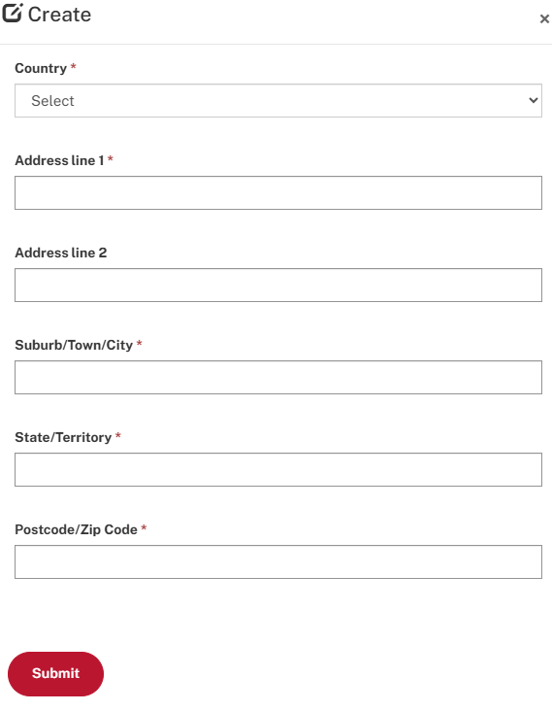
Provide the street address of the site(s) for the project. Please include the town/suburb, state, and postcode. Where there are multiple sites, please specify the addresses for all sites. Where an exact street address is not available, please provide details of the site locality (i.e. nearest main road). Select “Submit” to save the address and return to the main Contract Declaration page.

1.3 Construction type

Construction Type
Select the type of construction for the project. Only one type should be selected, so where a project involves more than one type, please select the type that covers the largest portion of the project that is being built by the accredited contractor.
- Civil or engineering construction – roads and bridges, railways, ports, water storage and supply, sewerage, telecommunications, pipelines, drainage, earthworks, heavy industry-related (refineries, pumping stations, mines, chemical plants, furnaces, steel mills, etc.).
- Commercial building – offices, shops, hotels, other business premises, industrial, social, and institutional, and mixed-use apartments (combined commercial and apartment developments).
- Residential building – detached houses, attached dwellings (e.g. terrace, row, or town houses), villa homes, home units, residential flats, duplexes, aged care facilities, apartments, and ancillary buildings to the above, but excluding mixed-use developments (combined commercial and apartment developments). Work such as installation of virtual power plant using solar panels on residential buildings, a contract requiring only the demolition of a residential building, or a contract for the remediation or preparation of a site that will later house a residential building under a separate contract is not considered residential building work.

Project description/type of work being undertaken (number and type of dwellings, stadium construction, road works etc)
Provide a description of the project including the type of work being undertaken. For example:
- Extend and widen pavement and shoulder and improve intersections along 10 kilometre section of XYZ Road.
- Extension to existing building, fit out and refurbishment of existing 3 floors.
- Demolition and excavation of site, construction of 8 storey building with underground and ground level car park.

1.4 High risk construction work hazard/s
Please indicate any high risk construction work hazard work being carried out on this project.
If applicable, tick the corresponding box/es if any of the work performed on this project falls within any of the high risk construction categories listed.
o Working at Heights | o Chemical, Fuel or Refrigerant Lines
o Telecommunications Towers | o Electrical
o Demolition | o Contaminated / Flammable Atmosphere
o Asbestos | o Tilt-up / Precast Concrete
o Structural Alterations / Temporary Support | o Traffic
o Confined Space | o Mobile Plant
o Excavation | o Artificial Extremes of Temperature
o Tunnels | o Diving
o Explosives  o Pressurised Gas | o Construction Work In, Over or Adjacent to Water / Liquids Where Risk of Drowning

Are there any unique or interesting aspects or challenges to the project?
The OFSC publishes case studies and news articles on www.fsc.gov.au and is always interested in hearing about unique challenges and how accredited contractors overcame them. If you are interested in sharing any onsite experiences, with a view to improving safety outcomes across the building and construction industry, please contact fsconline@dewr.gov.au to discuss.

2. Contract Information

2.1 Commonwealth Agency Information

Which Commonwealth agency is providing the funding
Provide the name of the Commonwealth Government department or agency that provided the funding for this project. If the department or agency is not in the list above, please contact the OFSC on 1800 652 500 or at fsconline@dewr.gov.au.

Amount of Commonwealth funding
Provide the amount of Commonwealth funding awarded to your company for this project.

2.2 Commonwealth Agency Contact Person Details
Please provide details of the person at the Commonwealth agency listed above the OFSC can contact regarding the project:
- Title
- First Name
- Last Name
- Position
- Company/Organisation
- Phone
- Mobile
- Email

2.3 Contract Details

Contract value (inclusive of GST)
Please Provide the total dollar value of the whole project. This includes the total amount of Commonwealth funding awarded to you and other contractors, as well as funding from other sources.

Date contract signed (DD/MM/YYYY)
Please provide the date that the contract was signed in the format Date/Month/Year.

2.4 Contracting Entity Details
Please provide additional information on the contracting entity that issued the contract to the accredited company or joint venture by selecting of the following options:
- Agency/Client or;
- Community Housing Provider
Selecting either option listed above will prompt a dropdown selection box allowing the user to elect the specific entity which issued the contract.

2.5 Contracting Entity Contact Details
Please provide additional information relating to the person who can be contacted by the OFSC at the Contracting Entity including the following details:
- Title
- First Name
- Last Name
- Position
- Company/Organisation
- Phone (Please provide a telephone number)
- Mobile (Please provide a telephone number)
- Email

4. Submission
Please click the "Submit" button to submit your report.


Validation Errors
Before submission is permitted, you must ensure that all the required fields have been completed and saved on each page before progressing to the next page.

Before clicking “Submit,” please make sure that all of the pages of the Contract Declaration have been correctly completed which is indicated by a tick corresponding to the section of the declaration.
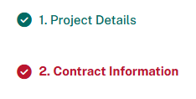
If you do see that a section has an “X” next to it, please click on that section and ensure that all of the required information has been provided and select “Save” before returning to the final page.
When the errors in the Contract Declaration have been resolved, users can click on the “Submit” button.
Please contact STARHelpdesk@dewr.gov.au for assistance with any persistent technical issues which are stopping submission.

Submitting a Scheme Biannual Report
Scheme Biannual Reports must be submitted via FSC Online every six months with the following conditions:
- Reports are due on 14 February for the previous July to December six-month period, and 31 July for the previous January to June six-month period;
- The Scheme Biannual Report includes reporting on each individual Scheme Project the accredited contractor was undertaking during the six-month reporting period;
- When a Scheme Project ends, this must be reported on the next Scheme Biannual Report. If the project has been completed during the Scheme Biannual reporting period, the information provided should cover the part of the six month reporting period it was active for. This is a change from previous requirements;
- All accredited contractors must submit a report, even if no Scheme Projects have been undertaken in the reporting period.
IMPORTANT!
Please note that all contract declarations and reportable incidents which arose within a respective reporting period should be lodged with the OFSC via the FSC Online portal before you commence your scheme biannual report.

Step One – Scheme Biannual Reports
The Scheme Biannual Report is located on the top navigation menu in FSC Online.



Step Two – Creating New Scheme Biannual Reports

Click the Create New Scheme Biannual Report button to open a new report. You can also Continue or View previously created Scheme Biannual Reports from this screen. You will also be able to Delete a Scheme Biannual Report that has not been submitted to the OFSC (these will have a status of Incomplete). If you have a Scheme Biannual Report that has been submitted to the OFSC that needs to be deleted, please contact the FSC Assist Line on 1800 652 500.

Creating New Scheme Biannual Report:



Continuing or Deleting an Incomplete Scheme Biannual Report:

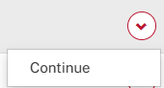

Add Scheme Biannual Report
Please select the reporting period from the drop-down list. Reports are required for the January to June and July to December periods each year. Only reports that have not yet been submitted to the OFSC will be shown in the drop-down list. The list will not show periods where your accreditation was not accredited for the entire period. When you have selected a reporting period, click the Create button.

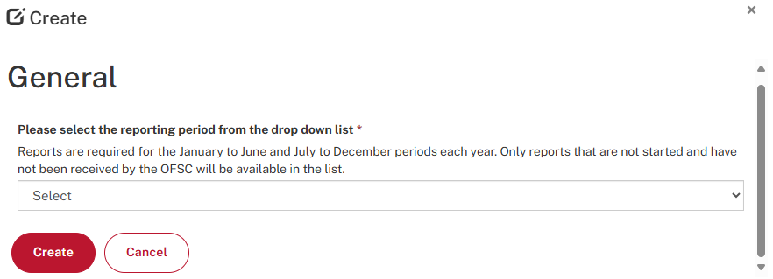

1. Workers’ Compensation & WHS Information

1.1 Scheme Biannual Report Details
The Accreditation Name, Accreditation number and Reporting Period Covered are not able to be changed at this point.

1.2 All current building and construction projects WHS information

Do you pay your workers’ compensation premiums on a state/territory basis, or are you self-insured, or do you have other workers’ compensation arrangements?
Please choose State/Territory based, self-insured, or other.
- State/Territory Based: Enter the workers’ compensation premium rate for each State and/or Territory your company operated in during the reporting period. Your insurer will be able to provide this figure. Report the rate as a percentage up to two decimal places only. No additional details are required when entering a rate. The rate is the percentage of payroll paid to the insurer which can vary by state operated in. It is NOT the percentage of where the insurance is paid e.g. 100% paid in ACT.

- Self-Insured: Provide information regarding your company’s workers’ compensation arrangements.
- Other: Enter the other workers’ compensation premium rate percentage (%) if you have one. If you select Other, you must provide details on your workers compensation arrangements.

Provide the total number of individuals, who are directly employed by the accredited contractor (i.e. are on the payroll of the company), that have worked on building or civil construction projects (irrelevant of project value) for the accredited contractor for any length of time during the reporting period.
Count each accredited contractor employee once only, even if they have worked on multiple projects in the reporting period. Administrative staff not working on site should not be included in this count. Do not count subcontractors.

Provide the number of workers’ compensation claims that were actioned for the employees counted in the previous field that originated from building or civil construction work performed during the period.
Only count claims that incurred a cost for the company. If claims carry through several reporting periods, these must be reported during each period they continue through.

Average cost per workers' compensation claim for all projects during the period
Provide the average cost of the workers' compensation claims the company had during the period on building and/or construction projects. Average costs must be for the claims listed in the previous question.
Average cost per claim is calculated using the following formula:
A = Cost of all claims in the period
B = Number of claims in the period
Average cost per claim = A/B

1.3 Pending or completed prosecution action details
Enter the number of pending or completed prosecution action(s) taken against the accredited contractor by a State or Territory

Provide the number and details of any pending or completed prosecution action against the contractor by a state/territory WHS authority during the period (include number, the dates of the on-site incidents that triggered each prosecution and brief description of each prosecution focused on what safety issue prompted the prosecution).1.4 Other WHS Information
Did your company receive any peer or industry recognition for WHS performance during the period? Please provide details
Enter details of peer or industry WHS recognition or safety awards that your company or any of your employees received during the reporting period. Include any awards that your company has won in the areas of workplace safety initiatives and any WHS leadership and contribution to safety categories. Also include any recognition of good WHS from other contractors or clients.
Provide details of any key WHS initiatives implemented by the accredited contractor during the period
Enter details of any WHS initiatives that your company has implemented during the reporting period. Examples of such initiatives could include company-wide WHS training, and health strategies such as sun protection or an alcohol and drugs program. Please outline the strategies used and the outcomes achieved as a result of the initiative(s).
Provide details on any other relevant information, trends, or developments in the industry that you would like to bring to the attention of the OFSC

2. Scheme Projects

2.1 What is a Scheme Project?
Projects that meet the following requirements are defined as Scheme Projects for the purposes of the Scheme:
Projects directly funded by the Australian Government:
Projects are considered to be directly funded when the Australian Government has responsibility for the project funding and development. The Scheme applies to projects that are directly funded where the value of the building contract is $4 million or more (GST inclusive).
Some typical examples of directly funded projects are a new Medicare office, a Defence facility, or the refurbishment of Australian Government office accommodation.
Projects indirectly funded by the Australian Government:
Projects are considered to be indirectly funded when the Australian Government contributes funding to a third-party recipient. The following thresholds apply for indirect funding:
- a head contract under the project includes building work of $4 million or more (GST inclusive) AND
  - the value of the Australian Government contribution to the project is at least $6 million (including GST) and represents at least 50 per cent of the total funding; OR
  - the Australian Government contribution to a project is $10 million (including GST) or more, irrespective of the proportion of Australian Government funding.
If a project meets the above requirements, where any ‘head contracts’ for building work are awarded that have a value of $4 million or more (inc. GST), the Scheme will apply, and an accredited builder must be appointed.
Some typical examples of indirect funding are where the Australian Government provides funding to a State or Territory government to build a new school, a hospital, or roads.
Preconstruction agreements, such as pre-commitment leases, public private partnerships (PPPs), build-own-operate (BOO) and build-own-operate-transfer (BOOT) agreements fall within the scope of the Scheme.
Any project that does not meet the above definition and for which the company is the head contractor is defined as a Non-Scheme Project for the purposes of the Scheme.

If you are unsure whether a project is a Scheme Project, please contact the FSC Assist Line on 1800 652 500 or email fscreporting@dewr.gov.au for advice.

2.1 Scheme Projects

Did you have any Scheme projects during the reporting period that are not listed above?
If you have any Scheme projects that are not listed in the Scheme Biannual Report, please contact FSCReporting@dewr.gov.au to have the Scheme Biannual deactivated and then submit a new Contract Declaration via the top menu selection item. Guidance on how to submit a Contract Declaration starts on page 8 of this guide. Once you have submitted the new Contract Declaration and it has been approved by the OFSC, you will be able to recreate the Scheme Biannual Report and the new Scheme Project will be listed.

2.2 Completing Listed Scheme Projects
You must enter each Scheme project by clicking on it within the table listing all Scheme projects previously declared in Contract Declarations.
NOTE: The “Scheme Projects” page will not provide a completed status until each Scheme project’s details have been provided.

Was this project completed during this reporting period?
- Yes: Please provide the date the building work was completed (Date/Month/Year)
- No: Please check the estimated building work end date for this project listed above, and confirm by re-entering it here or update if the date has changed
NOTE: If the project has been completed during the Scheme Biannual reporting period, the information provided should only cover the portion of the reporting period to the completion date.

Please check estimated work end date for this project listed above.
You must check the estimated building work end date for this project and confirm this date by entering or updating the date within this field.

What was the total number hours worked on this project during the reporting period (including subcontractor hours)?
Enter whole hours only with no decimal places. Where an exact figure is not available, the OFSC asks that you provide an informed approximate. Only include whole numbers, rounding up or down to the nearest hour when required.

Number of Dangerous Occurrence(s)
Enter the number of Dangerous Occurrence incidents that occurred on the project during the reporting period. Count each incident once only. Submit any outstanding incidents to the OFSC using the Incident Report form prior to attempting to submit this Scheme Biannual Report.
A dangerous occurrence is an incident where no person is injured, but could have been injured, resulting in Serious Personal Injury (which requires a week or more away from work), Incapacity or Death. Also commonly called a “near miss”. Only Dangerous Occurrences that are required to be reported under the relevant WHS legislation in the jurisdiction the project is being undertaken are required to be reported to the OFSC.

Number of Medically Treated Injuries (MTIs)
Enter the number of Medically Treated Injury (MTI) incidents that occurred on the project during the reporting period. Count each incident once only. Where an incident has resulted in both medical treatment and lost time, the incident should be counted as an LTI only. Submit any outstanding incidents to the OFSC using the Incident Report form prior to attempting to submit this Scheme Biannual Report.
An MTI is a work-related occurrence that results in treatment by, or under the order of, a qualified medical practitioner (see below), or any injury that could be considered as being one that would normally be treated by a medical practitioner but does not result in the loss of a full day/shift. Do not report first-aid treated injuries in this category.

MTIs include physical injuries as well as instances such as where a worker experiences psychological stress due to witnessing a traumatic event or being a victim of bullying, or if they required medical attention due to migraines caused by exposure to chemicals or gas. A qualified medical practitioner is defined as a person with a medical degree. The following would normally be considered medical treatment:
- Treatment of partial or full thickness burns
- Insertion of sutures
- Removal of foreign bodies embedded in eye
- Removal of foreign bodies from a wound if the procedure is complicated by the depth of embedment, size or location
- Surgical debridement
- Admission to a hospital or equivalent for treatment or observation
- Application of antiseptics during second or subsequent visits to medical personnel
- Any work injury that results in a loss of consciousness
- Treatment of infection
- Use of prescription medications (except a single dose administered on the first visit for minor injury or discomfort)
- Treatment (diagnosis and evaluation) by a Psychiatrist for mental illness or stress as a result of a workplace occurrence.
The following on their own would not normally be considered medical treatment:
- Administration of tetanus shots or boosters
- Physiotherapy
- Diagnostic procedures such as X-rays or laboratory analysis, unless they lead to further treatment
- Referral to/treatment by a Psychiatrist where the diagnosis is not a result of a workplace occurrence.

Number of Lost Time Injuries (LTIs)
Enter the number of Lost Time Injury (LTI) incidents that occurred on the project during the reporting period. Count each incident once only. Where an incident has resulted in medical treatment and lost time, the incident should be counted as an LTI only. Submit any outstanding incidents to the OFSC using the Incident Report form prior to attempting to submit this Scheme Biannual Report.
An LTI is a work-related occurrence that results in a permanent disability or injury resulting in time lost from work of one day/shift or more. Permanent disability is as defined in the legislation of the jurisdiction in which the project is being undertaken.
LTIs include physical injuries (i.e. cuts, burns, fractures etc.) as well as instances such as where a worker experiences psychological stress due to witnessing a traumatic event or being a victim of bullying (and may require time off work as a result), or if they required medical attention due to migraines caused by exposure to chemicals or gas.

Number of Fatal Incidents
Enter the number of Fatality incidents that occurred on the project during the reporting period. Submit any outstanding incidents to the OFSC using the Incident Report form prior to attempting to submit this Scheme Biannual Report.
A Fatality is a work-related occurrence that results directly or indirectly in the death of a person onsite (including deaths due to natural causes which occur on the project site).

Please provide the details of any interesting safety initiatives implemented, safety challenges overcome, or awards received for this Scheme Project during the period
Case studies and news articles are published on www.fsc.gov.au. The OFSC is always interested in hearing about safety awards and initiatives undertaken by accredited contractors.

Provide the number, date of issue and details of any Improvement, Prohibition, Infringement, or other Notice issued for building and civil construction work during the reporting period on this Scheme project. You must report all Notices that were issued to both the accredited contractor (as the head contractor or as a subcontractor on a site) and any issued to subcontractors of the accredited contractor working on site.
Enter a separate record for each Improvement, Prohibition, Infringement, or other Notice issued on this Scheme project during the reporting period. Click the Add Notices button to add new notices and Edit Notices or Delete Notices to perform each relevant task.

You must provide the type, date of issue and details of each Notice. Attach any documents relating to the Notices using the "Add Attachment" section. You must report all Notices that were issued to both the accredited contractor (as the head contractor or as a subcontractor on a site) and any issued to subcontractors of the accredited contractor working on site. Enforceable undertakings should be reported in the “Other notices” section.

3. Non-Scheme Projects
A Non-Scheme Project is any building or construction project that is being undertaken by the accredited company as a head contractor where the financial thresholds of the Scheme are not met.

3.1 Provide the number of Non-Scheme Projects valued at less than $4 million during the period
Enter the number of non-scheme projects valued at less than $4 million worked on by your company as head contractor during the biannual reporting period. This information must be provided in each of the three construction type fields:
- Civil Construction
- Residential Construction
- Commercial Construction

3.2 Provide the number of Non-Scheme Projects valued at $4 million or more during the period
Enter the number of non-scheme projects valued at more than $4 million the accredited contractor worked as head contractor during the biannual reporting period. This information must be provided in each of the three construction type fields:
- Civil Construction
- Residential Construction
- Commercial Construction

3.3 What was the total number of hours worked on Non-Scheme Projects valued at less than $4 million during the period
Enter the number of hours worked on Non-Scheme valued at less than $4 million during the period. If a project involves more than one construction type, please enter the hours in the construction type for the largest portion of the project that is managed/conducted by the accredited company. Do not split hours within a single project for this section of the report. Only include whole numbers, where you need to report part of an hour, round up or down to the nearest hour. This information must be provided in each of the three construction type fields and where there has been projects listed there must be hours and vice versa:
- Civil Construction
- Residential Construction
- Commercial Construction

3.4 What was the total number of hours worked on Non-Scheme Projects valued at $4 million or more during the period
Enter the total number of hours worked on Non-Scheme Projects valued at $4 million or more during the period. Select only one type of construction for each project. If a project involves more than one construction type, please select the type for the largest portion of the project that is managed/conducted by the accredited company. Do not split hours within a single project for this section of the report. Only include whole numbers, where you need to report part of an hour, round up or down to the nearest hour. This information must be provided in each of the three construction type fields and where there has been projects listed there must be hours and vice versa:
- Civil Construction
- Residential Construction
- Commercial Construction

3.5 Provide the number of incidents that occurred during the reporting period on Non-Scheme Projects valued at $4 million or more
Enter the number of Dangerous Occurrences, Medically Treated Injuries (MTIs) and Lost Time Injuries (LTIs) that occurred on non-scheme projects valued at $4 million or more during the period. Please see the OFSC reporting definitions and guidance on page 43 for more information on construction types to assist with completing this section. You should note that this requested information is also categorised by construction type (civil, residential, and commercial). Individual Incident Reports must be submitted for LTI of this value.

3.6 Provide the number of Non-Scheme fatalities in the reporting period for all Non-Scheme Projects of any value
A fatality is a work-related occurrence that results directly or indirectly in the death of a person (including deaths due to natural causes which occur on the project site). You should note that this requested information is also categorised by construction type (civil, residential, and commercial). Individual Incident Reports must be submitted for all fatalities.

3.7 Did your company perform building work on any Non-Scheme Projects during the reporting period valued at $4 million or more that involved work in any of the high risk construction categories listed below? If yes, please tick which hazards
o Where there is a risk of a person failing two metres or more | o On or near energised electrical installations and services
o On telecommunications towers | o In an area that may have a contaminated or flammable atmosphere
o Involving demolition | o Tilt-up and precast concrete construction work
o Involving structural alterations that require temporary support to prevent collapse | o On or adjacent to roadways or railways used by road or rail traffic
o Involving a confined space | o On construction sites where there is any movement of powered mobile plant
o Involving excavation to a depth greater than 1.5 metres | o In an area where there are artificial extremes of temperature
o The construction of tunnels | o Artificial extremes of temperature
o Involving the use of explosives | o In, over or adjacent to water or other liquids where there is a risk of drowning
o On or near pressurised gas distribution mains and consumer piping | o Involving diving
o On or near chemical, fuel, or refrigerant lines

4. Non-Scheme Notices and Infringements

4.1 Were there any Improvement notices issued to your company during this reporting period

If you select “Yes,” please enter the number of Improvement Notices issued to the accredited contractor on non-scheme projects with a value of $4 million or more (where the accredited contractor was the head contractor) during the reporting period. When completing this section, the number of notices for the period must include all notices issued to either the accredited contractor or any subcontractors of the accredited contractor working on site during the reporting period.

An Improvement Notice is as defined in the legislation of the jurisdiction in which the project is being undertaken, and is issued by the relevant WHS authority. In the various jurisdictions, a WHS inspector may issue an Improvement Notice if they believe someone has contravened the Act or regulations, or that a contravention may continue to be repeated. The notice will identify the provisions of the Act or regulations that have been, or may be contravened, the reasons for the notice, and a deadline for remedial action. An Improvement Notice may also include directions about how to remedy a breach. When completing OFSC reports, the number of notices for the period is to include all notices issued to both the accredited contractor and any subcontractors working on a site where the accredited contractor is the head contractor.

Adding a Notice.
You can provide information relating to an Improvement Notice by selecting the “Add Notice” icon.
You will then be able to provide both the date of the notice’s issue along with detail relevant to the notice before submitting it.
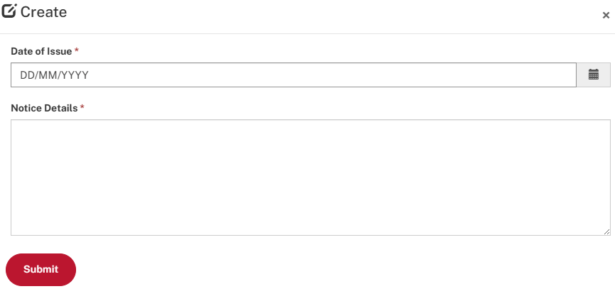

Number of prohibition notices
If you select “Yes,” please enter the number of Prohibition Notices issued to the accredited contractor on non-scheme projects with a value of $4 million or more (where the accredited contractor was the head contractor) during the reporting period. When completing this section, the number of notices for the period must include all notices issued to either the accredited contractor or any subcontractors of the accredited contractor working on site during the reporting period.
A Prohibition Notice is as defined in the legislation of the jurisdiction in which the project is being undertaken, and is issued by the relevant WHS authority. These notices are issued when a WHS inspector determines that there is a serious risk that needs urgent attention. Prohibition Notices are issued for any work that involves or will involve an immediate risk to the health, safety, and welfare of any person.

Adding a Notice.
You can provide information relating to a Prohibition Notice by selecting the “Add Notice” icon.
You will then be able to provide both the date of the notice’s issue along with detail relevant to the notice before submitting it.

Number of Infringement Notices
If you select “Yes,” please enter the number of Infringement Notices issued to the accredited contractor on non-scheme projects with a value of $4 million or more (where the accredited contractor was the head contractor) during the reporting period. When completing this section, the number of notices for the period must include all notices issued to either the accredited contractor or any subcontractors of the accredited contractor working on site during the reporting period.
An Infringement Notice is as defined in the legislation of the jurisdiction in which the project is being undertaken, and is issued by the relevant WHS authority. WHS regulations may allow for Infringement Notices to be issued as an alternative to prosecution for an offence that is not indictable.

Adding a Notice.
You can provide information relating to an Infringement Notice by selecting the “Add Notice” icon.
You will then be able to provide both the date of the notice’s issue along with detail relevant to the notice before submitting it.

Number of other Notices
If you select “Yes,” please enter the number of any other WHS related notices (other than infringement, prohibition, improvement notices) issued by a relevant WHS authority on non-scheme projects with a value of $4 million or more (where the accredited contractor was the head contractor) during the reporting period. Enforceable undertakings should also be reported here.
When completing this section, the number of notices for the period must include all notices issued to both the accredited contractor (as the head contractor or as a subcontractor on a site) and any issued to subcontractors of the accredited contractor working on site during the reporting period. Enter the number "0" if you had none.

Adding a Notice.
You can provide information relating to a notice by selecting the “Add Notice” icon.
You will then be able to provide both the date of the notice’s issue along with detail relevant to the notice before submitting it.

5. Company Information

5.1 Company information
You must click your company name in the provided list to enter and provide the required information.

Is this company based in Australia?
If the company’s head office is located in Australia select Yes, if the company’s head office is located overseas select No.

Please choose the country where the company’s head office is located
If the company is not based in Australia, select the name of the country where the company operates from.

Does this company identify as Australian Indigenous?
An Australian Indigenous business is defined as one where at least 50% of the ownership of the business is by person(s) of Aboriginal and/or Torres Strait Islander descent and is based in Australia.

6. Areas of Operation

6.1 Areas of operation
Select from the list the regions of Australia where your company has the capacity to perform building work. When a state/territory is selected, all regions within the jurisdiction will automatically be selected. Individual regions can be selected and unselected from the list. These regions have been taken from the ABS’s Australian Statistical Geography Standard (ASGS). The regions the OFSC is using specifically come from the Statistical Area Level 4 (SA4) ASGS Edition 2011. Further information and maps of the regions can be found in the Publications section of this webpage: http://www.abs.gov.au/AUSSTATS/abs@.nsf/DetailsPage/1270.0.55.001July%202011?OpenDocument

7. Submission
Please click "Submit" button to submit your report.

Validation Errors
Before submission is permitted, you must ensure that all the required fields have been completed and saved on each page before progressing to the next page.
Before clicking “Submit,” please make sure that all of the pages of the Scheme Biannual Report Form have been correctly completed which is indicated by a tick corresponding to the section of the declaration.
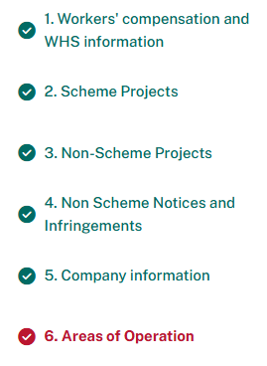
If you do see that a section has an “X” next to it, please click on that section and ensure that all of the required information has been provided and select “Save” before returning to the final page.
When the errors in the Scheme Biannual Report Form have been resolved, users can click on the “Submit” button.

Submitting an Incident Report
Only work-related incidents need to be reported to the OFSC. Typically, incidents that involve an accredited contractor’s employee or subcontractor off site and outside of work hours, incidents that are determined to be road traffic accidents by the appropriate law enforcement, and incidents such as those that involve diseases that are not work related do not need to be reported to the OFSC. However, if you are unsure if an incident is required to be reported to the OFSC please contact us on 1800 652 500 to discuss the details further.
The Incident Report is located in the Reporting Menu in FSC Online.

Step One – Reporting Menu



Step Two – Click the New Incident Report button to open a new report. You can also Continue or View previously created Incident Reports from this screen. You will also be able to delete Incident Reports that have not yet been submitted to the OFSC. If you have an Incident Report that has been submitted to the OFSC that needs to be deleted, please contact the FSC Assist Line on 1800 652 500.


When the new report opens, a dialogue box will ask for the following mandatory information:

Incident Type
- Fatalities should be reported via FSC Online for both Scheme and Non-Scheme Projects, irrespective of the project value (notify immediately to 1800 652 500 and provide report within 48 hours);
- LTIs should be reported via FSC Online for all Scheme and Non-Scheme Projects where the project value is $4 million or more (provide report within 2 weeks);
- MTIs or Dangerous Occurrences should be reported via FSC Online for all Scheme Projects (provide report within 2 weeks. Non-notifiable Dangerous Occurrences do not need to be reported to the OFSC).
*A notifiable incident is an incident that is required to be notified under the relevant WHS legislation in the jurisdiction in which the project is being undertaken.

Incident Definitions

Dangerous Occurrence(s)
Definition: A Dangerous Occurrence is an incident where no person is injured, but could have been injured, resulting in Serious Personal Injury (which requires a week or more away from work), Incapacity or Death. Also commonly called a “near miss”. Only Dangerous Occurrences that are required to be reported under the WHS legislation covering notifiable incidents in the jurisdiction the project is being undertaken are required to be reported to the OFSC.

Medically Treated Injuries (MTIs)
Definition: An MTI is a work-related occurrence that results in treatment by, or under the order of, a qualified medical practitioner (see below), or any injury that could be considered as being one that would normally be treated by a medical practitioner but does not result in the loss of a full day/shift. Do not report first-aid treated injuries in this category.
MTIs include physical injuries as well as instances such as where a worker experiences psychological stress due to witnessing a traumatic event or being a victim of bullying, or if they required medical attention due to migraines caused by exposure to chemicals or gas. A qualified medical practitioner is defined as a person with a medical degree. The following would normally be considered medical treatment:
- Treatment of partial or full thickness burns
- Insertion of sutures
- Removal of foreign bodies embedded in the eye
- Removal of foreign bodies from a wound if the procedure is complicated by the depth of embedment, size or location
- Surgical debridement
- Admission to a hospital or equivalent for treatment or observation
- Application of antiseptics during second or subsequent visits to medical personnel
- Any work injury that results in a loss of consciousness
- Treatment of infection
- Use of prescription medications (except a single dose administered on the first visit for minor injury or discomfort)
- Treatment (diagnosis and evaluation) by a Psychiatrist for mental illness or stress as a result of a workplace occurrence.
The following on their own would not normally be considered medical treatment:
- Administration of tetanus shots or boosters
- Physiotherapy
- Diagnostic procedures such as X-rays or laboratory analysis, unless they lead to further treatment
- Referral to/treatment by a Psychiatrist where the diagnosis is not a result of a workplace occurrence.

Lost Time Injuries (LTIs)
Definition: An LTI is a work-related occurrence that results in a permanent disability or injury resulting in time lost from work of one day/shift or more. Permanent disability is as defined in the legislation of the jurisdiction in which the project is being undertaken.
LTIs include physical injuries (i.e. cuts, burns, fractures etc.) as well as instances such as where a worker experiences psychological stress due to witnessing a traumatic event or being a victim of bullying (and may require time off work as a result), or if they required medical attention due to migraines caused by exposure to chemicals or gas.

Fatal incident
Definition: A fatality is a work-related occurrence that results directly or indirectly in the death of a person onsite (including deaths due to natural causes which occur on the project site).

Is this a notifiable incident?
A notifiable incident is one resulting in the death of a person, a serious injury or illness of a person, or a near miss event/ Dangerous Occurrence, which is required to be notified under the WHS legislation covering notifiable incidents in the jurisdiction in which the project is being undertaken. Reports for notifiable incidents should be provided to the OFSC within 48 hours.

Project Type
This field identifies whether the project where the incident occurred is a Scheme or Non-Scheme Project where the accredited contractor was the head contractor. This field is only available for LTI and Fatality incidents. If MTI or Dangerous Occurrence have been selected the system will automatically select Scheme Project. Non-Scheme MTI and Dangerous Occurrences are not reportable to the OFSC.

If LTI or Fatality is selected, a Project Type field will display. If Scheme Project is then selected, the project will be able to be selected from the drop down. If Non-Scheme is selected, the name of the project can by entered into the project name field.

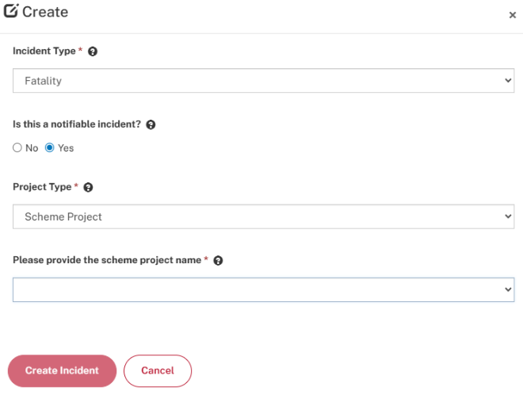

MTI or Dangerous Occurrence will only permit Scheme Projects to be selected from the drop down.

What is a Scheme Project?
Projects that meet the following requirements are defined as Scheme Projects for the purposes of the Scheme:
Projects directly funded by the Australian Government:
Projects are considered to be directly funded when the Australian Government has responsibility for the project funding and development. The Scheme applies to projects that are directly funded where the value of the building contract is $4 million or more (GST inclusive).
Some typical examples of directly funded projects are a new Medicare office, a Defence facility, or the refurbishment of Australian Government office accommodation.
Projects indirectly funded by the Australian Government:
Projects are considered to be indirectly funded when the Australian Government contributes funding to a third party recipient. The following thresholds apply for indirect funding:
- a head contract under the project includes building work of $4 million or more (GST inclusive) AND
  - the value of the Australian Government contribution to the project is at least $6 million (including GST) and represents at least 50 per cent of the total funding; OR
  - the Australian Government contribution to a project is $10 million (including GST) or more, irrespective of the proportion of Australian Government funding.
If a project meets the above requirements, where any ‘head contracts’ for building work are awarded that have a value of $4 million or more (inc. GST), the Scheme will apply and an accredited builder must be appointed.
Some typical examples of indirect funding are where the Australian Government provides funding to a State or Territory government to build a new school, a hospital, or roads.
Preconstruction agreements, such as pre-commitment leases, public private partnerships (PPPs), build-own-operate (BOO) and build-own-operate-transfer (BOOT) agreements fall within the scope of the Scheme.
Any project that does not meet the above definition and for which the company is the head contractor is defined as a Non-Scheme Project for the purposes of the Scheme.

If you are unsure whether a project is a Scheme Project, please contact the FSC Assist Line on 1800 652 500 or email fscreporting@dewr.gov.au for advice.

Please provide Project name
Provide the full name of the project. For Scheme Projects this should match the name that was provided on the Contract Declaration previously submitted to the OFSC and should be selectable in the system. Avoid using acronyms or abbreviations (particularly for Non-Scheme Projects) so that consistent records can be maintained by the OFSC across the life of a project.
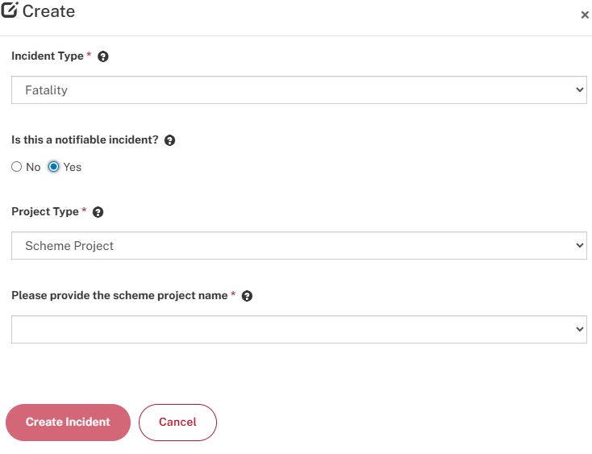

1. Project Details

1.1 Project details
Project Value in dollars (inclusive of GST)

1.2 Construction type

Construction type
Select the type of construction for the project. Only one type should be selected, so where a project involves more than one type, please select the type for the largest portion of the project that is managed by the accredited contractor. On Scheme projects the system may prepopulate this from the Contract Declaration.
- Civil or engineering construction – roads and bridges, railways, ports, water storage and supply, sewerage, telecommunications, pipelines, drainage, earthworks, heavy industry-related (refineries, pumping stations, mines, chemical plants, furnaces, steel mills, etc.).
- Commercial building – offices, shops, hotels, other business premises, industrial, social, and institutional, and mixed-use apartments (combined commercial and apartment developments).
- Residential building – detached houses, attached dwellings (e.g. terrace, row, or town houses), villa homes, home units, residential flats, duplexes, aged care facilities, apartments, and ancillary buildings to the above, but excluding mixed-use developments (combined commercial and apartment developments). Work such as installation of virtual power plant using solar panels on residential buildings, a contract requiring only the demolition of a residential building, or a contract for the remediation or preparation of a site that will later house a residential building under a separate contract is not considered residential building work.

2. Incident Details

2.1 Incident details

Date of incident (DD/MM/YYYY)
The date that the incident occurred in the format Date/Month/Year. This field can be entered manually or using the date finder.

Time of incident (12hr HH:MM AM/PM)
The time of the incident. Please enter the time in 12-hour format (HH:MM) and specify whether it was AM or PM.

Breakdown agency of incident
The break down agency of incident is intended to identify the object, substance or circumstance that was principally involved in, or more closely associated with, the point at which things started to go wrong and which ultimately led to the most serious injury or disease.
- Machinery and fixed plant
- Mobile plant and transport
- Powered equipment, tools, and appliances
- Non-powered hand tools, appliances, and equipment
- Chemicals and chemical products
- Material and substances
- Environmental agencies
- Animal, human, and biological agencies
- Other and unspecified agencies
The break down agency of incident is intended to identify the object, substance or circumstance that was principally involved in, or more closely associated with, the point at which things started to go wrong and which ultimately led to the most serious injury or disease. Subfields with drop down menus may appear when a category is selected it provide further detail.
- Machinery and fixed plant includes: Cutting, slicing, sawing machinery, crushing, pressing, rolling machinery, heating, cooking, baking equipment, cooling, refrigeration plant and equipment, conveyors and lifting plant, electrical installation, radiation-based equipment, filling, and bottling/packaging plant, other plant, and machinery.
- Mobile plant and transport includes: Self-propelled plant, semi-portable plant, other mobile plant, road transport, rail transport, air transport, water transport, other transport.
- Powered equipment, tools and appliances includes: Workshop and worksite tools and equipment, kitchen and domestic equipment, office and electronic equipment, garden and outdoor powered equipment, pressure-based equipment not covered elsewhere, other powered equipment, tools, and appliances.
- Non-powered hand tools, appliances and equipment includes: Hand tools, non-powered, edged, other hand tools, fastening, packing, and packaging equipment, furniture and fittings, other utensils, ladders, mobile ramps and stairways, and scaffolding, other non-powered equipment.
- Chemicals and chemical products includes: Nominated chemicals, other basic chemicals, chemical products.
- Material and substances includes: Non-metallic minerals and substances, other materials, objects, or substances.
- Environmental agencies include: Outdoor, indoor, and underground environments.
- Animal, human, and biological agencies includes: Live four-legged animals, other live animals, non-living animals, human agencies, biological agencies.
- Other and unspecified agencies include: Non-physical and other and unspecified agencies

High Risk Construction category
Select from the list of 19 high risk construction categories the one, if any, that relates to the incident.
o Working at Heights | o Chemical, Fuel or Refrigerant Lines
o Telecommunications Towers | o Electrical
o Demolition | o Contaminated / Flammable Atmosphere
o Asbestos | o Tilt-up / Precast Concrete
o Structural Alterations / Temporary Support | o Traffic
o Confined Space | o Mobile Plant
o Excavation | o Artificial Extremes of Temperature
o Tunnels | o Diving
o Explosives  o Pressurised Gas | o Construction Work In, Over or Adjacent to Water / Liquids Where Risk of Drowning

Please provide a description or further detail on the high-risk category selection.
You must provide as much additional information as possible regarding the high-risk category selection to assist the FSC in understanding the high-risk factors present in the incident.

Project Site Details
You must provide information relating to the location of the project where the incident occurred. You have the option of entering the Project address manually or entering a location in which FSC Online will determine the project location utilising the information provided.
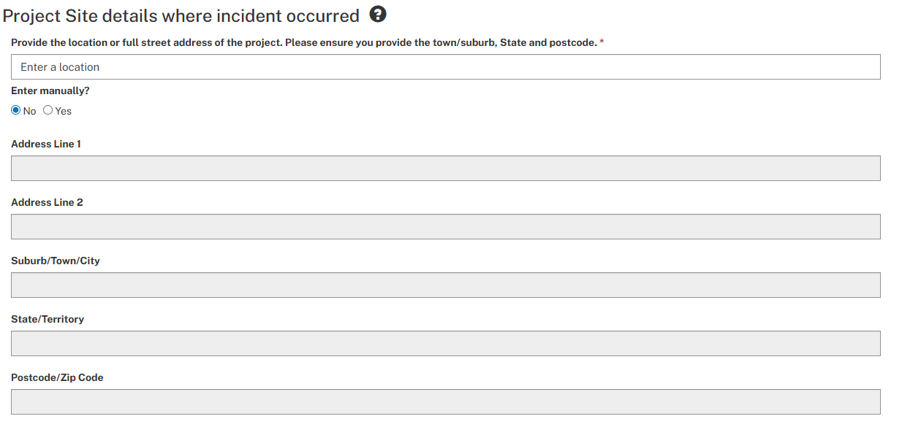

3. Worker(s) Involved
You may add details relating to the injured worker by selecting the “Add Worker Injury Details” icon on this screen.



3.1 Worker injury details

Gender
Indicate if the injured worker is male, female, or Indeterminate/Intersex/Unspecified.

Age
Provide the injured workers age, in years. If the worker's exact age is unknown, please provide an estimate of the worker's age.

Occupation
Select one option only from the list which most accurately defines the injured worker's usual occupation.
- Technicians & trade workers
- Electricians
- Bricklayers, carpenters & joiners
- Glaziers, plasterers & tilers
- Plumbers
- Painting Trades Workers
- Electronics & Telecommunications Workers
- Labourers
- Building & Plumbing labourers
- Structural Steel Construction Workers
- Concreters
- Traffic control labourers
- Machinery operators & drivers
- Earthmoving Plant Operators
- Truck drivers
- Stationary Plant Operators
- Managers
- Scaffolder/Formworker
- Other occupations

Who is the employer of the injured person?
Select one option from the three listed (accredited contractor, subcontractor or other). If the injured person is not employed by the accredited contractor or a subcontractor, please select the 'other' option. An example of a person who may fit this category is a Federal Safety Officer, a WorkCover auditor or other visitor to the site. If the person is an unauthorised party (i.e. a trespasser or unauthorised member of the public), please provide details in the next tab (Incident details) under 'Brief description of the incident'.

Hours worker had been on site on the day of the incident
Indicate the number of hours the injured worker had been present on that particular construction site prior to the incident in hours and minutes (HH:MM).

Hours on the project site in the seven days including and prior to the incident
Indicate how many cumulative hours the worker had been present on any building or construction site in the seven days prior to and including the day of the incident.

Nature of injury
Select one option only from the list which best identifies the most serious injury (or disease) that was experienced by the injured worker as a result of the incident.
- Intracranial injuries
- Fractures
- Wounds, lacerations, amputations, and internal organ damage
- Burns
- Injury to nerves and spinal cord
- Traumatic joint/ligament and muscle/tendon injuries
- Other injuries
- Diseases and conditions
- Other diseases and claims
When completing an Incident Report select one option only from the list which best identifies the most serious injury (or disease) that was experienced by the injured worker as a result of the incident. Subfields may open for more detailed information. Below are the kinds of injuries captured by each of the nature of injury categories:
- Intracranial injuries: Brain injury, other intracranial injury, not elsewhere classified or unspecified.
- Fractures: Fractured skull and facial bones, fracture of vertebral column without mention of spinal cord lesion, other fractures, not elsewhere classified or unspecified.
- Wounds, lacerations, amputations, and internal organ damage: Internal injury of chest, abdomen and pelvis, traumatic amputation, injury to major blood vessel, laceration or open wound not involving traumatic amputation, medical sharp/needle-stick puncture, superficial injury, contusion, bruising and superficial crushing.
- Burns: Electrical burn, chemical burn, cold burn, hot burn, friction burn, combination burn or burn not elsewhere classified or unspecified.
- Injury to nerves and spinal cord: Quadriplegia involving spinal cord injury, paraplegia involving spinal cord injury, injuries to nerves and spinal cord, not elsewhere classified or unspecified.
- Traumatic joint/ligament and muscle/tendon injury: Trauma to joints and ligaments, trauma to muscles and tendons, residual soft tissue disorders due to trauma or unknown mechanisms.
- Other injuries: Foreign body on external eye, in ear or nose or in respiratory, digestive or reproductive tract, poisoning and toxic effects of substances, audio shock, audio shriek, electrocution, shock from electric current, traumatic deafness from air pressure or explosion, heat stress/heat stroke, hypothermia and effects of reduced temperature, effects of weather, exposure, air pressure and other external causes, not elsewhere classified, multiple injuries, other specified injuries, not elsewhere classified, or unspecified.
- Diseases and conditions: Musculoskeletal and connective tissue diseases, mental diseases, digestive system diseases, skin, and subcutaneous tissue diseases, nervous system, and sense organ diseases. Respiratory system diseases, circulatory system diseases, infectious and parasitic diseases, neoplasms (cancer)
- Other diseases and claims: Other diseases, not elsewhere classified, unspecified diseases, exposure to substances without current injury or disease apparent, damage to artificial aid(s), not known.
These categories are based on the nature of injury classifications listed in the Type of Occurrence Classification System, Version 3.1 (TOOCS3.1). See this document at www.safeworkaustralia.gov.au for more detailed information.

Location of injury
Select one option only from the list which identifies the part of the body affected by the most serious injury. The parts of the body covered by each of the groups are listed below.
- Head
- Neck
- Trunk
- Upper limbs
- Lower limbs
- Multiple locations
- Systemic location
- Non-physical locations: Psychological system.
- Unspecified locations
When completing an Incident Report, select one option only from the list which identifies the part of the body affected by the most serious injury. Subfields may open for more detailed information. See the Question Mark Help (?) next to this field for further information.
The parts of the body covered by each of the groups are listed below:
- Head: Cranium, eye, ear, mouth, nose, face - not elsewhere classified, head - multiple or unspecified locations.
- Neck: Neck.
- Trunk: Back - upper or lower, chest (thorax), abdomen and pelvic region, trunk - multiple locations/unspecified locations.
- Upper limbs: Shoulder, upper arm, elbow, forearm, wrist, hand, fingers and thumb, upper limb - multiple or unspecified locations.
- Lower limbs: Hip, upper leg, knee, lower leg, ankle, foot and toes, lower limb - multiple or unspecified locations.
- Multiple locations: Neck and trunk, head and neck, head and other, trunk and limbs, upper and lower limbs, neck and shoulder, other specified multiple locations, unspecified multiple locations.
- Systemic location: Circulatory system, respiratory system, digestive system, genitourinary system, nervous system, other and multiple systemic conditions, unspecified systemic conditions.
- Non-physical locations: Psychological system.
- Unspecified locations: Unspecified locations.
These categories are based on the location of injury classifications listed in the Type of Occurrence Classification System, Version 3.1 (TOOCS3.1). See this document at https://www.safeworkaustralia.gov.au for more detailed information.

Mechanism of injury
Select one option from the mechanism of injury list. The mechanism of injury is the action, exposure or event which was the direct cause of the injury (i.e. 'how' the person was hurt). The following list of standard categories is to be used when completing this item. Entry is only required at group level but sub-groups are provided in the reporting definitions and guidance in a new window to assist with selection of the appropriate group.
- Group 0 - falls, trips and slips of a person
- Group 1 - hitting objects with a part of the body
- Group 2 - being hit by moving objects
- Group 3 - sound and pressure
- Group 4 - body stressing
- Group 5 - heat, electricity, and other environmental factors
- Group 6 - chemicals and other substances
- Group 7 - biological factors
- Group 8 - mental stress
- Group 9 - vehicle incidents and other
When completing an Incident report, the mechanism of injury is the action, exposure or event which was the direct cause of the injury (i.e., ‘how’ the person was hurt). Select one option from the list. The following list of standard categories is to be used when completing this item. Entry is only required at group level, but sub-groups are provided below to assist with selection of the appropriate group.

Group 0 -FALLS, TRIPS AND SLIPS OF A PERSON
- 01 Falls from a height
- 02 Falls on the same level
- 03 Stepping, kneeling or sitting on objects

Group 1-HITTING OBJECTS WITH A PART OF THE BODY
- 11 Hitting stationary objects
- 12 Hitting moving objects
- 13 Rubbing and chafing

Group 2-BEING HIT BY MOVING OBJECTS
- 21 Being hit by falling objects
- 22 Being bitten by an animal
- 23 Being hit by an animal
- 24 Being hit by a person accidentally
- 25 Being trapped by moving machinery or equipment
- 26 Being trapped between stationary and moving objects
- 27 Exposure to mechanical vibration
- 28 Being hit by moving objects
- 29 Being assaulted by a person or persons

Group 3-SOUND AND PRESSURE
- 31 Exposure to single, sudden sound
- 32 Long-term exposure to sound
- 33 Explosion
- 34 Other variations in pressure

Group 4-BODY STRESSING
- 41 Muscular stress while lifting, carrying, or putting down objects
- 42 Muscular stress while handling objects other than lifting, carrying or putting down
- 43 Muscular stress with no objects being handled
- 44 Repetitive movements, low muscle loading

Group 5-HEAT, ELECTRICITY AND OTHER ENVIRONMENTAL FACTORS
- 51 Contact with hot objects
- 52 Contact with cold objects
- 53 Exposure to environmental heat
- 54 Exposure to environmental cold
- 55 Exposure to non-ionising radiation
- 56 Exposure to ionising radiation
- 57 Contact with electricity
- 58 Drowning/immersion
- 59 Exposure to other environmental factors

Group 6-CHEMICALS AND OTHER SUBSTANCES
- 61 Single contact with chemical or substance
- 62 Long term contact with chemicals or substances
- 63 Insect and spider bites and stings
- 64 Contact with poisonous parts of plant or marine life
- 65 Other and unspecified contact with chemical or substance

Group 7-BIOLOGICAL FACTORS
- 71 Contact with, or exposure to, biological factors of non-human origin
- 72 Contact with, or exposure to, biological factors of human origin
- 73 Contracts with, or exposure to, biological factors of unknown origin.

Group 8-MENTAL STRESS
- 81 Exposure to a traumatic event
- 82 Exposure to workplace or occupational violence
- 83 Work pressure
- 84 Suicide or attempted suicide
- 85 Other mental stress factors
- 86 Work related harassment and/or workplace bullying
- 87 Other harassment

Group 9-VECHICLE INCIDENTS AND OTHER
- 91 Slide or cave-in
- 92 Vehicle incident
- 93 Rollover
- 94 Other and multiple mechanisms of incident
- 95 Unspecified mechanisms of incident
These categories are based on the ten major mechanism of incident classification groups listed in the Type of Occurrence Classification System, Version 3.1 (TOOCS3.1). See https://www.safeworkaustralia.gov.au for more detailed information on this Classification System.
Working days/shifts expected/actually lost
Please note: this section only needs to be completed for Lost Time Injuries (LTIs)
Indicate from the list, the number of working days or shifts that were lost for the injured worker as result of the incident. If the number of working days/shifts lost is not available at the time the report must be submitted (because it is continuing past the required due date for report submission), provide an indication of the working days/shifts that are expected to be lost. Please contact the OFSC after the report submission if the expected lost days differs from the final actual lost days.
Working days/shifts where a significant change to normal duties is made/expected
Please note: It is recommended that this section be completed for LTIs, but it may also be relevant for MTIs
Indicate from the list the period that the injured worker has, or is expected to have, at the time the report is due for submission, a significant change to their normal duties upon their return to work. This includes where the injured worker has a gradual return to their normal duties or returns to work to perform a different role. For example, the injured worker returns to work to perform administration duties where their usual duties involve intensive labour or operation of mobile plant. This may also include workers sent to unscheduled training due to their incapacity to perform normal duties.

4. Incident Description

4.1 Incident description

Detailed description of the incident
Provide a detailed description of the incident including what instigated it, the people, machinery, and equipment that were involved, and any injuries that were sustained as a result.

Please provide information regarding actions that have been subsequently taken to reduce the risk of a similar future occurrence

Have you conducted an incident investigation report regarding the fatality? (only complete this question for a fatality)
Select yes or no and provide the requested additional information corresponding to your response. If the information, such as an investigation report, is not available at the time the report is due to be submitted, please make a note of this in this section of the report and indicate when it is anticipated that the information will be available and forwarded to the OFSC.
Severity level of incident
Please select either Severe or Not severe/serious. Incidental is an internal use option for the OFSC.
The OFSC is still considering the full definition of a serious incident. For current reporting purposes please consider the below when filling out this field. It may be updated in future.
The OFSC considers a serious injury or illness of a person as one that presents a clear risk of significant harm, long-term recovery, or permanent disability or disfigurement.
A serious injury or illness includes any of the following:
(a) Life-threatening injuries, or injuries requiring critical care or emergency surgery
(b) immediate treatment for:
(i) the amputation of any part of his or her body
(ii) a serious head injury; or
(iii) a serious eye injury; or
(iv) a serious burn; or
(v) the separation of his or her skin from an underlying tissue (such as degloving or scalping); or
(vi) a spinal injury; or
(vii) the loss of a bodily function; or
(c) medical treatment within 48 hours of exposure to a known hazardous substance (e.g. asbestos, silica, chemical spill) where there is a clear risk of death, serious illness, disability, or long term health impact.
and includes any other injury or illness prescribed by the regulations but does not include an illness or injury of a prescribed kind.
Serious injuries on construction sites are those that result in serious harm, long-term recovery, or permanent impairment or disability.
Note: Incidents that result in precautionary hospital visits, minor or moderate treatment do not, on their own, meet the threshold for serious injury.

Uploading supporting files and documents
You may also upload supporting documents to FSC Online in relation to the incident which can include investigation reports by clicking “Add files.”


5. Submission
Please click "Submit" button to submit your report.

Validation Errors
Before submission is permitted, you must ensure that all the required fields have been completed and saved on each page before progressing to the next page.
Before clicking “Submit,” please make sure that all of the pages of the Incident Report Form have been correctly completed which is indicated by a tick corresponding to the section of the declaration.
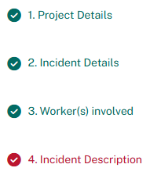
If you do see that a section has an “X” next to it, please click on that section and ensure that all of the required information has been provided and select “Save” before returning to the final page.
When the errors in the Incident Report have been resolved, users can click on the “Submit” button.

Definitions

Scheme Project

What is a Scheme Project?
Projects that meet the following requirements are defined as Scheme Projects for the purposes of the Scheme:
Projects directly funded by the Australian Government:
Projects are considered to be directly funded when the Australian Government has responsibility for the project funding and development. The Scheme applies to projects that are directly funded where the value of the building contract is $4 million or more (GST inclusive).
Some typical examples of directly funded projects are a new Medicare office, a Defence facility, or the refurbishment of Australian Government office accommodation.
Projects indirectly funded by the Australian Government:
Projects are considered to be indirectly funded when the Australian Government contributes funding to a third party recipient. The following thresholds apply for indirect funding:
- a head contract under the project includes building work of $4 million or more (GST inclusive) AND
  - the value of the Australian Government contribution to the project is at least $6 million (including GST) and represents at least 50 per cent of the total funding; OR
  - the Australian Government contribution to a project is $10 million (including GST) or more, irrespective of the proportion of Australian Government funding.
If a project meets the above requirements, where any ‘head contracts’ for building work are awarded that have a value of $4 million or more (inc. GST), the Scheme will apply and an accredited builder must be appointed.
Some typical examples of indirect funding are where the Australian Government provides funding to a State or Territory government to build a new school, a hospital, or roads.
Preconstruction agreements, such as pre-commitment leases, public private partnerships (PPPs), build-own-operate (BOO) and build-own-operate-transfer (BOOT) agreements fall within the scope of the Scheme.
Any project that does not meet the above definition and for which the company is the head contractor is defined as a Non-Scheme Project for the purposes of the Scheme.

If you are unsure whether a project is a Scheme Project, please contact the FSC Assist Line on 1800 652 500 or email fscreporting@dewr.gov.au for advice.

Incident report types
Dangerous Occurrence
A Dangerous Occurrence is incident where no person is injured, but could have been injured, resulting in Serious Personal Injury (which requires a week or more away from work), Incapacity or Death. Also commonly called a “near miss”. Only Dangerous Occurrences that are required to be reported under the WHS legislation covering notifiable incidents in the jurisdiction the project is being undertaken are required to be reported to the OFSC.
MTI (Medically Treated Injury)
An MTI is a work-related occurrence that results in treatment by, or under the order of, a qualified medical practitioner (see below), or any injury that could be considered as being one that would normally be treated by a medical practitioner but does not result in the loss of a full day/shift. Do not report first-aid treated injuries in this category.
MTIs include physical injuries as well as instances such as where a worker experiences psychological stress due to witnessing a traumatic event or being a victim of bullying, or if they required medical attention due to migraines caused by exposure to chemicals or gas. A qualified medical practitioner is defined as a person with a medical degree. The following would normally be considered medical treatment:
- Treatment of partial or full thickness burns
- Insertion of sutures
- Removal of foreign bodies embedded in eye
- Removal of foreign bodies from a wound if the procedure is complicated by the depth of embedment, size or location
- Surgical debridement
- Admission to a hospital or equivalent for treatment or observation
- Application of antiseptics during second or subsequent visits to medical personnel
- Any work injury that results in a loss of consciousness
- Treatment of infection
- Use of prescription medications (except a single dose administered on the first visit for minor injury or discomfort)
- Treatment (diagnosis and evaluation) by a Psychiatrist for mental illness or stress as a result of a workplace occurrence.
The following on their own would not normally be considered medical treatment:
- Administration of tetanus shots or boosters
- Physiotherapy
- Diagnostic procedures such as X-rays or laboratory analysis, unless they lead to further treatment
- Referral to/treatment by a Psychiatrist where the diagnosis is not a result of a workplace occurrence.
LTI (Lost Time Injury)
An LTI is a work-related occurrence that results in a permanent disability or injury resulting in time lost from work of one day/shift or more. Permanent disability is as defined in the legislation of the jurisdiction in which the project is being undertaken.
LTIs include physical injuries (i.e. cuts, burns, fractures etc.) as well as instances such as where a worker experiences psychological stress due to witnessing a traumatic event or being a victim of bullying (and may require time off work as a result), or if they required medical attention due to migraines caused by exposure to chemicals or gas.
Fatality
A work-related occurrence that results directly or indirectly in the death of a person onsite (including deaths due to natural causes which occur on the project site).

Is this a notifiable incident?
A notifiable incident is one resulting in the death of a person, a serious injury or illness of a person, or a near miss event/Dangerous Occurrence, which is required to be notified under the relevant WHS legislation in the jurisdiction in which the project is being undertaken. Reports for notifiable incidents should be provided to the OFSC within 48 hours.

Construction types
When completing a report, where it asks for the construction type, select the type of construction for the project. Only one type should be selected, so where a project involves more than one type, please select the type for the largest portion of the project that is managed by the accredited contractor as the head contractor.
- Civil or engineering construction – roads and bridges, railways, ports, water storage and supply, sewerage, telecommunications, pipelines, drainage, earthworks, heavy industry-related (refineries, pumping stations, mines, chemical plants, furnaces, steel mills, etc.).
- Commercial building – offices, shops, hotels, other business premises, industrial, social and institutional, and mixed-use apartments (combined commercial and apartment developments).
- Residential building – detached houses, attached dwellings (e.g. terrace, row, or town houses), villa homes, home units, residential flats, duplexes, aged care facilities, apartments, and ancillary buildings to the above, but excluding mixed-use developments (combined commercial and apartment developments). Work such as installation of virtual power plant using solar panels on residential buildings, a contract requiring only the demolition of a residential building, or a contract for the remediation or preparation of a site that will later house a residential building under a separate contract is not considered residential building work.

Breakdown agency
The break down agency of incident is intended to identify the object, substance or circumstance that was principally involved in, or more closely associated with, the point at which things started to go wrong, and which ultimately led to the most serious injury or disease.
- Machinery and Fixed Plant includes: Cutting, slicing, sawing machinery, crushing, pressing, rolling machinery, heating, cooking, baking equipment, cooling, refrigeration plant and equipment, conveyors and lifting plant, electrical installation, radiation-based equipment, filling and bottling/packaging plant, other plant and machinery.
- Mobile Plant and transport includes: Self-propelled plant, semi-portable plant, other mobile plant, road transport, rail transport, air transport, water transport, other transport.
- Powered equipment, tools and appliances includes: Workshop and worksite tools and equipment, kitchen and domestic equipment, office and electronic equipment, garden and outdoor powered equipment, pressure-based equipment not covered elsewhere, other powered equipment, tools and appliances.
- Non-powered hand tools, appliances and equipment includes: Hand tools, non-powered, edged, other hand tools, fastening, packing and packaging equipment, furniture and fittings, other utensils, ladders, mobile ramps and stairways, and scaffolding, other non-powered equipment.
- Chemicals and chemical products includes: Nominated chemicals, other basic chemicals, chemical products.
- Material and substances includes: Non-metallic minerals and substances, other materials, objects or substances.
- Environmental agencies include: Outdoor, indoor and underground environments.
- Animal, human and biological agencies includes: Live four-legged animals, other live animals, non-living animals, human agencies, biological agencies.
- Other and unspecified agencies include: Non-physical and other and unspecified agencies
These categories are based on the break down agency of incident classifications listed in the Type of Occurrence Classification System, Version 3.1 (TOOCS3.1). See www.safeworkaustralia.gov.au for more detailed information on this Classification System.

Nature of injury
When completing an Incident Report select one option only from the list which best identifies the most serious injury (or disease) that was experienced by the injured worker as a result of the incident. Below are the kinds of injuries captured by each of the nature of injury categories:
- Intracranial injuries: Brain injury, other intracranial injury, not elsewhere classified or unspecified.
- Fractures: Fractured skull and facial bones, fracture of vertebral column without mention of spinal cord lesion, other fractures, not elsewhere classified or unspecified.
- Wounds, lacerations, amputations, and internal organ damage: Internal injury of chest, abdomen and pelvis, traumatic amputation, injury to major blood vessel, laceration or open wound not involving traumatic amputation, medical sharp/needle-stick puncture, superficial injury, contusion, bruising and superficial crushing.
- Burns: Electrical burn, chemical burn, cold burn, hot burn, friction burn, combination burn or burn not elsewhere classified or unspecified.
- Injury to nerves and spinal cord: Quadriplegia involving spinal cord injury, paraplegia involving spinal cord injury, injuries to nerves and spinal cord, not elsewhere classified or unspecified.
- Traumatic joint/ligament and muscle/tendon injury: Trauma to joints and ligaments, trauma to muscles and tendons, residual soft tissue disorders due to trauma or unknown mechanisms.
- Other injuries: Foreign body on external eye, in ear or nose or in respiratory, digestive or reproductive tract, poisoning and toxic effects of substances, audio shock, audio shriek, electrocution, shock from electric current, traumatic deafness from air pressure or explosion, heat stress/heat stroke, hypothermia and effects of reduced temperature, effects of weather, exposure, air pressure and other external causes, not elsewhere classified, multiple injuries, other specified injuries, not elsewhere classified, or unspecified.
- Diseases and conditions: Musculoskeletal and connective tissue diseases, mental diseases, digestive system diseases, skin, and subcutaneous tissue diseases, nervous system, and sense organ diseases. Respiratory system diseases, circulatory system diseases, infectious and parasitic diseases, neoplasms (cancer)
- Other diseases and claims: Other diseases, not elsewhere classified, unspecified diseases, exposure to substances without current injury or disease apparent, damage to artificial aid(s), not known.
These categories are based on the nature of injury classifications listed in the Type of Occurrence Classification System, Version 3.1 (TOOCS3.1). See www.safeworkaustralia.gov.au for more detailed information on this Classification System.

Location of injury
When completing an Incident report, select one option only from the list which identifies the part of the body affected by the most serious injury. See the Question Mark Help (?) next to this field for further information. Select one option only from the list which identifies the part of the body affected by the most serious injury.
The parts of the body covered by each of the groups are listed below.
- Head: Cranium, eye, ear, mouth, nose, face - not elsewhere classified, head - multiple or unspecified locations.
- Neck: Neck.
- Trunk: Back - upper or lower, chest (thorax), abdomen and pelvic region, trunk - multiple locations/unspecified locations.
- Upper limbs: Shoulder, upper arm, elbow, forearm, wrist, hand, fingers and thumb, upper limb - multiple or unspecified locations.
- Lower limbs: Hip, upper leg, knee, lower leg, ankle, foot and toes, lower limb - multiple or unspecified locations.
- Multiple locations: Neck and trunk, head and neck, head and other, trunk and limbs, upper and lower limbs, neck and shoulder, other specified multiple locations, unspecified multiple locations.
- Systemic location: Circulatory system, respiratory system, digestive system, genitourinary system, nervous system, other and multiple systemic conditions, unspecified systemic conditions.
- Non-physical locations: Psychological system.
- Unspecified locations: Unspecified locations.
These categories are based on the location of injury classifications listed in the Type of Occurrence Classification System, Version 3.1 (TOOCS3.1). See https://www.safeworkaustralia.gov.au for more detailed information on this Classification System.

Mechanism of injury
When completing an Incident Report, the mechanism of injury is the action, exposure or event which was the direct cause of the injury (i.e., how the person was hurt). Select one option from the list. The following list of standard categories is to be used when completing this item. Entry is only required at group level, but sub-groups are provided below to assist with selection of the appropriate group.

Group 0 -FALLS, TRIPS AND SLIPS OF A PERSON
- 01 Falls from a height
- 02 Falls on the same level
- 03 Stepping, kneeling or sitting on objects

Group 1-HITTING OBJECTS WITH A PART OF THE BODY
- 11 Hitting stationary objects
- 12 Hitting moving objects
- 13 Rubbing and chafing

Group 2-BEING HIT BY MOVING OBJECTS
- 21 Being hit by falling objects
- 22 Being bitten by an animal
- 23 Being hit by an animal
- 24 Being hit by a person accidentally
- 25 Being trapped by moving machinery or equipment
- 26 Being trapped between stationary and moving objects
- 27 Exposure to mechanical vibration
- 28 Being hit by moving objects
- 29 Being assaulted by a person or persons

Group 3-SOUND AND PRESSURE
- 31 Exposure to single, sudden sound
- 32 Long-term exposure to sounds
- 33 Explosion
- 34 Other variations in pressure

Group 4-BODY STRESSING
- 41 Muscular stress while lifting, carrying, or putting down objects
- 42 Muscular stress while handling objects other than lifting, carrying or putting down
- 43 Muscular stress with no objects being handled
- 44 Repetitive movement, low muscle loading

Group 5-HEAT, ELECTRICITY AND OTHER ENVIRONMENTAL FACTORS
- 51 Contact with hot objects
- 52 Contact with cold objects
- 53 Exposure to environmental heat
- 54 Exposure to environmental cold
- 55 Exposure to non-ionising radiation
- 56 Exposure to ionising radiation
- 57 Contact with electricity
- 58 Drowning/immersion
- 59 Exposure to other environmental factors

Group 6-CHEMICALS AND OTHER SUBSTANCES
- 61 Single contact with chemical or substance
- 62 Long term contact with chemicals or substances
- 63 Insect and spider bites and stings
- 64 Contact with poisonous parts of plant or marine life
- 65 Other and unspecified contact with chemical or substance

Group 7-BIOLOGICAL FACTORS
- 71 Contact with, or exposure to, biological factors of non-human origin
- 72 Contact with, or exposure to, biological factors of human origin
- 73 Contracts with, or exposure to, biological factors of unknown origin.

Group 8-MENTAL STRESS
- 81 Exposure to a traumatic event
- 82 Exposure to workplace or occupational violence
- 83 Work pressure
- 84 Suicide or attempted suicide
- 85 Other mental stress factors
- 86 Work related harassment and/or workplace bullying
- 87 Other harassment

Group 9-VECHICLE INCIDENTS AND OTHER
- 91 Slide or cave-in
- 92 Vehicle incident
- 93 Rollover
- 94 Other and multiple mechanisms of incident
- 95 Unspecified mechanisms of incident

These categories are based on the ten major mechanism of incident classification groups listed in the Type of Occurrence Classification System, Version 3.1 (TOOCS3.1). See https://www.safeworkaustralia.gov.au for more detailed information on this Classification System.

Frequently asked questions

Why does the OFSC measure Accredited Contractor WHS performance?
Despite the efforts of WHS regulators, industry and workers, the incidence of death and injury on building and construction industry worksites remains unacceptably high. The OFSC was established to address the relatively poor WHS performance of the building and construction industry when compared with other industries. The ongoing aim of the Scheme is to encourage cultural change in the building and construction industry and lift WHS performance, not only on Australian Government building sites, but across all Australian building sites. The reports required of accredited contractors are designed to monitor their WHS performance, and collect data for the provision of guidance on how improvements in WHS performance may be achieved and sustained.

What happens to the information provided in reports?
The OFSC may use the information in the WHS performance reports for the following purposes:
- To monitor the WHS performance of accredited contractors;
- To assist a Commonwealth agency or authority to assess the suitability of accredited contractors when entering into Commonwealth building contracts; and
- To enable the analysis of trends in each accredited contractor’s WHS performance.
All information provided to the OFSC is strictly confidential and will be treated as Commercial-in-Confidence. However, in administering the Scheme the FSC may disclose some of the information collected to other Australian Government agencies, and Commonwealth, state, or territory authorities. The FSC may also disclose the information if it is in the public interest that the information be disclosed. Any such disclosure would be undertaken in accordance with the Federal Safety Commissioner Act 2022.
The OFSC publishes the Federal Safety Commissioner’s Annual Data Report on www.fsc.gov.au. The report provides a broad summary of the Biannual Report data collected with comparisons to previous Biannual Report periods and to industry wide data.

What projects do I need to report on?
Accredited contractors must submit a Contract Declaration when they are awarded a Scheme Project. In addition, accredited contractors will need to submit Incident Reports for:
- All fatalities on both Scheme and Non-Scheme Projects, irrespective of the project value (notify immediately to 1800 652 500 and provide report within 48 hours);
- Any incident resulting in a LTI on Scheme and Non-Scheme Projects where the project value is $4 million or more (provide report within 2 weeks); and
- Any MTI or Dangerous Occurrence on a Scheme Project (provide report within 2 weeks).
Accredited contractors must also submit a Scheme Biannual Report for the January to June and July to December reporting periods each year. These reports cover both Scheme and Non-Scheme Projects that are carried out by the accredited contractor during these periods.
If you are unsure of whether you need to report on a particular project or for a particular type of incident, please contact the OFSC on 1800 652 500.

I currently have a maintenance contract with a number of projects under it. Does this count as one project, or do I include the number of projects as well?
Accredited contractors are required to report on the number of head contracts for Scheme Projects that they are carrying out. The head contract may comprise a number of sub-projects which should not be included in calculating the number of contracts. Similarly, in submitting reports for Scheme Projects, accredited contractors should submit only one report for each head contract even if there are a number of sub-projects under that contract. This means, for example, that the Scheme Project Report should include the aggregate figures for all projects under the contract.

A number of our subsidiaries and affiliated companies are also accredited under the Scheme. Do we just submit one report for all companies?
Every accreditation must submit their own reports. This means that if subsidiaries and affiliated companies are accredited independently of each other, each company must submit its own reports. Where a number of entities or companies have been granted joint accreditation under the Scheme, only one set of reports needs to be provided for the accredited entity as a whole.

We did not undertake any Scheme Projects in the six-month Scheme Biannual reporting period. Are we still required to submit reports?
Yes. Accredited contractors are required to submit reports where incidents occur on Scheme and Non-Scheme Projects where they are the head contractor. Accredited contractors are also required to submit Scheme Biannual Reports even if they did not undertake any Scheme Projects in the six-month Scheme Biannual reporting period.

Can we provide copies of the submitted OFSC reports to our clients and other persons?
Accredited contractors can share information they have provided to the OFSC with any other person, entity, or organisation. All information provided to the OFSC is treated confidentially by the OFSC and can only be disclosed in the circumstances set out in the Federal Safety Commissioner Act 2022.

We have signed a new contract but we are not sure if it falls within the Scheme or has Commonwealth Government funding. How do we find out if we are required to submit Scheme project reports for this project?
The tender and contract documents should indicate whether this is a Scheme Project and if so, who is required to be accredited. If accredited contractors require further confirmation, at first instance they should ask the entity that awarded the contract if the project falls within the Scheme thresholds. Should the entity that awarded the contract not be able to provide this information, accredited contractors can contact the OFSC on 1800 652 500 or at fscreporting@dewr.gov.au.

It is my responsibility to complete the OFSC reporting for the international Accredited contractor I am employed by. Do I report on all the building and construction projects we work on, or just those in Australia?
The OFSC only requires international accredited contractors to report on the building and construction work they perform within Australia as a head contractor; this includes any incidents such as fatalities.

I’m unsure what information a particular section of a report is asking for, where can I seek guidance on definitions or calculations?
The Question Mark help buttons and “Help and Guidance” section in FSC Online will provide further explanation of reporting requirements. If you require further assistance in completing your OFSC reports, please contact the OFSC via the details below.
Telephone: 1800 652 500
Email: For questions regarding reports fscreporting@dewr.gov.au
For technical questions or queries regarding FSC Online STARHelpdesk@dewr.gov.au

