


WHS Accreditation Scheme – health surveillance and exposure monitoring (WH14)
  - Safe Work Month 2026
WH14 is focused on the documented processes a company has developed to support workers who may be exposed to health hazards on site. This guidance refers to common issues typically found by Federal Safety Officers in audits relating to WH14.1 to WH14.3, outlines best-practice processes and includes high level examples of improvements that may assist companies to improve their practices. A detailed flowchart on the best practice steps is available at our website.
This document is for information only and does not prescribe one-size-fits-all requirements for meeting WH14. Other solutions may be more appropriate depending on a company’s specific operating environment – refer to the Audit Criteria Guidelines for more detail.

  - Summary Overview of the Occupational Hygiene Lifecycle (WH14.1 – WH14.3)
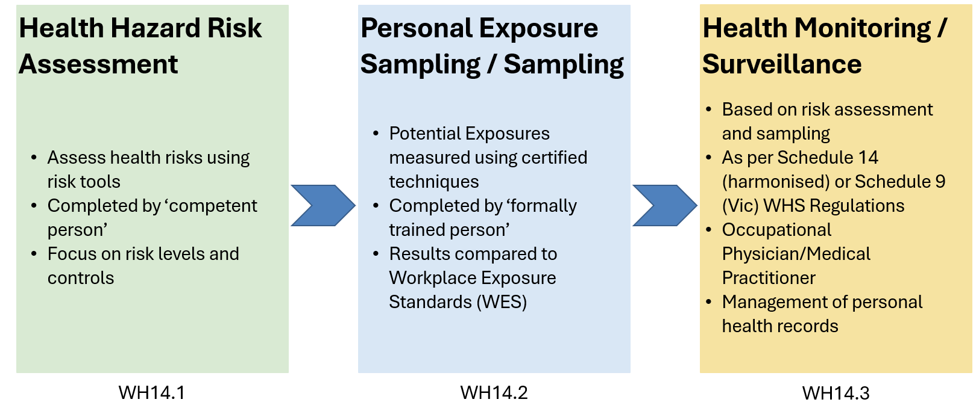

  - WH14.1
  - There is a documented process to ensure a competent person completes a site-specific assessment of potential health hazards, which may include:
- biological;
- physical; and
- chemical/atmospheric contaminants.

Key steps
The documented process needs to outline the approach for conducting an assessment of potential health hazards on site prior to project commencement. The assessment should identify potential health hazards as part of the project scope of works, including those that may affect contractors. It considers how work will be carried out and what health hazards may arise from equipment, plant, materials used, the work environment and activities.
Because assessments under this subcriteria need to be site-specific, they are often undertaken as part of a project risk assessment, a health risk assessment, or a more specific hazard risk assessment for sites with more complex hazards.
When undertaking an assessment process to meet this criterion, the ideal steps are:
- Step 1 – Record in the assessment who is identified in the WHS management system as a ‘competent’ person (suitably skilled and knowledgeable) to either perform the assessment or create an assessment tool or process for others to use.
- Step 2 – Record in the assessment all potential health hazards and their causes that are specific to the company's activities and work environments including biological, physical and chemical/atmospheric exposures (for example, bloodborne viruses, noise-induced hearing loss, asbestos, respirable crystalline silica).
- Step 3 – Record in the assessment which work group(s) each hazard affects, so broader or more targeted risk management strategies can be applied.
- Step 4 - Record in the assessment the controls to eliminate, or where not practicable, minimise the risk (for example, eliminating hazards through design choices, and hazard-specific control approaches for biological, manual handling, noise and airborne contaminant risks).
- Step 5 – Confirm in the assessment the company and its subcontractors have controls in place for identified health hazards, covering site-wide controls (for example, PPE, sunscreen), task-specific controls (for example, manual handling), and evidence of exposure monitoring where relevant. Include routine controls already in place and any additional site-based controls to be used. During the subcontractor tender process, interview questions can be used to confirm subcontractors understand of the management of health hazards and that they have established safe systems of work to manage these hazards.
- Step 6 – Determine and record in the assessment training needs, including any jurisdiction-specific mandatory courses (for example, 11084NAT Asbestos Awareness, 10830NAT Crystalline Silica Exposure Prevention).
- Final step - Review control measures to confirm they remain effective and consistent with the documented safe system of work.

Common issues identified at audit
- Training in a company's hazard identification, risk assessment and control (HIRAC) process alone does not make a person competent to assess site-specific health hazards. When nominating a ‘competent’ person, make sure they are capable of producing a detailed assessment and understand potential health hazards in construction associated with the company’s activities. Consider who may have this knowledge in the context of your operations and whether you need to seek external specialist assistance.
- Site-specific health hazard assessments are often generic or broad and fail to identify the specific work groups exposed to those hazards.

  - WH14.2

There is a documented process to ensure that, where identified as required, personal exposure to health hazards is measured and evaluated on the project by a formally trained person.

Key steps
When undertaking an assessment process to meet this criterion, the ideal steps are:
- Step 7 -Ensure there is a prompt that defines the trigger point for when personal exposure monitoring must be undertaken. Examples include when residual risk is above a defined or tolerable level, where controls are unable to effectively reduce the risks, or where the level of exposure or health hazard is not properly understood.
- Step 8 - Identify a formally trained person (for example, a Certified Occupational Hygienist, or a person holding a relevant unit such as MSS025008A for noise or MSS403032 for manual handling) appropriate to the hazard type. Where any health hazards or the risk to workers are not understood, engage a ‘formally trained person’ to measure and evaluate the health hazard.
- Step 9 - Plan the evaluation/assessment by defining what is being measured, the activities involved, whether it is project or task-specific, the controls to be tested, and ensuring the right people, records and photographic or video evidence are captured on the day.
- Step 10 - Communicate the evaluation to affected work groups, including health and safety representatives, covering why, how and when monitoring will occur and how results will be reported. Samples are typically analysed by a National Association of Testing Authorities (NATA) accredited laboratory and assessed against the Workplace exposure standards for airborne contaminants (WES) (note, from 1 December 2026 the Workplace exposure limits for airborne contaminants (WEL) will replace the WES). Ensure that where exposure exceeds the limit, controls are reviewed and monitoring is repeated to verify that exposures have been reduced. Where exposure cannot be further reduced, ensure appropriate PPE is used and for crystalline silica work workers are included on the Silica Worker Register, where required in NSW.
- Final step - Review control measures to confirm they remain effective and consistent with the documented safe system of work. Compare personal exposure monitoring results to the WES, where an applicable WES exists, or other recommended or regulated health standards.

Common issues identified at audit
- Occupational hygiene monitoring is not organised to take place when hazards and work activities can be observed (for example, an air exposure monitoring sample is not taken in the breathing zones of workers during work).
- Evidence of calibrated equipment being used is not provided as part of a report.
- Personal exposure monitoring is not undertaken using appropriate methods and calibrated equipment.
- A formally trained person is not engaged (this includes where a person is formally trained but the training is not relevant to the management and evaluation of personal exposure to health hazards). Examples of formally trained persons for assessing potential health hazards include, but are not limited to:
Health Hazard | Evidence of Formal Training | Information
Biological | Certified Occupational Hygienist | Australian Institute of Occupational Hygienists
Physical - Noise | Certified Occupational Hygienist; or  MSS025008A Monitor and evaluate noise | Australian Institute of Occupational Hygienists  Training.gov.au
Physical – Manual Handling | Allied Health professional - Occupational Therapists & Physiotherapists  MSS403032 Analyse manual handling processes | Training.gov.au
Chemical / atmospheric contaminants | Certified Occupational Hygienist | Australian Institute of Occupational Hygienists
Chemical / atmospheric contaminants - Asbestos | Certified Occupational Hygienist  Licence Asbestos Assessor (requirement varies based on local WHS/OHS jurisdiction requirements) | See the requirements of the locals State or Territory WHS regulator

  - WH14.3
  - There is a documented process to ensure that worker health surveillance/monitoring:
- is carried out in accordance with identified health hazards;
- carried out in accordance with relevant legislation, codes of practice and Australian standards;
- includes a process for management and communication of health monitoring results and records.

Key steps
When undertaking an assessment process to meet this criterion, the ideal steps are:
- Step 11 - Identify the need for health surveillance/monitoring, referencing the primary obligations under the Model WHS Regulations or Victorian OHS Regulations for noise, hazardous chemicals, lead, crystalline silica and asbestos, and including the specific work groups affected.
- Step 12 - Undertake health monitoring under the supervision of, or by, an appropriately qualified medical practitioner, consistent with regulatory requirements and at the required frequency/trigger events, with costs borne by the company. Companies should obtain sufficient information from subcontractors (for example, via a letter, or captured during the tender interview process) confirming what monitoring is being done and when, without requiring private or confidential information unless consent has been obtained.
- Step 13 - Manage and retain health monitoring records. Keep them confidential, only release them with the worker’s consent, make them available to the worker on request, and retain them in accordance with regulatory timeframes (typically 30 years or 40 years for asbestos-related surveillance).
- Final step - Review control measures to confirm they remain effective and consistent with the documented safe system of work.

Common issues identified at audit
- Companies and subcontractors do not adequately understand their WHS/OHS obligations for health monitoring.
- The head contractor does not assure itself that:
  - subcontractors understand their obligations for health monitoring; and
  - subcontractors can provide evidence that health monitoring is being performed.

- Private and confidential records are provided as evidence of health monitoring without workers’ consent.
Note
Australia is transitioning from the Workplace Exposure Standards (WES) to Workplace Exposure Limits (WEL) for airborne contaminants on 1 December 2026. For the purposes of this factsheet, references to WES should be read as including the equivalent WEL requirements, where applicable after this date.
Further information on the transition from the WES to the WEL is available at Safe Work Australia’s website, and from the WHS regulator in each jurisdiction.
This factsheet contains general information only and is not a substitute for independent professional advice. Further information about the intended purpose and use of this factsheet can be accessed on the Office of the Federal Safety Commissioner’s website; specifically, the disclaimer available at https://www.fsc.gov.au/disclaimer applies to this publication.
Last updated 1 October 2026.

